ORACLE SOA 11g

1. TABLE OF CONTENTS

1 SOA introduction 6

1.1 Basic Concepts of SOA 6

1.1.1 What is a Service? 6

1.1.2 Anatomy of Service 6

1.1.3 What is Web Service? 6

1.1.4 What is Web WSDL? 6

1.1.5 What is Web BPEL? 6

1.1.6 SOA Definition 7

1.1.7 Why SOA 7

1.1.8 SOA Architecture 7

1.1.9 SOA-Framework 8

1.1.10 Principles of SOA 8

2 Oracle SOA 10

2.1 Components of Oracle SOA Suite 10

2.2 SOA Installation 11

2.2.1 List of Softwares 11

2.3 Start Working with Oracle SOA 12

2.3.1 JCA Adapters 12

2.3.1.1 Oracle JCA Adapter for Files/FTP 12

2.3.1.2 Oracle JCA Adapter for JMS 13

2.3.1.3 Oracle JCA Adapter for Database 13

2.3.1.4 Oracle JCA Adapter for Oracle Streams Advanced Queuing (AQ) 13

2.3.1.5 Oracle JCA Adapter for MQ Series 13

2.3.1.6 Oracle JCA Adapter for Sockets 13

2.3.2 Working with WebLogic Server Console 13

2.3.3 Starting the Administration Console 14

2.3.4 Creating the JMS resources 15

3 Getting started with SOA 22

3.1 Working with JDeveloper 22

3.1.1 Creating an Application in JDeveloper 22

3.1.2 Creating an SOA Project in JDeveloper 23

3.1.3 What is a SOA Composite 23

3.1.3.1 BPEL Process 24

3.1.4 BPEL 1.1 and BPEL 2.0 Specification 24

3.1.5 BPEL Service Components 25

3.1.5.1 Business Rule 25

3.1.5.2 Mediator 25

3.1.5.3 Human Task 25

3.1.5.4 Spring Context 25

3.1.6 BPEL Web Service Activities 26

3.1.6.1 Invoke Activity 26

3.1.6.2 Partner Link Activity 26

3.1.6.3 Receive Activity 26

3.1.6.4 Reply Activity 27

3.1.7 BPEL Basic Activities 27

3.1.7.1 Assign Activity 27

3.1.7.2 Compensate Activity 27

3.1.7.3 CompensateScope Activity 27

3.1.7.4 Empty Activity 27

3.1.7.5 Exit Activity 27

3.1.7.6 Throw Activity 27

3.1.7.7 Rethrow Activity 27

3.1.7.8 Validate Activity 28

3.1.7.9 Wait Activity 28

3.1.8 Structured Activities 28

3.1.8.1 Flow Activity 28

3.1.8.2 forEach Activity 28

3.1.8.3 If Activity 28

3.1.8.4 Pick Activity 28

3.1.8.5 RepeatUntil Activity 30

3.1.8.6 Scope Activity 30

3.1.8.7 Sequence Activity 30

3.1.8.8 While Activity 31

3.1.9 Oracle Extensions 31

3.1.9.1 Assert Activity 31

3.1.9.2 Dehydrate Activity 31

3.1.9.3 Email Activity 31

3.1.9.4 IM Activity 32

3.1.9.5 Java Embedding Activity 32

3.1.9.6 Phase Activity 32

3.1.9.7 Receive Signal Activity 32

3.1.9.8 Replay Activity 32

3.1.9.9 Signal Activity 32

3.1.9.10 SMS Activity 33

3.1.9.11 Transform Activity 33

3.1.9.12 User Notification Activity 33

3.1.9.13 Voice Activity 33

4 create and execute simple composite 34

4.1.1 Creating a First Application in JDeveloper 34

4.1.2 Compiling the Project 40

4.1.3 Deploying the Project 41

4.1.4 Testing the Project from Console 43

4.1.5 Testing the Project from SOAP UI 45

5 ADVANCED SOA CONCEPTS 47

5.1 MetaData Services (MDS) in a SOA environment 47

5.1.1 Managing the MDS Repository 47

5.2 Transaction Management in Oracle SOA (BPEL) 47

5.3 Exception Handling 49

5.3.1 System faults 49

5.3.1.1 bindingFault 49

5.3.1.2 remoteFault 49

5.3.1.3 replayFault 50

5.3.2 Business faults 50

5.3.3 Fault Management Framework 50

5.3.3.1 Fault Policies 50

5.3.3.2 Fault Bindings 53

5.4 Protecting Personally Identifiable Information 53

5.4.1 Understanding Personally Identifiable Information 53

5.4.2 Protecting PII Information 54

5.4.3 Compose the XPath Expressions to Protect the PII Data 54

5.4.4 Configure the PII Encryption Key 55

5.4.5 Attach the pii_security_policy Policy 55

5.4.6 Attach the pii_security_policy to SOA Composite 55

5.4.7 Attach the pii_security_policy to JCA Binding 57

5.5 Domain Value Maps 57

5.5.1 Domain Value Map Features 57

5.5.1.1 Qualifier Support 58

5.5.1.2 Qualifier Order Support 58

5.5.1.3 One-to-Many Mapping Support 59

5.6 Embedding Java Code 59

5.7 Using soa-direct protocol (SOA-Direct) 60

6 SOA TASKS 62

6.1 Working with AQ Tables, AQ Adapter, Files and File Adapter 62

6.1.1 Create type and Queue table in database 62

6.1.2 Configuring AQ Adapter 63

6.1.3 Composite to Read the message from xml file and Enqueue Message in AQ 64

6.1.3.1 Create a file adapter to read message from XML file 65

6.1.3.2 Create AQ Adapter for Enqueue operation 67

6.1.3.3 Create Mediator component to route the messages 69

6.1.4 Composite for Dequeue Message from AQ and write into XML file 70

6.1.4.1 Create AQ Adapter for Dequeue operation 70

6.1.4.2 Create a file adapter to write messages into XML file 72

6.1.4.3 Create Mediator component to route the messages 74

6.2 Working with JMS Queue 74

6.2.1 Create a Simple JMS Queue in Weblogic Server 11g 74

6.2.1.1 Introduction and Definitions 74

6.2.1.2 Configuration Steps 75

6.2.2 Composite for Produce Message in JMS Queue 79

6.2.3 Composite for Consume Message in JMS Queue 84

6.3 FTP Adapter configuration 89

6.4 Working with Transformations 94

6.4.1 Using for-each for parent-child in Transformation 94

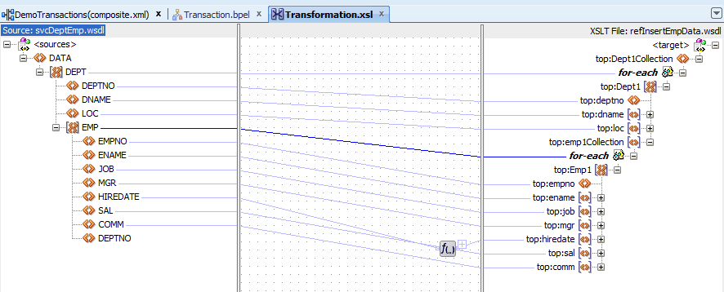 95

6.4.2 Using date format in Transformation 95

6.4.3 Sorting records in Transformation 95

6.5 Global and Local Transactions 96

6.6 Working with Exception Handling 101

6.6.1 Handling remote faults 102

6.6.2 Creating a fault policy 103

6.6.3 Handling exceptions in BPEL 107

6.6.4 Using a custom Java fault handler 111

6.7 Calling ODI scenario from BPEL 112

6.7.1 Calling Synchronous ODI 113

6.7.2 Calling Asynchronous ODI 115

6.8 Incorporating Java and Java EE Code in a BPEL Process 116

6.8.1 Creating a simple java class and jar file 116

6.8.2 Use java class from the .jar file inside the BPEL process 119

6.8.3 Get SAO Server Details using Java Embedding 120

6.9 Use Pick Activity in BPEL 121

6.9.1 Use on message acitvity the BPEL process 121

6.10 Use Human Task Activity in BPEL 123

6.10.1 Create simple Approve/Reject Human Activity 123

6.11 Use Direct-Binding in BPEL 132

6.11.1 Creating Direct-Binding for synchronous BPEL process 132

6.12 Working with Spring Context 134

6.12.1 Creating the direct Exposed Service from Spring Context 134

6.13 Create a simple Class and Interface in Spring Context 138

6.14 Token Configurations in Oracle SOA Suite PS6 ( 11.1.1.7.0) 147

6.15 Security 153

6.16 Securing Composites and Calling Secure Web Services 153

6.16.1 Restricting a composite with HTTP Basic Security 153

6.16.2 Securing Oracle SOA/OSB services with OWSM Policies 156

6.17 Change DB JNDI dynamically in SOA 11g 157

7 Oracle Service bus 161

7.1 What is Bus? 161

7.2 Resources in Oracle Service Bus 161

7.3 Proxy Services and Business Services 161

7.4 Message Flows and Pipelines 162

7.5 Pipeline Pairs 162

7.6 OSB Components 162

7.7 OSB Tasks 162

7.7.1 Creating the project and importing resources 162

7.7.2 Calling asynchronous BPEL Service from OSB by using Direct-Binding 173

7.7.3 Using simple Assign and Replace activities in OSB (Adding Two numbers) 180

7.7.4 Using simple if condition in OSB (Subtracting Two numbers) 184

# SOA introduction

A **service-oriented architecture** (**SOA**) is a style of software design where services are provided to the other components by application components, through a communication protocol over a network.

### Basic Concepts of SOA

#### What is a Service?

* A service is a package of closely related standardized functions which are called repeatedly in similar fashion and should therefore implemented by dedicated facility which is specific to perform them.
* A service can be partitioned and have multiple service functions
* The smallest subset within service functions are called service primitives

#### Anatomy of Service

#### What is Web Service?

A **web service** is any piece of software that makes itself available over the internet and uses a standardized XML messaging system. XML is used to encode all communications to a **web service**. For example, a client invokes a **web service** by sending an XML message, then waits for a corresponding XML response.

#### What is Web WSDL?

A **WSDL** is an XML document that describes a web service. It actually stands for Web Services Description Language

#### What is Web BPEL?

BPEL (Business Process Execution Language) is an XML-based language that allows Web services in a service-oriented architecture (SOA) to interconnect and share data. Programmers use BPEL to define how a business process that involves web services will be executed. BPEL messages are typically used to invoke remote services, orchestrate process execution and manage events and exceptions. BPEL is often associated with Business Process Management Notation (BPMN), a standard for representing business processes graphically. In many organizations, analysts use BPMN to visualize business processes and developers transform the visualizations to BPEL for execution.

#### SOA Definition

Architecture based on reusable, well defined services implemented by IT companies.

* Components are loosely coupled
* Provide platform, technology and language independent.

#### Why SOA

SOA functionality is not depending on any vendor, product or application.

#### SOA Architecture

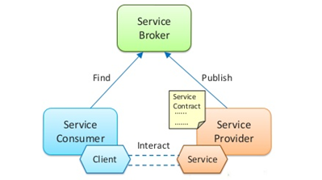

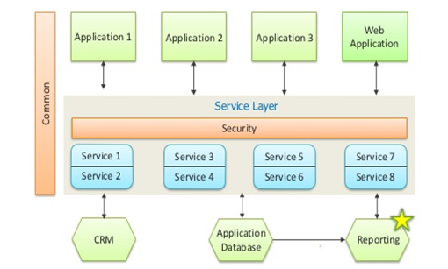

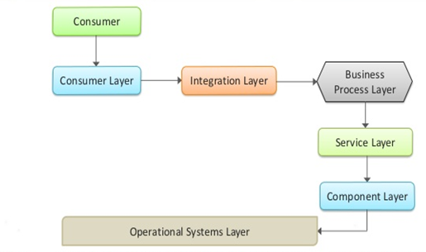

#### SOA-Framework

* **Consumer Interface Layer** – This layer is used by the customers
* **Business Process Layer** – Provides the business Process flow. Also accommodates new changes in the business easily, hence this layer is provided
* **Service Layer** – Comprises of all the services provided in the enterprise
* **Component Layer** – This layer has the actual service to be provided.
* **Operational subsystem layer** – This layer contains the data model

#### Principles of SOA

* **Service loose coupling** – Service does not have high dependency
* **Service abstraction** – Hides the implementation details
* **Service Reusability** – Services can be reused again and again without rewriting them
* **Service Statelessness** – Do not maintain the state to reduce the resource consumption
* **Service Discoverability** – Services can be registered and discovered from the service registry

# Oracle SOA

**Oracle SOA** Suite provides a comprehensive suite of components for developing, securing, and monitoring service-oriented architecture (**SOA**). Service components (BPEL process, business rule, human task, spring, and mediator) are the building blocks that you use to construct a **SOA** composite application.

### Components of Oracle SOA Suite

**Service Infrastructure**

The Service Infrastructure provides the internal message routing infrastructure capabilities for connecting components and enabling data flow

[**Oracle Mediator**](http://docs.oracle.com/cd/E28280_01/doc.1111/e10223/03_mediator.htm)

Using Oracle Mediator, you create routing services and rules for them

[**Oracle Adapters**](http://docs.oracle.com/cd/E28280_01/doc.1111/e10223/05_adapters.htm)

Oracle Adapters use JCA technology to connect external systems to the Oracle SOA Suite

[**Business Events and Events Delivery Network**](http://docs.oracle.com/cd/E28280_01/doc.1111/e10223/06_business_events.htm)

Business events are messages sent as the result of an occurrence or situation, such as a new order or completion of an order

[**Oracle Metadata Repository**](http://docs.oracle.com/cd/E28280_01/doc.1111/e10223/07_mds.htm)

The Oracle Metadata Repository (MDS) stores business events, rulesets for use by Oracle Business Rules, XSLT files for Oracle Service Bus and Oracle Mediator, XSD XML schema files for Oracle BPEL Process Manager, WSDL files, and metadata files for Complex Event Processing.

[**Oracle Business Rules**](http://docs.oracle.com/cd/E28280_01/doc.1111/e10223/08_business_rules.htm)

Oracle Business Rules, initiated by a BPEL process service component, enable dynamic decisions at runtime allowing you to automate policies, constraints, computations, and reasoning while separating rule logic from underlying application code

[**Oracle WSM Policy Manager**](http://docs.oracle.com/cd/E28280_01/doc.1111/e10223/09_policy_mgr.htm)

Oracle WSM Policy Manager provides the infrastructure for enforcing global security and auditing policies in the Service Infrastructure

[**Oracle BPEL Process Manager**](http://docs.oracle.com/cd/E28280_01/doc.1111/e10223/10_bpel.htm)

Oracle BPEL Process Manager provides the standard for assembling a set of discrete services into an end-to-end process flow, radically reducing the cost and complexity of process integration initiatives

[**Spring Context**](http://docs.oracle.com/cd/E28280_01/doc.1111/e10223/11_spring.htm)

Oracle SOA Suite provides support for the spring framework functionality of the WebLogic Service Component Architecture (SCA) of Oracle WebLogic Server

[**Human Workflow**](http://docs.oracle.com/cd/E28280_01/doc.1111/e10223/12_human_workflow.htm)

Many end-to-end business processes require human interactions with the process. For example, humans may be needed for approvals, exception management, or performing activities required to advance the business process

[**Oracle Business Activity Monitoring**](http://docs.oracle.com/cd/E28280_01/doc.1111/e10223/13_bam.htm)

Oracle Business Activity Monitoring (Oracle BAM) is a complete solution for building real-time operational dashboards and monitoring and alerting applications over the Web

[**Oracle User Messaging Service**](http://docs.oracle.com/cd/E28280_01/doc.1111/e10223/15_message.htm)

Oracle User Messaging Service provides a common service responsible for sending out messages from applications to devices

[**Oracle B2B**](http://docs.oracle.com/cd/E28280_01/doc.1111/e10223/16_b2b.htm)

Oracle B2B is an eCommerce gateway that enables the secure and reliable exchange of messages between an enterprise and its trading partners

[**Oracle JDeveloper**](http://docs.oracle.com/cd/E28280_01/doc.1111/e10223/17_jdev.htm)

Oracle JDeveloper is the development component of Oracle SOA Suite

[**Oracle Enterprise Manager**](http://docs.oracle.com/cd/E28280_01/doc.1111/e10223/18_em.htm)

You can configure, monitor, and manage your SOA composite application during run time from Oracle Enterprise Manager Fusion Middleware Control Console

[**Oracle Service Bus**](http://docs.oracle.com/cd/E28280_01/doc.1111/e10223/04_osb.htm)

Oracle Service Bus connects, mediates, and manages interactions between heterogeneous services, not just Web services, but also Java and .Net, messaging services and legacy endpoints

[**Oracle Complex Event Processing**](http://docs.oracle.com/cd/E28280_01/doc.1111/e10223/14_cep.htm)

Oracle SOA Suite provides Oracle Complex Event Processing (Oracle CEP), a data management infrastructure that supports the notion of streams of structured data records together with stored relations

### SOA Installation

#### List of Softwares

**Below listed are the softwares required for SOA(11g).**

* oracle 11g database
* Java 1.7
* oracle SOA suite 11g
* Jdeveloper 11.1.1.7.0
* Weblogic server 10.3.6
* SOAP UI 5.2.1
* OSB 11.1.1.8.0 (oracle enterprise pack for Eclipse)

### Start Working with Oracle SOA

#### JCA Adapters

To optimize business processes, you can integrate applications by using JCA 1.5 compliant resource adapters. Adapters support a robust, light weight, highly scalable, and standards-based integration framework, which enables disparate applications to communicate with each other. For example, adapters enable you to integrate packaged applications, legacy applications, databases, and Web services. Using Oracle JCA Adapters, you can ensure interoperability by integrating applications that are heterogeneous, provided by different vendors, based on different technologies, and run on different platforms.

Java EE Connector Architecture (JCA) is a Java-based technology solution for connecting application servers and enterprise information systems (EIS) as part of enterprise application integration (EAI) solutions.

#### Oracle JCA Adapter for Files/FTP

The Oracle File and FTP Adapters enable a BPEL process or a Mediator to exchange (read and write) files on local file systems and remote file systems (through use of the file transfer protocol (FTP)). The file contents can be both XML and non-XML data formats.

|  |  |
| --- | --- |
| **Recursive** | If this property is set to *true*, then the adapter can process all the sub-directories under the main input directory recursively. |
| **PollingFrequency** | This parameter specifies how often to poll a given input directory for new files. The parameter is of type *int* and is mandatory. The default value is 1 minute. |
| **UseHeaders** | This parameter can be set to *true* or false. If you must read file headers and skip reading the payload while using inbound Oracle File or FTP Adapter, then set the UseHeader property to true.  This is typically used in large payload scenarios where the inbound adapter is used as a notifier. |
| **MinimumAge** | This parameter specifies the minimum age of files to be retrieved. This specification enables a large file to be completely copied into the input directory before it is retrieved for processing. The age is determined by the last modified time stamp. For example, if you know that it takes three to four minutes for a file to be written, then set the minimum age of pollable files to five minutes. If a file is detected in the input directory and its modification time is within five minutes of the current time, then the file is not retrieved because it is still potentially being written to. |
| **DeleteFile** | If set to true, the Oracle File or FTP Adapter deletes the file after processing. |

#### Oracle JCA Adapter for JMS

The JMS architecture uses one client interface to many messaging servers. The JMS model has two messaging domains, point-to-point and publish-subscribe. In the point-to-point domain, messages are exchanged through a queue and each message is delivered to only one receiver. In the publish-subscribe model, messages are sent to a topic and can be read by many subscribed clients.

#### Oracle JCA Adapter for Database

The Oracle Database Adapter is a JCA 1.5 connector, which runs on the Oracle Application Server. It relies on an underlying JDBC connector/driver to enact the database communication. In contrast to JDBC, it is non-programmatic. The interaction (series of SELECT, UPDATE, INSERT) is loosely modelled using the Adapter Configuration Wizard. The inputs/outputs are XML, most easily seen as input parameters and result sets converted to XML. These XML inputs and outputs allow the Oracle Database Adapter services to be plugged into Oracle Fusion Middleware.

#### Oracle JCA Adapter for Oracle Streams Advanced Queuing (AQ)

Oracle Streams Advanced Queuing (AQ) provides a flexible mechanism for bidirectional, asynchronous communication between participating applications. Advanced queues are an Oracle database feature, and are therefore scalable and reliable. Other features of Oracle database, such as backup and recovery (including any-point-in-time recovery), logging, transactional services, and system management, are also inherited by advanced queues. Multiple queues can also service a single application, partitioning messages in a variety of ways and providing another level of scalability through load balancing.

#### Oracle JCA Adapter for MQ Series

Message queuing is a technique for asynchronous program-to-program communication. It enables application integration by allowing independent applications on a distributed system to communicate with each other. One application sends messages to a queue owned by a queue manager, and another application retrieves the messages from the queue. The communication between applications is maintained even if the applications are running at different times or are temporarily unavailable

#### Oracle JCA Adapter for Sockets

Oracle Socket Adapter is a JCA 1.5 compliant adapter for modelling standard or nonstandard protocols for communication over TCP/IP sockets. You can use an Oracle Socket Adapter to create a client or a server socket, and establish a connection. The data that is transported can be text or binary.

#### Working with WebLogic Server Console

WebLogic Server Administration Console, which includes tabs for configuring BEA Liquid Data for WebLogic.

**Using the Administration Console to Manage Liquid Data**

You can configure, manage, and monitor Liquid Data through the BEA WebLogic Server Administration Console. When Liquid Data is installed, it is deployed as an application in an instance of WebLogic Server. When you start the Liquid Data Server, the hosting WebLogic server is automatically started. Upon installation, Liquid Data becomes a *managed resource* known to the WLS JMX management framework. You will use the tabs on the Liquid Data node in the Administration Console to ad and configure Liquid Data data sources.

#### Starting the Administration Console

1. Open a web browser (either Netscape 4x or higher, or Internet Explorer 4.x or higher) and open the following URL:

http://*hostname*:*port*/console

Where

* + *hostname* is the machine name or IP address of the host server
  + *port* is the address of the port on which the host server is listening for requests (7001 by default)

For example, to start the Administration Console for a local instance of WebLogic Server (running on your own machine), type the following URL in a Web browser address field:

http://localhost:7001/console/

If you started the Administration Server using Secure Socket Layer (SSL), you must add s after http, as follows:

https://*hostname*:*port*/console

**Note:** On Windows, you can start the Administration Console through the start menu: Start—>Programs—>BEA WebLogic Platform 8.1—>Liquid Data for WebLogic 8.1—>Liquid Data Samples—>Admin Console

1. When the login page appears, enter the user name and the password you used to start the Administration Server.

Note : Default username is ‘weblogic’ and password is ‘welcome1’

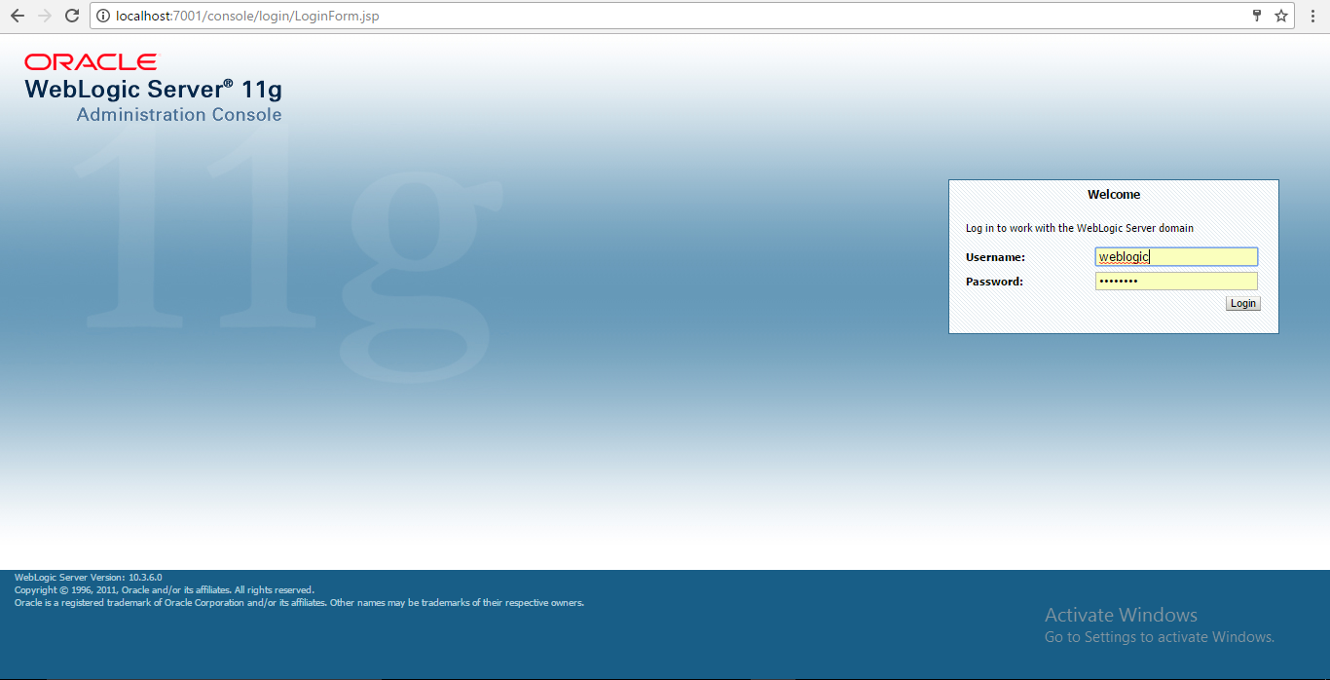

#### Creating the JMS resources

1. Make sure that your server has started.

**First add the JMS Queue:**

1. In the WLS console, on the left navigation bar, expand Services | Messaging and click on JMS Modules.
2. Click on SOAJMSModule (click on the name, not the checkbox).

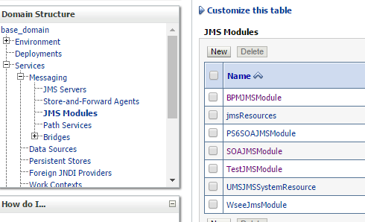

1. In the Summary of Resources table, click on New.
2. Select the resource type: Queue and click on Next.
3. Enter Name as demoQueue and JNDI Name as jms/demoQueue.

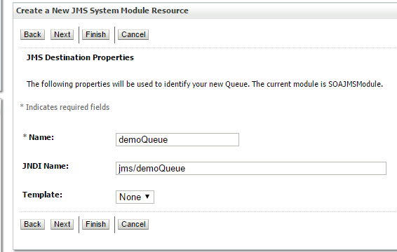

1. Click on Next.
2. From the Subdeployments list, select SOASubDeployment.
3. From the JMS Servers list, select SOAJMSServer.

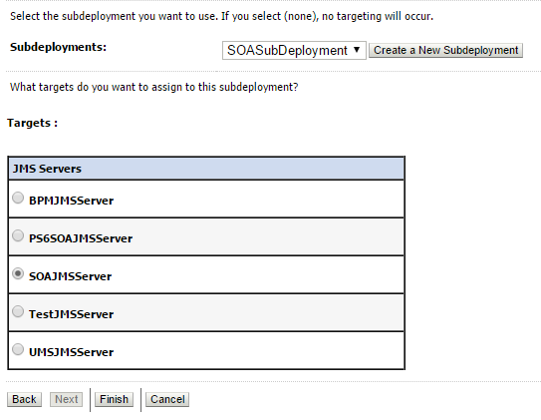

1. Click on Finish.

**Now add the Connection Factory.**

1. In the Summary of Resources table, click on New.
2. Select the resource type: Connection Factory and click on Next.
3. Enter Name as demoConFac and JNDI name as jms/demoConFac.

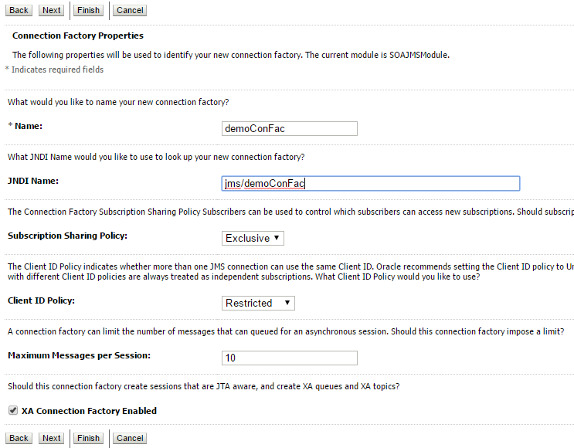

1. Click on Next.
2. Click on Finish.

You should see both the queue and the connection factory listed in the Summary of Resources as shown here:



Now add the connection pool. The connection pool is configured in the JMSAdapter application and uses a Deployment Plan. First, create a directory to contain that plan.

1. Create a directory here: C:\Oracle\Middleware\home_11gR1\Oracle_SOA1\soa\JMSPlan (adjust the path according to your installation).
2. In the left navigation bar of the WLS console, click on Deployments.
3. Click on JMSAdapter (click on the name, not the checkbox).
4. Click the Configuration tab and then the Outbound Connection Pools tab.

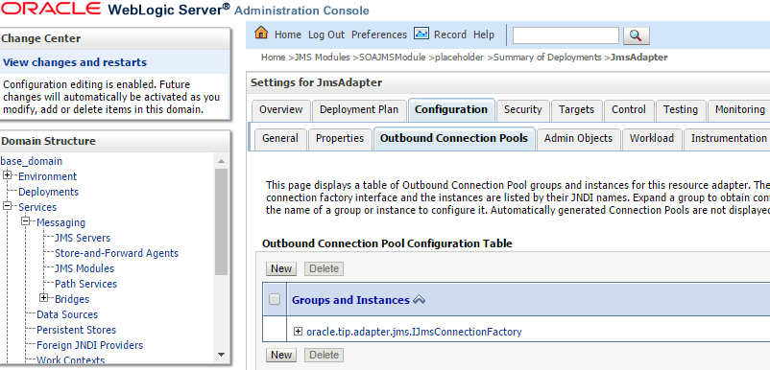

1. Click on New.
2. Select the oracle.tip.adapter.jms.IJmsConnectionFactory factory.

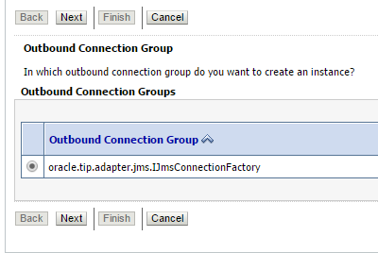

1. Click on Next.
2. Enter eis/Queue/demo.

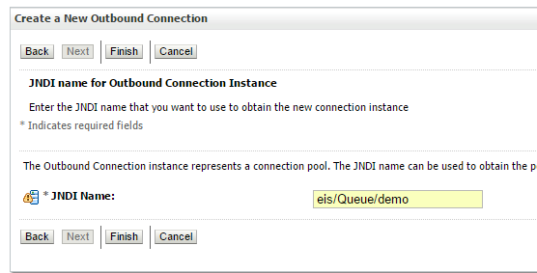

1. Click on Finish.
2. At this point, you are asked for the deployment plan location. Click on the path to the directory you created earlier and enter Plan.xml for the plan name.

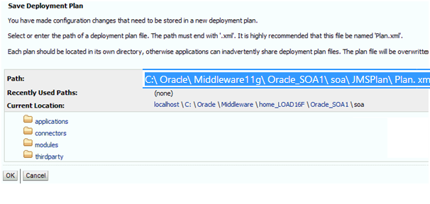

1. Click on OK.
2. Verify the plan name is set to Plan.xml in the JMSPlan directory.

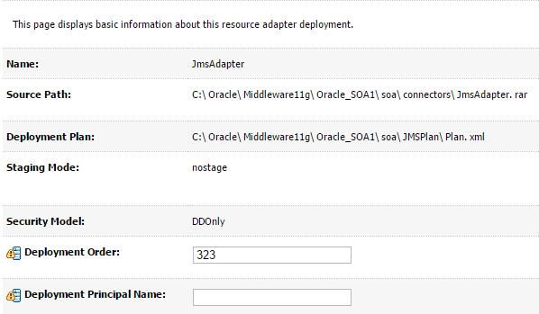

Go back to the new connection pool to hook up the connection factory:

1. Click on the Configuration tab.
2. Expand the group: oracle.tip.adapter.jms.IJmsConnectionFactory.
3. Click on eis/Queue/demo.

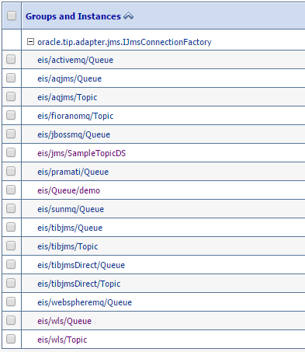

1. To change a property value you must enter the value and then press the Enter key and then click on the Save button. Do not use the Tab key after entering the value. Follow these instructions exactly:
2. Select the cell on the far right for the property **ConnectionFactoryLocation**.
3. An edit box appears. Type in the value jms/demoConFac and press the Enter key.
4. You must use the Enter key for the value to be entered in the field.

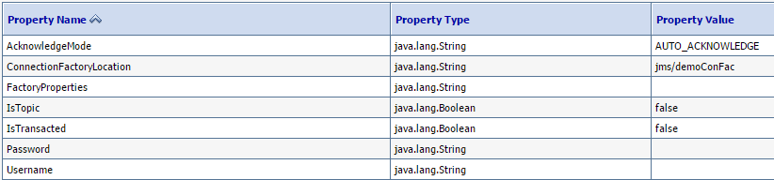

1. Click on Save. You must use the Save button to save the value.
2. Now the adapter must be redeployed. Click on Deployments in the left navigation bar.
3. Select the checkbox next to JMSAdapter.
4. Click on Update at the top of the Deployment table.
5. Verify that the correct deployment plan is selected.

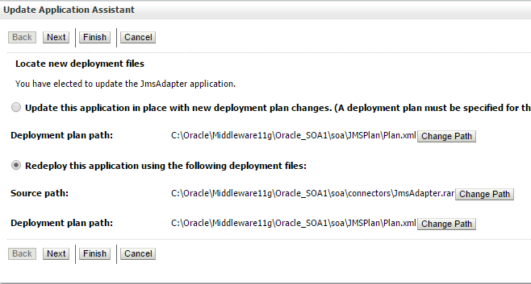

1. Click on Next.
2. Click on Finish.

# Getting started with SOA

We create SOA application in JDeveloper and deploy it in WebLogic Server and test it. Before creating the SOA application, make sure the Admin and Managed SOA Servers are up. All the adapters need for creating the application have to be created.

### Working with JDeveloper

JDeveloper is an Integrated Development Environment (IDE) for developing, debugging, deploying the SOA applications. It used java code, xml and SQL for developing the application. This runs on all platforms like Window, Linux, Mac OS etc. SOA Application in JDeveloper is used to create different projects like bpel, human tasks etc.

To start the JDeveloper go to the application and click on the JDeveloper icon.

* On the left hand side we have Application Navigator for creating and managing different SOA components.
* On the right hand side we have Resource Palette with provides visual elements used to create the SOA components.
* Middle space is used to drag and drop the visual elements from Resource Palette in sequence to create the SOA components.

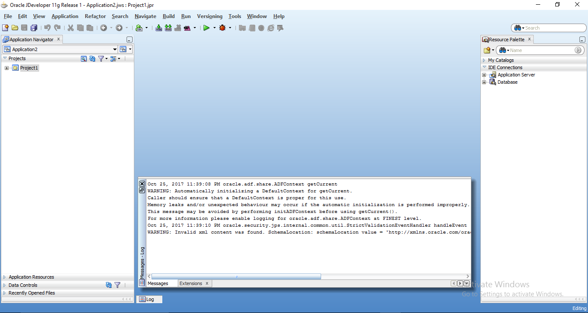

#### Creating an Application in JDeveloper

An Application is the higher level of represent the interrelated or independent components. We can have multiple applications under the Application Navigator and it displays all the SOA components created under the each application.

To create Application

* Select drop down under the Application Navigator
* Select New Application.
* Give the application name and select the location where you want to save your application and select Generic in Application template.

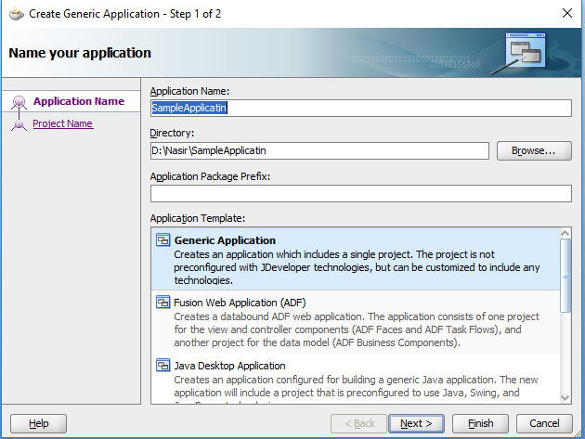

* Click next and then enter the project name and technology of project you are creating under the application.
* Click on finish.

#### Creating an SOA Project in JDeveloper

* Right click on the project
* Select New Project
* Select Project under All Technologies Tab
* Select SOA Project from Items and click on OK
* Enter the project name click on next
* Select the composite template and click on finish.

#### What is a SOA Composite

A composite is collection of services and service components that are wired together to form a design which helps the business needs.

Following types of composite can be created based on business need.

#### BPEL Process

BPEL (Business Process Execution Language) is a XML based language used for defining and executing the business logic using web services. It enables composition, orchestration, and coordination of Web services.

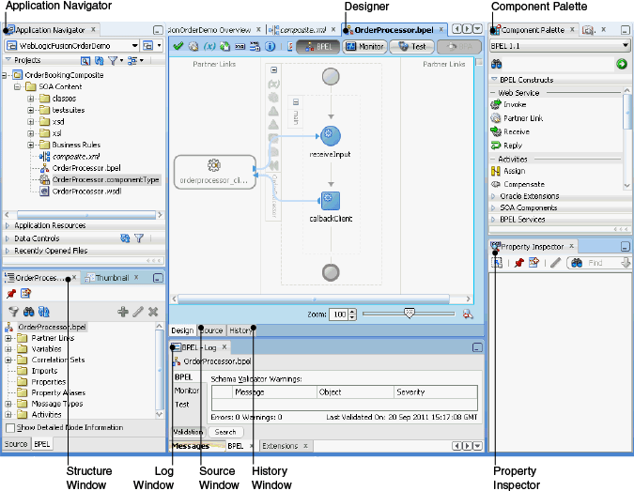

#### BPEL 1.1 and BPEL 2.0 Specification

Oracle SOA Suite 11g provides the option to use both the BPEL 1.1 and BPEL 2.0 versions.

If we are migrating the BPEL process from 10g to 11g version the BPEL 1.1 version will be used in the migrated process but new processes can be developed in BPEL 2.0.

[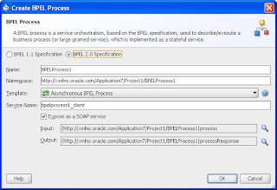](http://2.bp.blogspot.com/-QYSjN3Exves/UFNDAC7bh4I/AAAAAAAABlE/S5grG3mU92c/s1600/untitled.JPG)

**New Activities 2.0**

* <forEach> activity to repeat the set of activities. Replace the FlowN activity in BPEL 1.1 version.
* <repeatUntil> - Use this activity if the body of an activity must be performed at least once. The XPath expression condition in the repeatUntil activity is evaluated after the body of the activity completes.
* <if>-<elseif>-<else> - Replaces the switch activity in BPEL 2.0 - This activity enables you to define conditional behavior for specific activities to decide between two or more branches. Only one activity is selected for execution from a set of branches.
* Changed <terminate> to <exit>
* <compensateScope>  - to compensate the specified child scope
* A <rethrow> activity has been added to fault handlers this activity enables you to rethrow a fault originally captured by the immediately enclosing fault handler.

#### BPEL Service Components

#### Business Rule

Oracle Business Rules enable dynamic decisions at runtime allowing you to automate policies, computations, and reasoning while separating rule logic from underlying application code. This allows more agile rule maintenance and empowers business analysts with the ability to modify rule logic without programmer assistance and without interrupting business processes.

#### Mediator

Oracle Mediator is a service component of the Oracle SOA Suite that provides mediation capabilities such as selective routing, transformation, and validation capabilities, along with various message exchange patterns, such as synchronous, asynchronous, and event publishing or subscriptions.

#### Human Task

The Human Task component provides a set of functionality that handles different human interaction patterns within a broader business process.

#### Spring Context

Oracle SOA Suite provides support for the spring framework functionality of the WebLogic Service Component Architecture (SCA) of Oracle WebLogic Server. Spring is a popular application framework that enables developers to quickly and easily create high quality applications for deployment into high-end application servers. The spring framework provides a lightweight container that makes it easy to use different types of services. Lightweight containers can accept any JavaBean, instead of specific types of components.

You can use the spring framework to create Java applications using plain old Java objects (POJOs) and expose components as SCA services and references. In SCA terms, a WebLogic spring framework SCA application is a collection of POJOs plus a spring SCA context file that wires the classes together with SCA services and references.

Oracle SOA Suite provides a spring context service component that enables you to use Java interfaces instead of WSDL files in SOA composite applications. You can also integrate components that use Java interfaces with components that use WSDL files in the same SOA composite application. For example, you can have a spring context service component invoke an Oracle BPEL Process Manager service component or an Oracle Mediator service component invoke a spring context service component or Enterprise JavaBean.

#### BPEL Web Service Activities

#### Invoke Activity

This activity enables you to specify an operation you want to invoke for the service (identified by its partner link). The operation can be one-way or request-response on a port provided by the service. You can also automatically create variables in an invoke activity. An invoke activity invokes a synchronous web service or initiates an asynchronous web service.

The invoke activity opens a port in the process to send and receive data. It uses this port to submit required data and receive a response. For synchronous callbacks, only one port is needed for both the send and the receive functions.

The invoke activity supports the bpelx:inputProperty and bpelx:outputProperty that facilitate the passing of properties through the SOAP header and the obtaining of SOA runtime system properties for useful information such as the tracking.compositeInstanceId and tracking.conversationId.

#### Partner Link Activity

This service enables you to define the external services with which your process interacts. A partner link type characterizes the conversational relationship between two services by defining the roles played by each service in the conversation and specifying the port type provided by each service to receive messages within the conversation. For example, if you are creating a process to interact with a Credit Rating Service and two loan provider services (United Loan and Star Loan), you create partner links for all three services.

#### Receive Activity

This activity specifies the partner link from which to receive information and the port type and operation for the partner link to invoke. This activity waits for an asynchronous callback response message from a service, such as a loan application approver service. While the BPEL process is waiting, it is dehydrated (compressed and stored) until the callback message arrives. The contents of this response are stored in a response variable in the process.

The receive activity supports the bpelx:property extensions that facilitate the passing of properties through the SOAP header, and the obtaining of SOA runtime system properties for useful information such as tracking.compositeInstanceId and tracking.conversationId.

#### Reply Activity

This activity allows the process to send a message in reply to a message that was received through a receive activity. The combination of a receive activity and a reply activity forms a request-response operation on the WSDL port type for the process.

#### BPEL Basic Activities

#### Assign Activity

This activity provides a method for data manipulation, such as copying the contents of one variable to another. Copy operations enable you to transfer information between variables, expressions, endpoints, and other elements.

#### Compensate Activity

This activity invokes compensation on an inner scope activity that has successfully completed. This activity can be invoked only from within a fault handler or another compensation handler. Compensation occurs when a process cannot complete several operations after completing others. The process must return and undo the previously completed operations. For example, assume a process is designed to book a rental car, a hotel, and a flight. The process books the car and the hotel, but cannot book a flight for the correct day. In this case, the process performs compensation by unbooking the car and the hotel. The compensation handler is invoked with the compensate activity, which names the scope on which the compensation handler is to be invoked.

#### CompensateScope Activity

This activity enables you to start compensation on a specified inner scope that has already completed successfully. This activity must only be used from within a fault handler, another compensation handler, or a termination handler.

#### Empty Activity

This activity enables you to insert a no-operation instruction into a process. This activity is useful when you must use an activity that does nothing (for example, when a fault must be caught and suppressed).

#### Exit Activity

This activity enables you to immediately end all currently running activities on all parallel branches without involving any termination handling, fault handling, or compensation handling mechanisms.

#### Throw Activity

This activity generates a fault from inside the business process.

#### Rethrow Activity

This activity enables you to rethrow a fault originally captured by the immediately enclosing fault handler.

#### Validate Activity

This activity enables you to validate variables in the list. The variables are validated against their XML schema.

#### Wait Activity

This activity allows a process to specify a delay for a certain period or until a certain deadline is reached. A typical use of this activity is to invoke an operation at a certain time. This activity enables you to wait for a given time period or until a certain time has passed. Exactly one of the expiration criteria must be specified.

#### Structured Activities

#### Flow Activity

This activity enables you to specify one or more activities to be performed concurrently. A flow activity completes when all activities in the flow have finished processing. Completion of a flow activity includes the possibility that it can be skipped if its enabling condition is false.

For example, assume you use a flow activity to enable two loan offer providers (United Loan service and Star Loan service) to start in parallel. In this case, the flow activity contains two parallel activities – the sequence to invoke the United Loan service and the sequence to invoke the Star Loan service. Each service can take an arbitrary amount of time to complete their loan processes.

#### forEach Activity

This activity enables you to process multiple sets of activities sequentially or in parallel. The forEach activity executes its contained (child) scope activity exactly N+1 times, where N equals the final counter value minus the starting counter value that you specify in the Counter Values tab of the For Each dialog. While other structured activities such as a flow activity can have any type of activity as its contained activity, the forEach activity can only use a scope activity.

#### If Activity

This activity enables you to define conditional behavior for specific activities to decide between two or more branches. Only one activity is selected for execution from a set of branches.

#### Pick Activity

This activity waits for the occurrence of one event in a set of events and performs the activity associated with that event. The occurrence of the events is often mutually exclusive (the process either receives an acceptance or rejection message, but not both). If multiple events occur, the selection of the activity to perform depends on which event occurred first. If the events occur nearly simultaneously, there is a race and the choice of activity to be performed is dependent on both timing and implementation.

Pick activity is very important in BPEL. We use this activity in following cases.

* When we call asynchronous service and we need response back in certain time frame otherwise we need to throw exception.
* When we want to have multiple entry point for any composite. E.g. when we want our process when it is invoked by client or when any message is put to JMS queue by client.

Pick activity has two branches, OnMessage Branch and OnAlarm Branch which are explained below. Out of these two branches, only one will execute.

OnMessage is same as Receive activity. It is used when we need to receive message from external system.

[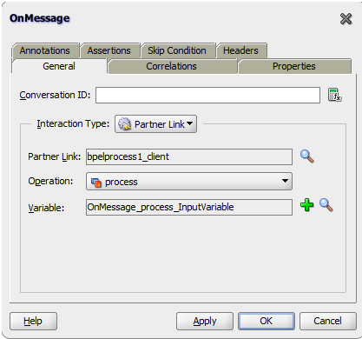](http://1.bp.blogspot.com/-C-CWXDRMREo/U3OIZlr-KbI/AAAAAAAAFUE/9pLF8aY7wrI/s1600/PickActivity_OnMessage.png)

OnAlarm branch is used when we want to specify expiry time.

[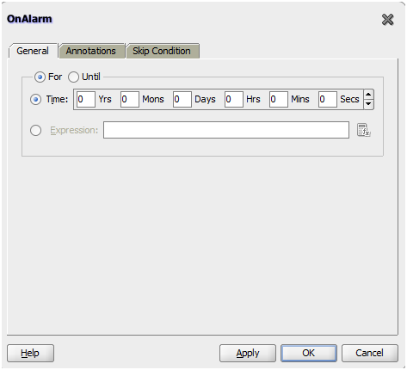](http://2.bp.blogspot.com/-j1SF_-S3M2E/U3OInmGydvI/AAAAAAAAFUM/S4tTQDVj77E/s1600/PickActivity_OnAlarm.png)

#### RepeatUntil Activity

Use this activity if the body of an activity must be performed at least once. The XPath expression condition in the repeatUntil activity is evaluated after the body of the activity completes. The condition is evaluated repeatedly (and the body of the activity processed) until the provided boolean condition is true.

#### Scope Activity

This activity consists of a collection of nested activities that can have their own local variables, fault handlers, compensation handlers, and so on. A scope activity is analogous to a { } block in a programming language.

Each scope has a primary activity that defines its behavior. The primary activity can be a complex structured activity, with many nested activities within it to arbitrary depth. The scope is shared by all the nested activities.

#### Sequence Activity

This activity enables you to define a collection of activities to be performed in sequential order. For example, you may want the following activities performed in a specific order:

* A customer request is received in a receive activity.
* The request is processed inside a flow activity that enables concurrent behavior.
* A reply message with the final approval status of the request is sent back to the customer in a reply activity.

A sequence activity makes the assumption that the request can be processed in a reasonable amount of time, justifying the requirement that the invoker wait for a synchronous response (because this service is offered as a request-response operation).

When this assumption cannot be made, it is better to define the customer interaction as a pair of asynchronous message exchanges.

When you double-click the Sequence icon, the activity area shown in [Figure A-36](https://docs.oracle.com/cd/E25054_01/dev.1111/e10224/bp_appx_ref.htm#CIADFHDH) appears. Drag and define appropriate activities inside the sequence activity.

#### While Activity

This activity supports repeated performance of a specified iterative activity. The iterative activity is repeated until the given while condition is no longer true.

#### Oracle Extensions

#### Assert Activity

This activity enables you to perform an assertion on a specified expression.

This is a standalone activity in which to specify assertions. You can also specify assertions from the Assertions tab in invoke activities, receive activities, and the onMessage branch of pick and scope activities.

#### Dehydrate Activity

By default, dehydration points are set on activities such as a wait and receive. The dehydrate activity enables you to explicitly specify a dehydration point. This activity acts as a dehydration point to automatically maintain long-running asynchronous processes and their current state information in a database while they wait for asynchronous callbacks. Storing the process in a database preserves the process and prevents any loss of state or reliability if a system shuts down or a network problem occurs. This feature increases both BPEL process reliability and scalability.

The bpelx:dehydrate extension implements dehydration. For BPEL projects that support BPEL version 1.1, the syntax is as follows:

<bpelx:dehydrate name="DehydrateInstance"/>

#### Email Activity

This activity enables you to send an email notification about an event.

For example, an online shopping business process of an online bookstore sends a courtesy email message to you after the items are shipped. The business process calls the notification service with your user ID and notification message. The notification service gets the email address from Oracle Internet Directory.

#### IM Activity

This activity enables you to send an automatic, asynchronous instant message (IM) notification to a user, group, or destination address.

#### Java Embedding Activity

This activity enables you to add custom Java code to a BPEL process using the Java BPEL exec extension bpelx:exec. This is useful when you have Java code that can perform a function, and want to use this existing code instead of starting over. In BPEL 2.0 projects, the bpelx:exec extension and Java code are wrapped in an <extensionActivity> element.

#### Phase Activity

This activity creates Oracle Mediator and business rules service components for integration with a BPEL process. You create message request input and message response output variables and design business rules for evaluating variable content for the BPEL process.

When you complete these tasks, the following activities and service components are created:

* An assign activity that includes the message request input and message response output variables.
* An invoke activity, which is automatically designed to invoke an Oracle Mediator partner link in the BPEL process.
* The Oracle Mediator partner link, which is automatically designed to route the message request input variable to the business rules service component in the SOA composite application of which this BPEL process is a part. The business rules service component displays in the SOA Composite Editor. Oracle Mediator also displays as a service component in the SOA Composite Editor.
* The business rules service component, which evaluates the content of the message request input variable and returns the results in the message response output variable to Oracle Mediator. Oracle Mediator then makes a routing decision and routes the message to the correct target destinations.

#### Receive Signal Activity

Use this activity in detail processes to wait for the notification signal from the master process to begin processing and use in a master process to wait for the notification signal from all detail processes indicating that processing has completed.

#### Replay Activity

This activity enables you to re-execute the activities inside a selected scope.

#### Signal Activity

This activity is used in a master process to notify detail processes to perform processing at runtime and used in detail processes to notify a master process that processing has completed.

#### SMS Activity

This activity enables you to send a short message system (SMS) notification about an event.

#### Transform Activity

This activity enables you to create a transformation that maps source elements to target elements (for example, incoming purchase order data into outgoing purchase order acknowledgment data).

#### User Notification Activity

This activity enables you to design a BPEL process in which you do not explicitly select a notification channel during design time, but simply indicate that a notification must be sent. The channel to use for sending notifications is resolved at runtime based on preferences defined by the end user in the User Messaging Preferences user interface of the Oracle User Messaging Service. This moves the responsibility of notification channel selection from Oracle BPEL Designer to the end user. If the end user does not select a preferred channel or rule, email is used by default for sending notifications to that user.

#### Voice Activity

This activity enables you to send a telephone voice notification about an event.

# create and execute simple composite

#### Creating a First Application in JDeveloper

* Select drop down under the Application Navigator
* Select New Application.
* Give the application name (MyFirstApp) and select the location where you want to save your application and select Generic in Application template.

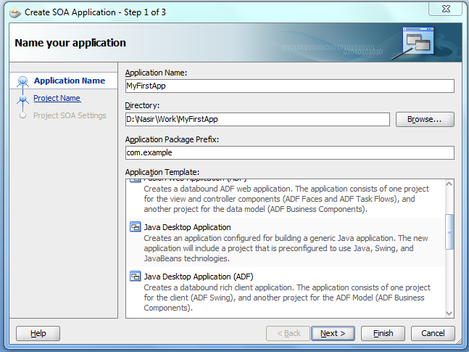

* Click next and then enter the project name (MyFirstProject) and technology of project you are creating under the application.

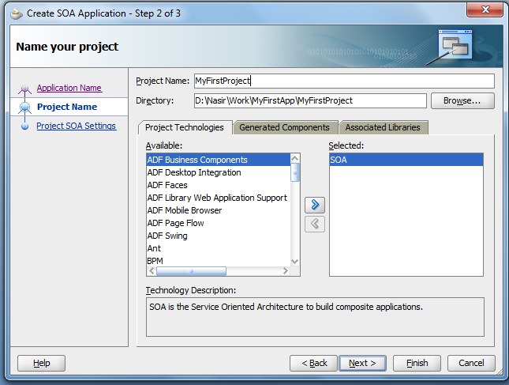

* Select Composite with BPEL Process from Composite template.

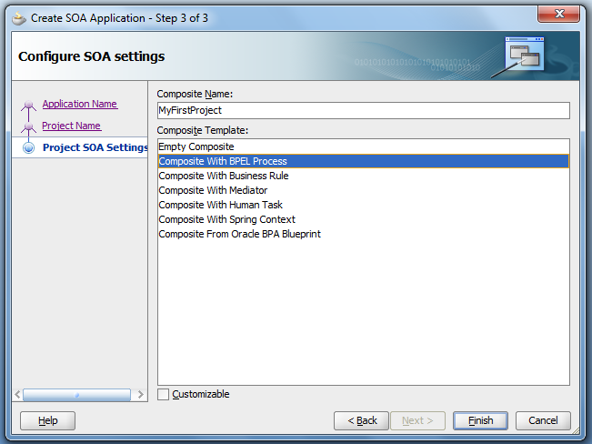

* Click on finish.
* Select BPEL 2.0 Speicification and enter the name (MyFirstBPELPRocess).
* Select synchronous BPEL Process from template.
* Leave the default settings and Select OK.

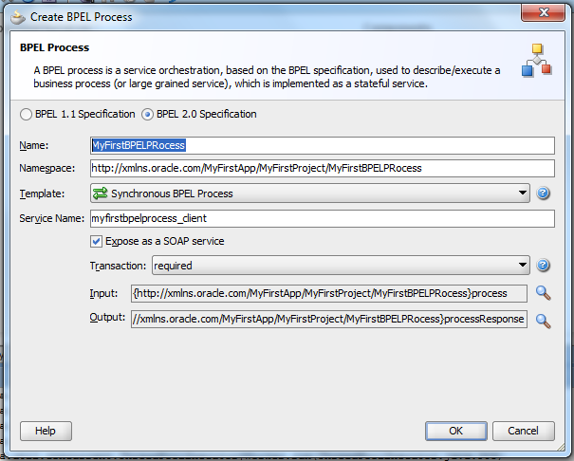

**Directory structure of the BPEL Composite**

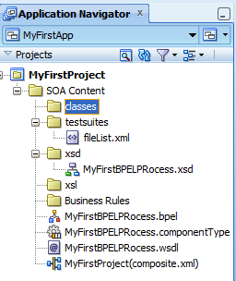

**Composite**

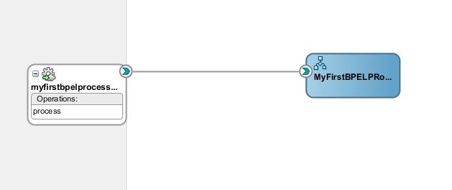

**BPEL Structure**

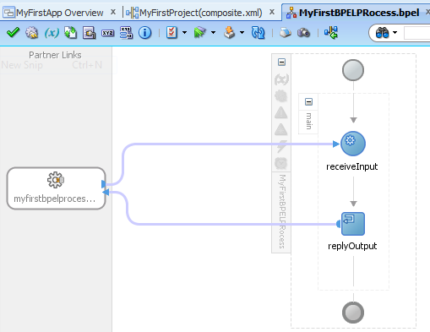

Note : The business logic should be implemented between receive and reply activity.

**Partner Link (myfirstbpelprocess_client) :** Starting and ending point of data flow of the activity which provides the input to the receive activity and receives the result from the reply activity.

**Receive Activity (receiveInput) :** Receives the input passed as an input to the composite from Partner Link. We can pass this input to the BPEL body.

**Reply Activity (replyOutput) :** After completing the processing of the data it returns the result to the Partner Link.

**Variables:** Basic variables are crated for the receive and reply activity automatically for holding input and output data.

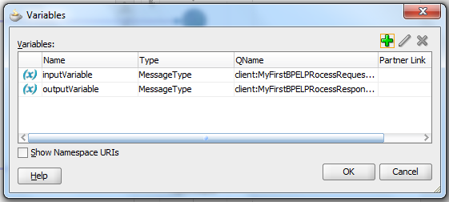

* Drag the Assign activity from component palette.

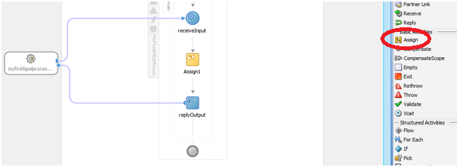

* To edit the Assign activity, double click on it.
* In ‘General’ tab give the name for the Assign activity.

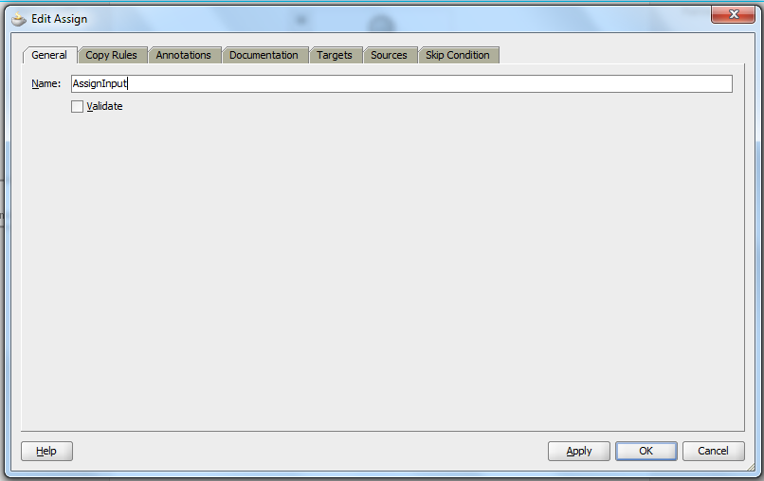

* Go to Copy Rules Tab and select the Expression Icon on top right and drag on the result variable.

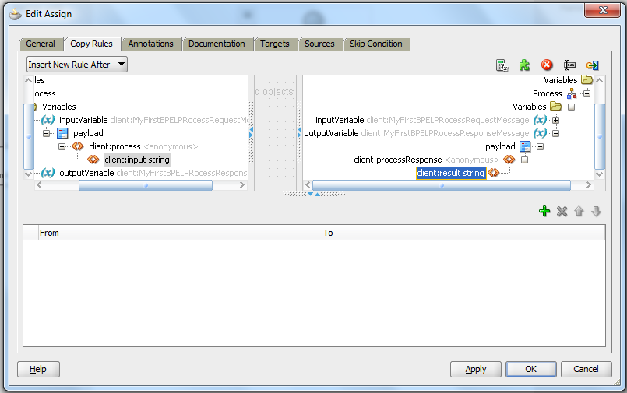

* Expression window will open and select the String Functions from the drop down list of functions.

(We are using concatenate function to concatenating given input with ‘Hello’ as prefix.)

* Drag the concat() function to the Expression area and add the input variable from the BPEL variables section and concatenate with the text.

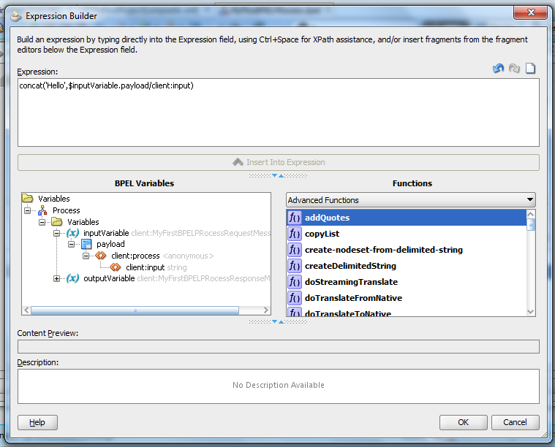

* Click on Ok, click on apply and then OK.
* Save the project and compile.

#### Compiling the Project

* To compile the project click on the ‘Make’ icon.

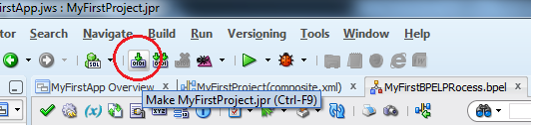

* A log window at the bottom of the window as build successful. This means no errors in the composite creation.

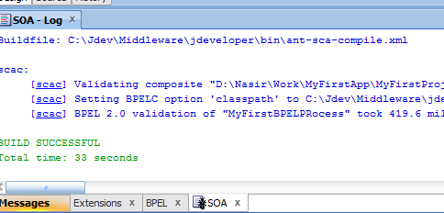

#### Deploying the Project

* Right click on the project.
* Select deploy and then click on project name.

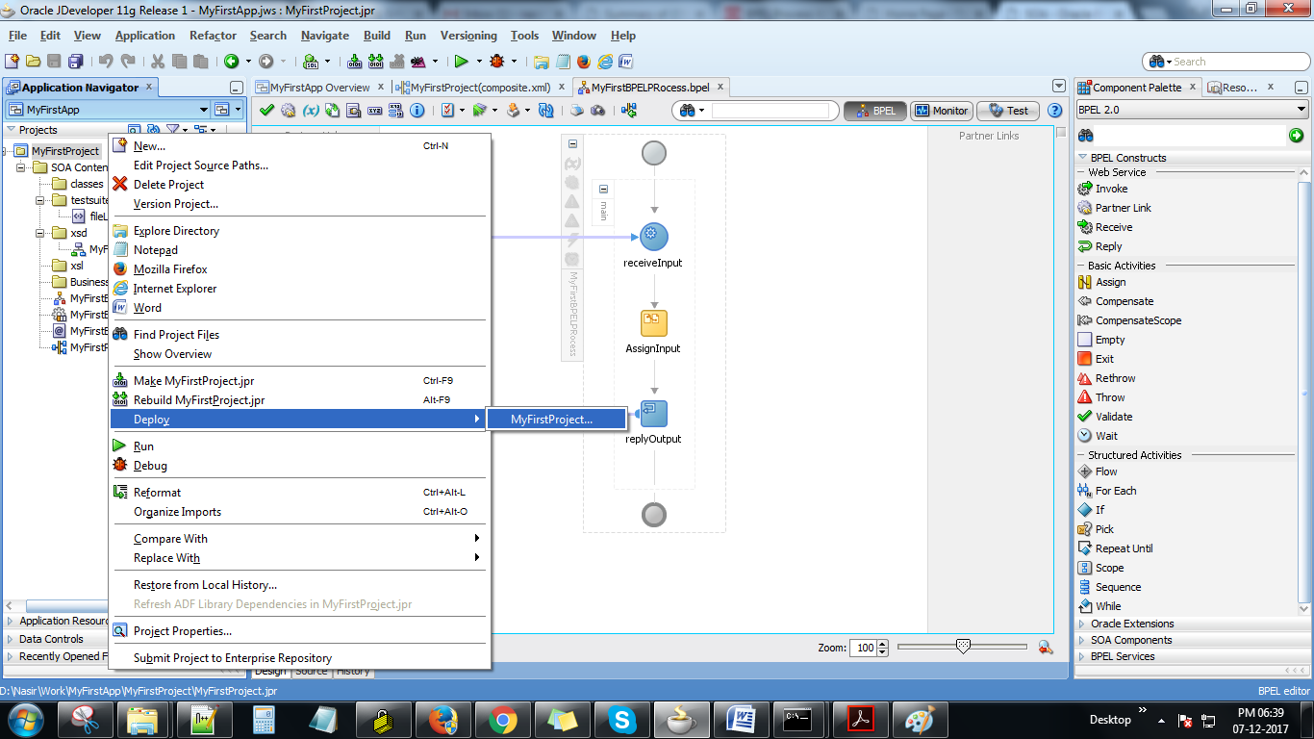

* A deployment window will open.
* Select deploy to Application Server.

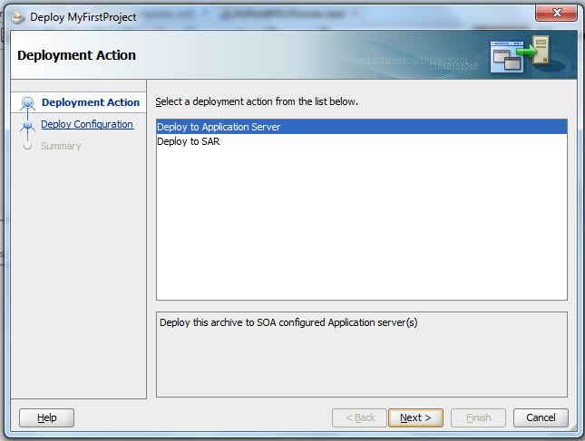

* Select version (Default is 1.0) and select next.
* Select the application you want to deploy.

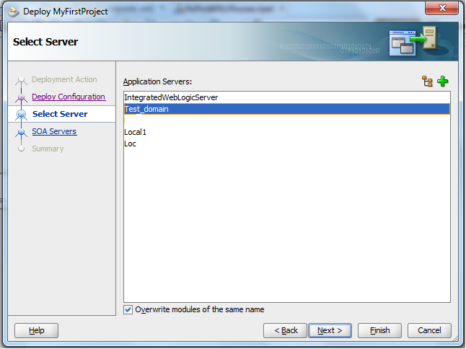

* Select the partition you want to deploy.

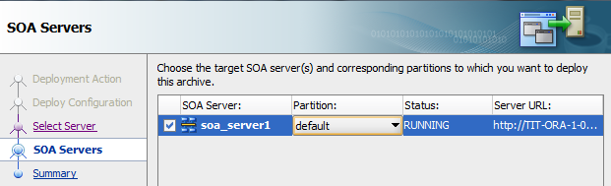

* Click on next and then select Finish.
* Deployment log will notify when the deployment completes.

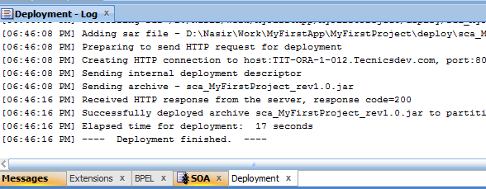

#### Testing the Project from Console

* To test the project, open the Enterprise Manager console and enter the username and password for login.

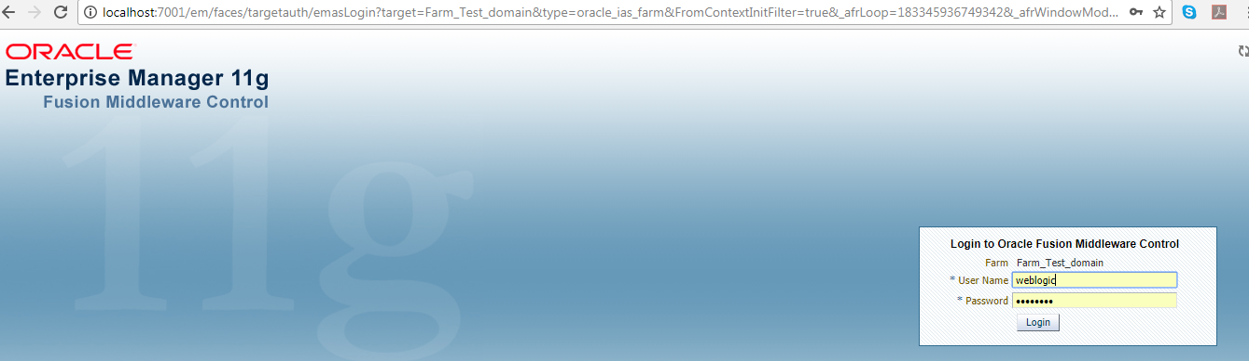

* In the SOA domain you can able to see the project we have deployed under the default partition.
* Click on the project then the composite dash board will open.
* Click on Test button.

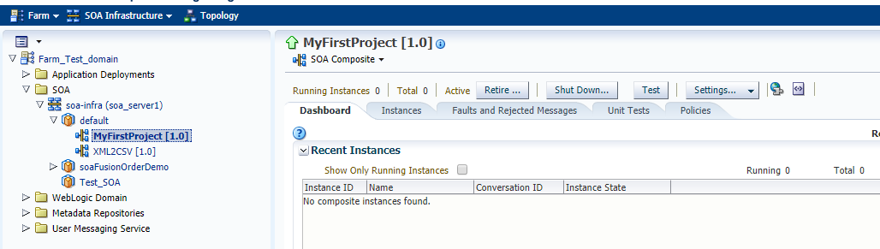

* Enter the input at the input field and click on Test Web Service button.

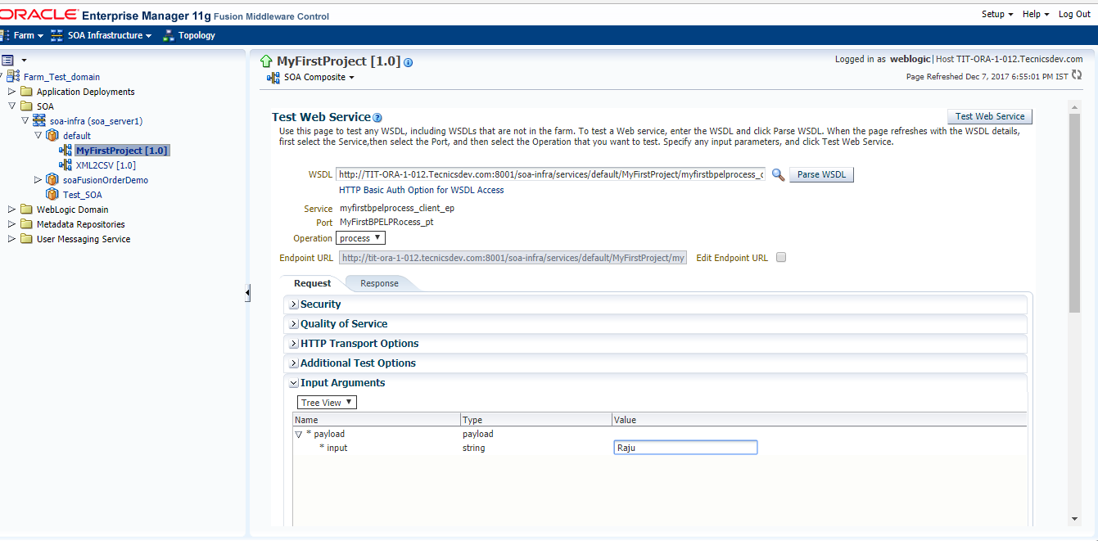

* You can able to see the output.

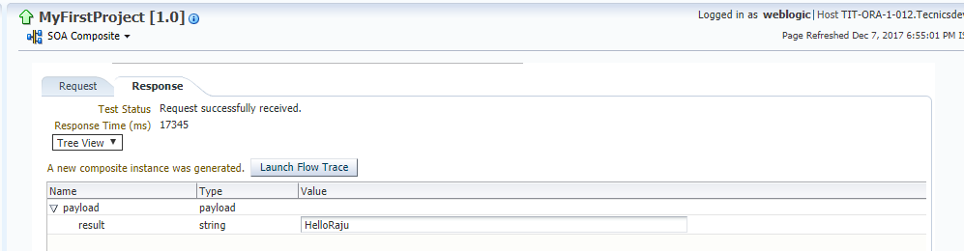

* If you want to view the flow of the executing of the composite, click on the Launch Flow Trace.
* Flow Trace will open and then click on the BPEL process.

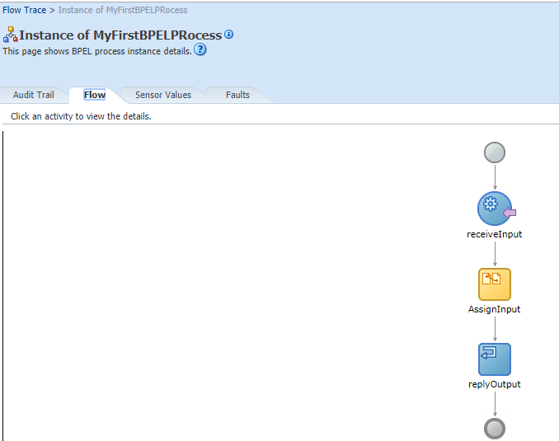

#### Testing the Project from SOAP UI

* Open SOAP UI and select New SOAP Project from File menu.
* Enter the project name and enter the WSDL file URL in the ‘initalWSDL’ location.

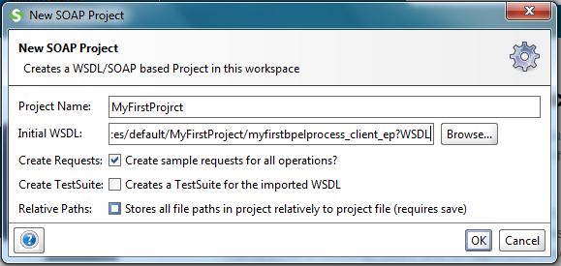

(You can get URL from the EM console by clicking on test button)

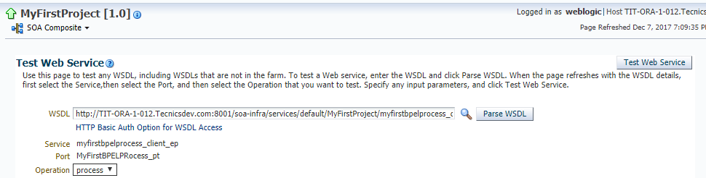

* Click on the project and browse to the request.
* Double click on the request then SOAP UI Starter page will open.

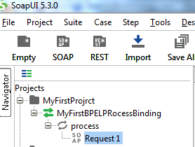

* Enter the input at the input filed of the xml and click on submit request.
* You can able to see the output in the XML format.

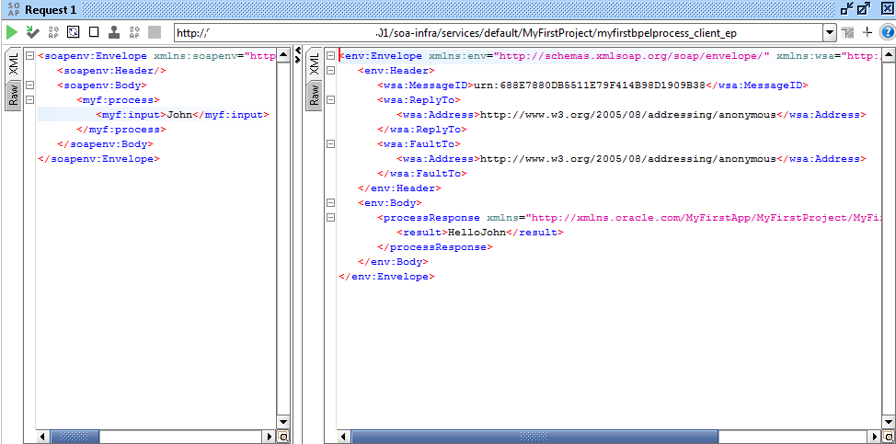

# ADVANCED SOA CONCEPTS

### MetaData Services (MDS) in a SOA environment

A metadata repository contains metadata for Oracle Fusion Middleware components, such as Oracle BPEL Process Manager, Oracle B2B, and Oracle WebCenter Portal. It can also contain metadata about the configuration of Oracle Fusion Middleware and metadata for your applications.

Oracle Fusion Middleware supports multiple repository types. A repository type represents a specific schema or set of schemas that belong to a specific Oracle Fusion Middleware component (for example, Oracle BPEL Process Manager or Oracle Internet Directory.) Oracle Fusion Middleware supports Edition-Based Redefinition (EBR), which enables you to upgrade the database component of an application while it is in use, thereby minimizing or eliminating down time. The schemas in a repository can be EBR-enabled schemas.

A particular type of repository, the Oracle Metadata Services (MDS) Repository, contains metadata for certain types of deployed applications. This includes custom Java EE applications developed by your organization and some Oracle Fusion Middleware component applications, such as Oracle B2B.

You can create a database-based repository or, for MDS, a database-based repository or a file-based repository. For production environments, you use a database-based repository. Most components, such as Oracle BPEL Process Manager, require that a schema be installed in a database, necessitating the use of a database-based repository. MDS supports Edition-Based Redefinition (EBR) enabled schemas.

#### Managing the MDS Repository

Oracle Metadata Services (MDS) Repository contains metadata for certain types of deployed applications. Those deployed applications can be custom Java EE applications developed by your organization and some Oracle Fusion Middleware component applications, such as Oracle B2B and Oracle Web Services Manager. A Metadata Archive (MAR), a compressed archive of selected metadata, is used to deploy metadata content to the MDS Repository, which contains the metadata for the application.

You should deploy your applications to MDS in the following situations, so that the metadata can be managed after deployment:

* The application contains seeded metadata packaged in a MAR.
* You want to enable user personalizations at run time.
* You have a custom Oracle WebCenter Portal application.
* You have a SOA composite application (SCA).

### Transaction Management in Oracle SOA (BPEL)

Transaction context between different BPEL services are controlled by mainly two properties/attributes.  Those are Delivery and Transaction attributes.   
**Details**

**Case1**: If BPEL Process is Async or one-way process then, Delivery policy attribute can have three values. Those are 1)- async.persit  2)- async.cache 3)- sync

* **async.persit**: Delivery messages are persisted in the database in table dlv_message. With this setting, reliability is obtained with some performance impact on the database. When the client initiates a process instance, an invocation request is placed in an internal queue. Inside Oracle BPEL Server, a message-driven bean (MDB), WorkerBean, monitors the queue for invocation requests. When a message is dequeued, Oracle BPEL Server allocates a thread to process the message.

  <component name="BPELASynchCall" version="2.0">

    <implementation.bpel src="BPELASynchCall.bpel"/>

    <property name="bpel.config.transaction" type="xs:string" many="false">required</property>

    <property name="bpel.config.oneWayDeliveryPolicy" type="xs:string"

              many="false">async.persist</property>

  </component>

* **async.cache** : Incoming delivery messages are kept only in the in-memory cache. If performance is preferred over reliability, this setting should be considered. Message are not dehydrated into dlv_message table. Rest all is same as async.persist.

  <component name="BPELASynchCall" version="2.0">

    <implementation.bpel src="BPELASynchCall.bpel"/>

    <property name="bpel.config.transaction" type="xs:string" many="false">required</property>

    <property name="bpel.config.oneWayDeliveryPolicy" type="xs:string"

              many="false">async.cache</property>

  </component>

* **sync** : Directs Oracle BPEL Server to bypass the scheduling of messages in the invoke queue, and invokes the BPEL instance synchronously. In some cases this setting can improve database performance. So there is no role of invoke queue and worker bean here.

  <component name="BPELTest" version="1.1">

    <implementation.bpel src="BPELTest.bpel"/>

    <property name="bpel.config.transaction" type="xs:string" many="false">required</property>

    <property name="bpel.config.oneWayDeliveryPolicy" type="xs:string"

              many="false">sync</property>

  </component>

**Case2:** If BPEL Process is Sync process then, transaction context between client and bpel-process is controlled by "Transaction" Attribute. Values of these attributes are 1)- Required 2)- Requires New

* **Required**: This makes the BPEL process execute as part of the calling transaction. If no calling transaction exists, it will create a new one.

bpel.config.transaction property is set to requiresNew:

<component name="BPELProcess2" version="1.1">

    <implementation.bpel src="BPELProcess2.bpel"/>

    <property name="bpel.config.transaction" many="false" type="xs:string">required</property>

</component>

* **RequiresNew**: This is the default value and makes the BPEL process execute as a separate transaction. Any existing transaction will be suspended.

bpel.config.transaction property is set to requiresNew:

<component name="BPELProcess2" version="1.1">

     <implementation.bpel src="BPELProcess2.bpel"/>

     <property name="bpel.config.transaction" many="false" type="xs:string">requiresNew</property>

</component>

### Exception Handling

With service-oriented applications, the need for strong **exception handling** is even more important as the quality of service becomes a critical factor in service reusability. Inadequate or faulty exception handling can severely impact the usability of a service.

How exceptions are handled depends on the type of exceptions that can possibly occur. Exceptions that occur in a service-oriented composite application can be broadly classified into two categories—**System Faults** and **Business Faults**.

#### System faults

System faults are generally thrown by the underlying infrastructure when a runtime, system-level error occurs. For example, if a service being invoked is not reachable either because of network issues or due to unavailability of the service provider, the SOA infrastructure will throw a connection exception. Given the nature of these exceptions, you can generalize exception handling across all components as well as composite applications. For example, you may create a single exception handler that notifies system administrators about service unavailability for all connection-related errors.

#### bindingFault

A **bindingFault** is thrown inside an activity if the preparation of the invocation fails. For example, the WSDL of the process fails to load. A bindingFault is not retryable. This type of fault usually must be fixed by human intervention.

#### remoteFault

A **remoteFault** is also thrown inside an activity. It is thrown because the invocation fails. For example, a SOAP fault is returned by the remote service. A remoteFault can be configured to be retried.

#### replayFault

A **replayFault** replays the activity inside a scope. At any point inside a scope, this fault is migrated up to the scope. Oracle BPEL Server then re-executes the scope from the beginning.

#### Business faults

Business faults are thrown when an exception condition occurs during processing of a service operation, in the business logic of the service. This exception condition may be due to the violation of certain business rules, to invalid data, or to other non-system related conditions. Generally, business exceptions are handled specifically by the invoker of the service and not as generic exceptions as is done for system faults.

#### Fault Management Framework

Oracle SOA Suite provides a generic fault management framework for handling faults in BPEL processes. If a fault occurs during runtime in an invoke activity in a process, the framework catches the fault and performs a user-specified action defined in a fault policy file associated with the activity. If a fault results in a condition in which human intervention is the prescribed action, you perform recovery actions from Oracle Enterprise Manager Fusion Middleware Control. The fault management framework provides an alternative to designing a BPEL process with catch activities in scope activities. Fault policies enable you to handle errors automatically or through human intervention. fault policy-based error handling consists of the following components:

* Fault policies
* Fault bindings

**Fault Policies used by Multiple SOA Composite Applications**

<property name="oracle.composite.faultPolicyFile"> oramds:/apps/faultpolicyfiles/fault-policies.xml

</property>

<property name="oracle.composite.faultBindingFile"> oramds:/apps/faultpolicyfiles/fault-bindings.xml

</property>

#### Fault Policies

A fault policy defines error conditions and corresponding actions. Fault policies are defined in the **fault-policies.xml** file, which should be created based on the XML schema.

**Sample Fault Policy File**

<?xml version="1.0" encoding="UTF-8"?>

<faultPolicies xmlns="http://schemas.oracle.com/bpel/faultpolicy"

xmlns:xsi="http://www.w3.org/2001/XMLSchema-instance">

<faultPolicy version="0.0.1" id="FusionMidFaults"

xmlns:env="http://schemas.xmlsoap.org/soap/envelope/"

xmlns:xs="http://www.w3.org/2001/XMLSchema"

xmlns="http://schemas.oracle.com/bpel/faultpolicy"

xmlns:xsi="http://www.w3.org/2001/XMLSchema-instance">

<Conditions>

<faultName xmlns:medns="http://schemas.oracle.com/mediator/faults"

name="medns:mediatorFault">

<condition>

<action ref="MediatorJavaAction"/>

</condition>

</faultName>

<faultName xmlns:bpelx="http://schemas.oracle.com/bpel/extension"

name="bpelx:remoteFault">

<condition>

<action ref="BPELJavaAction"/>

</condition>

</faultName>

<faultName xmlns:bpelx="http://schemas.oracle.com/bpel/extension"

name="bpelx:bindingFault">

<condition>

<action ref="BPELJavaAction"/>

</condition>

</faultName>

<faultName xmlns:bpelx="http://schemas.oracle.com/bpel/extension"

name="bpelx:runtimeFault">

<condition>

<action ref="BPELJavaAction"/>

</condition>

</faultName>

</Conditions>

<Actions>

<!-- Generics -->

<Action id="default-terminate">

<abort/>

</Action>

<Action id="default-replay-scope">

<replayScope/>

</Action>

<Action id="default-rethrow-fault">

<rethrowFault/>

</Action>

<Action id="default-human-intervention">

<humanIntervention/>

</Action>

<Action id="MediatorJavaAction">

<!-- this is user provided class-->

<javaAction className="MediatorJavaAction.myClass"

defaultAction="default-terminate">

<returnValue value="MANUAL" ref="default-human-intervention"/>

</javaAction>

</Action>

<Action id="BPELJavaAction">

<!-- this is user provided class-->

<javaAction className="BPELJavaAction.myAnotherClass"

defaultAction="default-terminate">

<returnValue value="MANUAL" ref="default-human-intervention"/>

</javaAction>

</Action>

</Actions>

</faultPolicy>

</faultPolicies>

**Conditions**

Conditions allow you to identify error or fault conditions and then specify the actions to be taken when a particular error or fault condition occurs. For example, for a particular error occurring because of a service not being available, you can perform an action such as a retry. Similarly, for another error occurring because of the failure of Schematron validation, you can perform the action of human intervention. This fault can be recovered manually by editing the payload and then resubmitting it through Oracle Enterprise Manager Fusion Middleware Control.

Conditions are defined in the fault-policies.xml file.

**Actions**

Actions specify the tasks to perform when an error occurs. A set of actions is identified by an ID in the fault policy file.

**Retry Action**

Retry actions such as enqueueing a message to a JMS queue that is stopped, inserting a record with a unique key constraint error, and so on, enable you to retry a task that caused the error. A new thread is started with every retry action. Therefore, with every retry action, a new transaction starts. [Table](https://docs.oracle.com/cd/E36909_01/dev.1111/e10224/med_faulthandling.htm#CHDGCIHE) describes the options available with the retry action. Retry actions are applicable to parallel routing rules only.

**Retry Action Options**

| **Option** | **Description** |
| --- | --- |
| Retry Count | Retry *N* times. |
| Retry Interval | Delay in seconds for a retry. |
| Exponential Backoff | Retry interval increase with an exponential backoff. |
| Retry Failure Action | Chain to this action if a retry *N* times fails. |
| Retry Success Action | Chain to this action if a retry succeeds. |

**Rethrow Action**

Rethrow executes the fault policy in the caller's thread and returns the original exception to the user.

<Action id="ora-rethrow-fault"><rethrowFault/></Action>

**Human Intervention Action**

The human intervention action allows you to manually recover the fault by correcting the error (for example, altering the payload) and then manually retrying the message. This action is applicable to parallel routing rules only.

<Action id="ora-human-intervention"><humanIntervention/></Action>

**Abort Action**

The abort action enables you to terminate the message flow. This action is applicable to both parallel and sequential routing rules.

<Action id="ora-terminate"><abort/></Action>

**Java Code Action**

The Java code action lets you call a customized Java class that implements the oracle.integration.platform.faultpolicy.IFaultRecoveryJavaClass interface. This action is applicable to both parallel and sequential routing rules.

#### Fault Bindings

Fault bindings associate fault policies with composites or components, and are defined in the fault-bindings.xml file. Create the fault-bindings.xml file based on the XML schema.

**Sample Fault Binding File**

<?xml version="1.0" encoding="UTF-8"?>

<faultPolicyBindings version="2.0.1"

xmlns="http://schemas.oracle.com/bpel/faultpolicy"

xmlns:xsi="http://www.w3.org/2001/XMLSchema-instance">

<composite faultPolicy="ConnectionFaults"/>

<component faultPolicy="ServiceFaults">

<name>Component1</name>

<name>Component2</name>

</component>

<!-- Below listed component names use polic CRM_SeriveFaults -->

<component faultPolicy="CRM_ServiceFaults">

<name>HelloWorld</name>

<name>ShippingComponent</name>

<name>AnotherComponent"</name>

</component>

<!-- Below listed reference names and port types use polic CRM_ServiceFaults

-->

<reference faultPolicy="CRM_ServiceFaults">

<name>creditRatingService</name>

<name>anotherReference</name>

<portType

xmlns:credit="http://services.otn.com">credit:CreditRatingService</portType>

<portType

xmlns:db="http://xmlns.oracle.com/pcbpel/adapter/db/insert/">db:insert_

plt</portType>

</reference>

<reference faultPolicy="test1">

<name>CreditRating3</name>

</reference>

### Protecting Personally Identifiable Information

This chapter describes a solution for protecting Personally Identifiable Information (PII) when outside the control of a security policy. PII refers to Social Security numbers, addresses, bank account numbers, and other similar information that is typically associated with one specific user and must generally be protected.

#### Understanding Personally Identifiable Information

Personally Identifiable Information (PII) refers to Social Security numbers, addresses, bank account numbers, and other similar information that is typically associated with one specific user and must generally be protected. OWSM provides a solution for protecting PII when outside the control of a security policy so that PII is hidden in logs, in messages, in audits, and so forth.

#### Protecting PII Information

This section describes how to protect PII with the **oracle/pii_security_policy** policy.

* Deploy the SOA application and use JDeveloper (or another mechanism) to look at the SOAP messages and determine what you need to protect.
* Deploy the SOA application and look at the WSDL of the deployed application to determine what you need to protect.

You need to look at what data is being passed during both the request and response phases. That is, you may need to protect different data during the request and response.

#### Compose the XPath Expressions to Protect the PII Data

Compose the XPath expressions to protect the PII data in both the request and response messages.

* You use XPath expressions to specify the PII data to be protected.
* More specifically, you use [XPath expressions](http://www.w3schools.com/xpath/xpath_syntax.asp) to specify exactly which elements you want to protect. The XPath must end in an XPath text node.
* If the result of the XPath is a text node, the contents of the text node are encrypted. Empty text nodes (that is, containing all whitespace) are not encrypted or decrypted.
* If any XPath returns multiple nodes, all of them are encrypted. If nothing is returned, it is ignored.
* The specified XPaths will be evaluated with the first element child of **env:Body** set as the root node.
* Assume that you use JDeveloper to view the following SOAP message:

<soap:Envelope xmlns:soap="http://schemas.xmlsoap.org/soap/envelope/">

<soap:Body xmlns:ns1="http://xmlns.oracle.com/apps/prc/po/editDocument/purchaseOrderService/types/">

<ns1:createPurchaseOrder>

<ns1:createOrderEntry xmlns:ns2="http://xmlns.oracle.com/apps/prc/po/editDocument/purchaseOrderService/">

<ns2:DocumentStyleId>1</ns2:DocumentStyleId>

<ns2:ProcurementBuId>204</ns2:ProcurementBuId>

<ns2:BuyerId>100010026863783</ns2:BuyerId>

<ns2:RequisitioningBuId>204</ns2:RequisitioningBuId>

<ns2:SupplierId>559</ns2:SupplierId>

<ns2:SupplierSiteId>5058</ns2:SupplierSiteId>

<ns2:SupplierContactId>100000011552368</ns2:SupplierContactId>

<ns2:ApprovalActionCode>BYPASS</ns2:ApprovalActionCode>

<ns2:DocumentDescription>DO NOT TOUCH THIS ORDER (V15)</ns2:DocumentDescription>

<ns2:PurchaseOrderEntryLine>

<ns2:LineTypeId>1</ns2:LineTypeId>

<ns2:ItemId>199</ns2:ItemId>

<ns2:Quantity>10</ns2:Quantity>

<ns2:UnitOfMeasureCode>Ea</ns2:UnitOfMeasureCode>

<ns2:PurchaseOrderEntrySchedule>

<ns2:ShipToLocationId>207</ns2:ShipToLocationId>

<ns2:ShipToOrganizationId>207</ns2:ShipToOrganizationId>

<ns2:NeedByDate>2020-12-31</ns2:NeedByDate>

<ns2:PurchaseOrderEntryDistribution/>

</ns2:PurchaseOrderEntrySchedule>

</ns2:PurchaseOrderEntryLine>

</ns1:createOrderEntry>

</ns1:createPurchaseOrder>

</soap:Body>

</soap:Envelope>

#### Configure the PII Encryption Key

Configure a password CSF key to be used for generating the PII encryption key, as described in ["Adding Keys and User Credentials to the Credential Store"](https://docs.oracle.com/middleware/1213/owsm/security/configure-messageprotection.htm#CHDIFFCD). The PII encryption key is derived from this password credential.

By default, oracle/pii_security_policy expects a key value of pii-csf-key, but you can change this.

If the web service client and the web service do not share a single credential store, the PII encryption key must be present and identical in their respective credential stores.

#### Attach the pii_security_policy Policy

#### Attach the pii_security_policy to SOA Composite

You must attach the policy only at the service/reference level, and then to both the client and web service.

Consider the SOA composite represented in JDeveloper shown in [Figure](https://docs.oracle.com/middleware/1213/owsm/security/owsm-pii.htm#CHDFFJCC). For this composite, you would attach the policy to both the bpelprocess_1client_ep client and the PartnerLink1 reference. You cannot attach the policy to a component.

***Where to Attach the pii_security_policy for a SOA Composite***

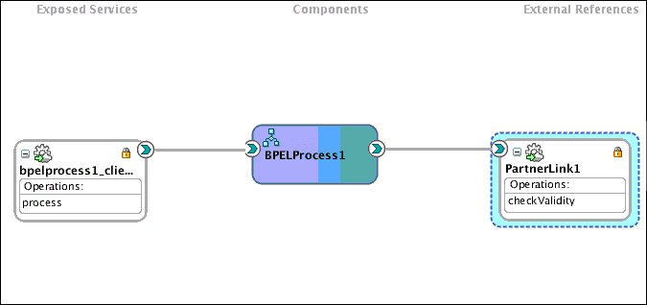

Perform the following steps to view the SOA composite and attach the oracle/pii_security_policy policy.

1. In the navigator, expand SOA deployments.
2. Select soa-infra, expand the SOA partition (for example, the default partition) and select the target SOA composite application.

The SOA composite home page displays.

1. Select the Dashboard tab if it is not already selected.

The Components section of this tab lists the SOA components being used in the composite application, and the Services and References section displays the web service and reference bindings, as shown in [Figure](https://docs.oracle.com/middleware/1213/owsm/security/owsm-pii.htm#CFHDAGDJ).

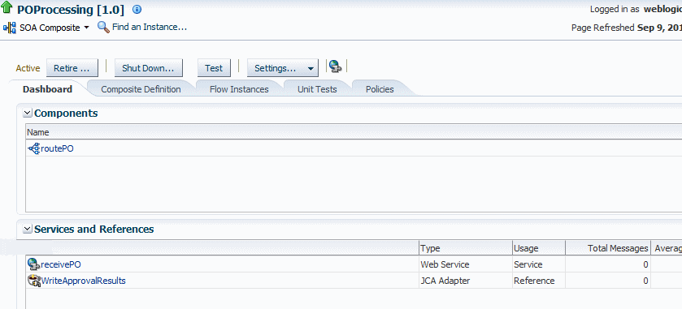

1. Attach a copy of the oracle/pii_security_policy policy to both the web service client and the reference binding.

For example, in [Figure](https://docs.oracle.com/middleware/1213/owsm/security/owsm-pii.htm#CFHDAGDJ) you would attach the copy to both routePO service and to the WriteApprovalresults reference.

See [Chapter 4, "Attaching Policies"](https://docs.oracle.com/middleware/1213/owsm/security/attach-owsm-policy.htm#BABEEGCH) for information on attaching policies. Also see ["Attaching Policies to Binding Components and Service Components"](https://docs.oracle.com/middleware/1213/soasuite/develop-soa/soa-security-policies-jdev.htm#SOASE9131) in [Developing SOA Applications with Oracle SOA Suite](http://www.oracle.com/pls/topic/lookup?ctx=fmw121300&id=SOASE) for additional SOA-specific information.

1. Examine the Salt, Iteration, and Key Size settings to make sure the defaults are acceptable, and change as needed. See [Table 18-92](https://docs.oracle.com/middleware/1213/owsm/security/owsm-predefined-assertions.htm#CIHJCCJJ) for a description of these settings.
2. Use Fusion Middleware Control, WLST, or JDeveloper (or another mechanism) to override request.xpaths, response.xpaths and other attributes.

The PII data for the request and response may be different.

[Figure](https://docs.oracle.com/middleware/1213/owsm/security/owsm-pii.htm#CFHDHIHI) shows a sample JDeveloper screen.

***Figure Overriding request.xpaths Attribute***

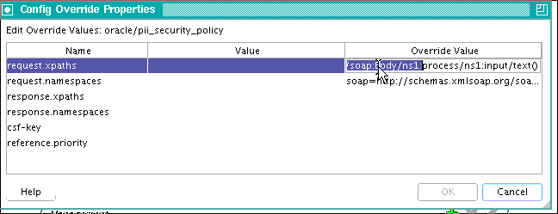

Do this for both the web service and client, and ensure that they match.

See ["Understanding the PII Security Policy"](https://docs.oracle.com/middleware/1213/owsm/concepts/owsm-security-concepts.htm#OWSMC5435) in Understanding Oracle Web Services Manager to specify the XPaths, namespaces, csf.key, and so forth.

See [Chapter 5, "Overriding Policy Configuration Properties"](https://docs.oracle.com/middleware/1213/owsm/security/override-owsm-policy-config.htm#CACIHIIJ) for information on overriding configuration policies.

#### Attach the pii_security_policy to JCA Binding

You can attach the PII policy to JCA adapters for both SOA and Oracle Service Bus.

### Domain Value Maps

Domain value maps operate on actual data values that transit through the infrastructure at runtime. They enable you to map from one vocabulary used in a given domain to another vocabulary used in a different domain. For example, one domain may represent a city with a long name (Boston), while another domain may represent a city with a short name (BO). In such cases, you can directly map the values by using domain value maps. A direct mapping of values between two or more domains is known as point-to-point mapping.

Each domain value map typically holds a specific category of mappings among multiple applications. For example, one domain value map may hold mappings for city codes and another may hold mappings for state codes.

Domain value map values are static. You specify the domain value map values at design time using Oracle JDeveloper, and then at runtime, the domain value map columns are looked up for values.

#### Domain Value Map Features

This section describes domain value map functionality.

#### Qualifier Support

Qualifiers qualify mappings. A mapping may not be valid unless qualified with additional information. For example, a domain value map containing a city code-to-city name mapping may have multiple mappings from KN to Kensington because Kensington is a city in both Canada and the USA. Therefore, this mapping requires a qualifier (USA or Canada) to qualify when the mapping becomes valid, as shown in [Table](https://docs.oracle.com/cd/E25054_01/dev.1111/e10224/med_dvm.htm#CACBDHCH).

| **Country (Qualifier)** | **CityCode** | **CityName** |
| --- | --- | --- |
| USA | BO | Boston |
| USA | BELG_NC | Belgrade |
| USA | BELG_MN_Streams | Belgrade |
| USA | NP | Northport |
| USA | KN | Kensington |
| Canada | KN | Kensington |

You can also specify multiple qualifiers for a domain value map. For example, as shown in [table](https://docs.oracle.com/cd/E25054_01/dev.1111/e10224/med_dvm.htm#CACICCFB), BELG to Belgrade mapping can also be qualified with a state name.

| **Country (Qualifier)** | **State (Qualifier)** | **CityCode** | **CityName** |
| --- | --- | --- | --- |
| USA | Massachusetts | BO | Boston |
| USA | North Carolina | BELG | Belgrade |
| USA | Minnesota | BELG | Belgrade |
| USA | Alabama | NP | Northport |
| USA | Kansas | KN | Kensington |
| Canada | Prince Edward Island | KN | Kensington |

#### Qualifier Order Support

A qualifier order is used to find the best match during lookup at runtime. The order of a qualifier varies from highest to lowest depending on the role of the qualifier in defining a more exact match. In [Table 44-3](https://docs.oracle.com/cd/E25054_01/dev.1111/e10224/med_dvm.htm#CACICCFB), the state qualifier can have a higher order than the country qualifier, as a matching state indicates a more exact match.

Domain value maps support hierarchical lookup. If you specify a qualifier value during a lookup and no exact match is found, then the lookup mechanism tries to find a more generalized match by setting the higher order qualifiers to a "". It proceeds until a match is found, or until a match is not found with all qualifiers set to a "". [Figure](https://docs.oracle.com/cd/E25054_01/dev.1111/e10224/med_dvm.htm#CACCFBIC) describes the hierarchical lookup performed for the following lookup in [Table](https://docs.oracle.com/cd/E25054_01/dev.1111/e10224/med_dvm.htm#CACICCFB).

State=Arkansas, Country=Canada, CityCode=KN_USA

In this example, the State qualifier has a qualifier value of 1 and the Country qualifier has a qualifier value of 2.

As shown in [Figure 44-1](https://docs.oracle.com/cd/E25054_01/dev.1111/e10224/med_dvm.htm#CACCFBIC), the lookup mechanism sets the higher order qualifier State to the exact lookup value Arkansas and uses Canada|"" for the lower order qualifier Country.

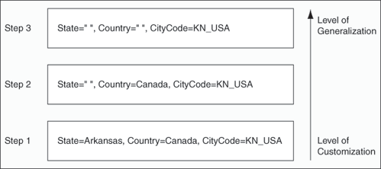

#### One-to-Many Mapping Support

You can map one value to multiple values in a domain value map. For example, a domain value map for payment terms can contain a mapping of payment terms to three values, such as discount percentage, discount period, and net credit period, as shown in Table.

| **Payment Term** | **Discount Percentage** | **Discount Period** | **Net Credit Period** |
| --- | --- | --- | --- |
| GoldCustomerPaymentTerm | 10 | 20 | 30 |
| SilverCustomerPaymentTerm | 5 | 20 | 30 |
| RegularPaymentTerm | 2 | 20 | 30 |

### Embedding Java Code

* Drag and drop Java Embedding from the Oracle Extensions in Component palette.
* Add the java code.(In the image we are creating random number between 11111 and 99999 , assigning to a variable called ‘trid’)

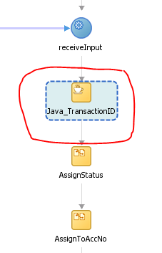

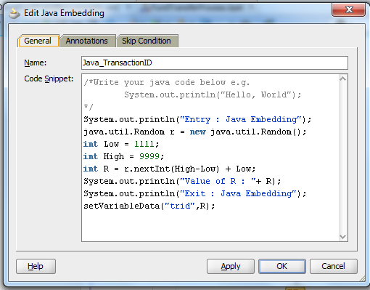

### Using soa-direct protocol (SOA-Direct)

A common way to invoke a composite is to use SOAP over HTTP. This is enabled by creating a SOAP service for your composite using web service binding. However, you can also use direct binding, which provides a tighter integration alternative. Direct binding enables Java clients to directly invoke composite services, bypassing the intermediate conversion to XML required with web service binding.

Direct binding provides two types of invocation styles:

* Inbound direct binding

The direct service binding component allows an external client to send messages using the Direct Binding Invocation API, where the Direct Binding Invocation API takes the JNDI connection parameters and creates a connection object on behalf of the client.

* Outbound direct binding (or direct reference binding)

The direct reference binding component provides support for sending SOA messages directly to external services over RMI. These external services must implement the SOA invocation API (the same as the direct inbound invocation API).

In the case of direct outbound binding, the connection object is created with the JNDI name of the external service bean configured for the binding.

Direct binding must be associated with the interface.wsdl, providing the interface clause and, optionally, the callbackInterface clause. The associated WSDL must be imported into the composite.

Below are the advantages of SOA-Direct protocol

* Invocation of any SOA binding component services through Java remote method invocation (RMI)
* WS-Addressing, including optional auto-generation of ReplyTo properties for asynchronous callbacks
* Identity propagation
* Transaction propagation
* Attachments
* Optimized RMI transport for invoking SOA services
* High availability and clustering support
* Failover and load balancing (not available for services in the Service Callback role)
* Connection and application retries on errors

# SOA TASKS

### Working with AQ Tables, AQ Adapter, Files and File Adapter

#### Create type and Queue table in database

sqlplus system/password as SYSDBA

-- Grant access to execute AQ

GRANT connect, resource TO soademo IDENTIFIED BY soademo;

GRANT aq_user_role TO soademo;

GRANT execute ON sys.dbms_aqadm TO soademo;

GRANT execute ON sys.dbms_aq TO soademo;

GRANT execute ON sys.dbms_aqin TO soademo;

GRANT execute ON sys.dbms_aqjms TO soademo;

-- Create the Queue Table and Advanced Queue and Start the AQ

-- The following commands are executed as the soademo database user.

-- Create the Queue Table

connect soademo/soademo;

CREATE TYPE message_type AS OBJECT (

message_id NUMBER(15)

, header VARCHAR2(100)

, text VARCHAR2(100)

)

/

BEGIN

dbms_aqadm.create_queue_table (

queue_table => 'myQueueTable',

queue_payload_type => 'soademo.message_type',

multiple_consumers => false

);

END;

/

Create the AQ

BEGIN

dbms_aqadm.create_queue (

queue_name => 'userQueue',

queue_table => 'myQueueTable'

);

END;

/

-- Start the AQ

BEGIN

dbms_aqadm.start_queue (

queue_name => 'userQueue');

END;

/

-- To delete queue table and queue.

EXECUTE dbms_aqadm.stop_queue(queue_name => 'soademo.userQueue');

EXECUTE dbms_aqadm.drop_queue(queue_name => 'soademo.userQueue');

EXECUTE dbms_aqadm.drop_queue_table(queue_table => 'soademo.myQueueTable');

select * from all_queues where name = 'USERQUEUE';

SELECT * FROM MYQUEUETABLE;

-- Enqueue message directly in database.

DECLARE

queue_options DBMS_AQ.ENQUEUE_OPTIONS_T;

message_properties DBMS_AQ.MESSAGE_PROPERTIES_T;

message_id RAW(16);

my_message SOADEMO.message_type;

v_user_name varchar2(100);

v_user_id varchar2(100);

v_resp_id varchar2(100);

v_resp_appln_id varchar2(100);

BEGIN

my_message := SOADEMO.message_type (1234,'TEST','XYZ');

-- message_properties.CORRELATION := 'QUORUM2AR_INV';

-- ENQUEUE

DBMS_AQ.enqueue (queue_name => 'SOADEMO.USERQUEUE',

enqueue_options => queue_options,

message_properties => message_properties,

payload => my_message,

msgid => message_id);

dbms_output.put_line('Enqueue successfully for SOA service MSG ID '||message_id);

commit;

END;

#### Configuring AQ Adapter

* Login to weblogic server console
* Go to deployments 🡪Select AQ Adapter 🡪 Configuration 🡪 Outbound Connection Pools
* Select new 🡪 Select default 🡪 Enter JNDI name 🡪 Click on finish.
* Activate the changes.
* You can able to see the AQ adapter we created.

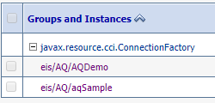

* Give the name of the AQ data source you want to create in AQ adapter.

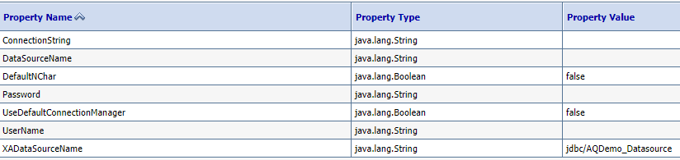

**Create AQ Datasource**

* Go to services 🡪 Data source 🡪 New
* Select defaults and give the database connection details.
* Click next and test the configuration and select next.
* Select the server to deploy datasource

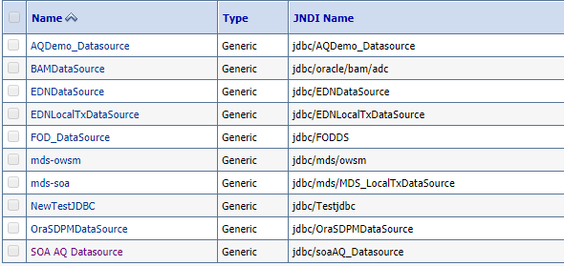

#### Composite to Read the message from xml file and Enqueue Message in AQ

* Create a project with empty Composite.

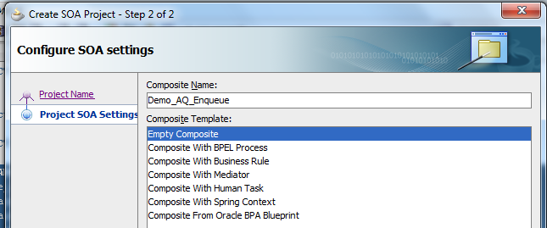

**Crate QueueMessage.xsd file as the input source**

<?xml version="1.0" encoding="windows-1252" ?>

<xsd:schema xmlns:xsd="http://www.w3.org/2001/XMLSchema"

xmlns="http://www.example.org"

targetNamespace="http://www.example.org"

elementFormDefault="qualified">

<xsd:element name="InputMessage">

<xsd:annotation>

<xsd:documentation>

A sample element

</xsd:documentation>

</xsd:annotation>

<xsd:complexType>

<xsd:sequence>

<xsd:element name="msgId" type="xsd:int"/>

<xsd:element name="header" type="xsd:string"/>

<xsd:element name="text" type="xsd:string"/>

</xsd:sequence>

</xsd:complexType>

</xsd:element>

</xsd:schema>

#### Create a file adapter to read message from XML file

* Select the File adapter from the Service Adapters and drag on the External Reference area. Give the name for the file adapter.

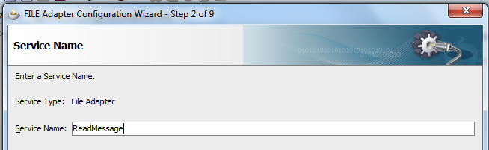

* Select Read File from Operation Type.

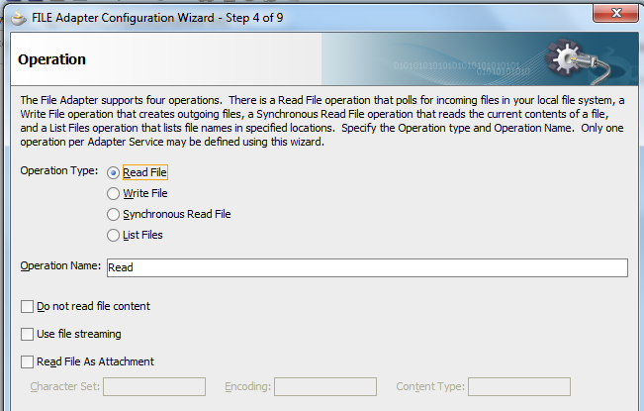

* Give the physical path to read the file and give the file naming convention.

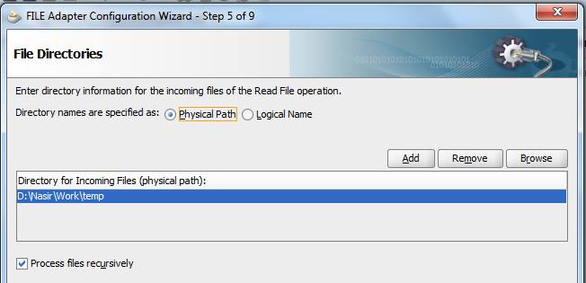

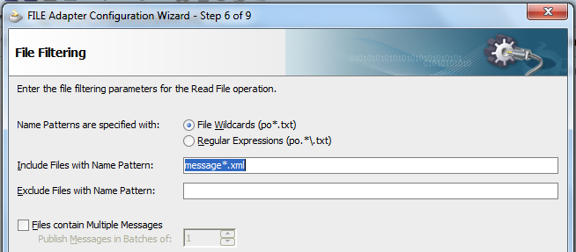

* Select the message type by clicking on the magnifying icon. Select Input Message we have created.

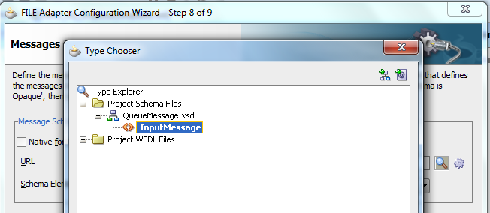

* Select next and click on finish.

#### Create AQ Adapter for Enqueue operation

* Drag AQ adapter on the Exposed Services area and give the Service Name

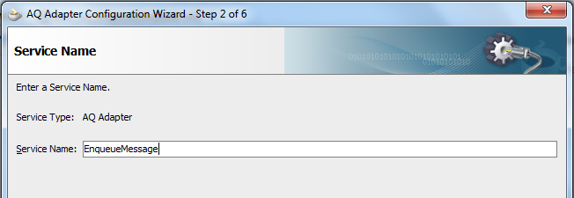

* Select the Enqueue from the Operation type.

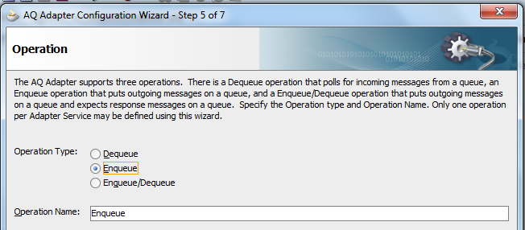

* Select the database schema and select queue by clicking on the browse button.

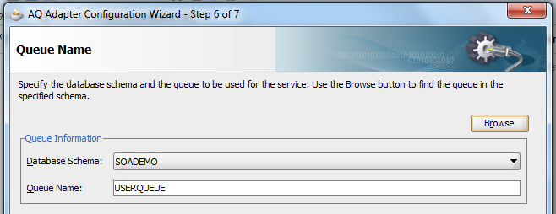

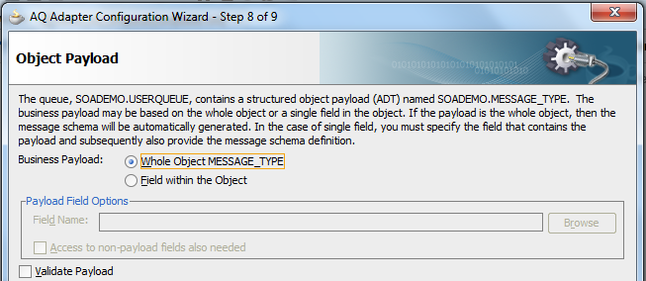

* Select the complete object type and click on finish. AQ adapter is created.

#### Create Mediator component to route the messages

* Drag and drop mediator component from the Service Components and name it. Select ‘Define Interface Later’ in template and click on Ok.
* Wire from AQ adapter to mediator and then from mediator to file adapter.

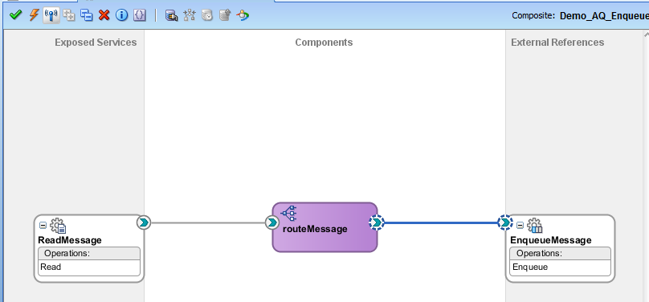

* Double click on the mediator components and open it. Click on the transformation icon and open the Transformation Mapping. Select ‘Create New Mapper File’. Click on OK.

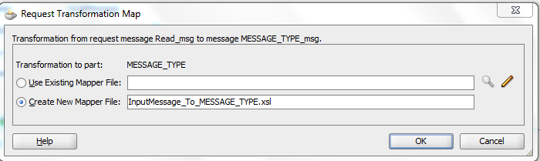

Give the transformation in the new xsl file.

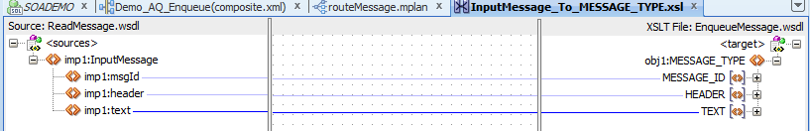

* Composite is ready. Compile, Deploy and test it.

#### Composite for Dequeue Message from AQ and write into XML file

* Create a new project with empty Composite

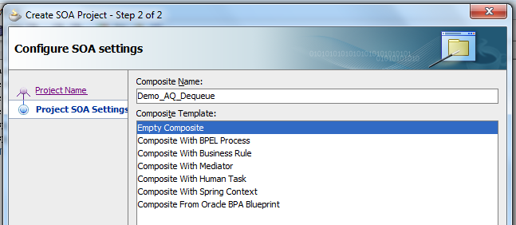

#### Create AQ Adapter for Dequeue operation

* Drag AQ adapter on the Exposed Services area and give the Service Name

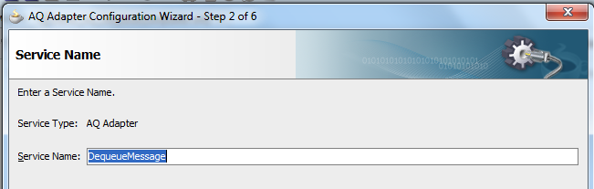

* Give the JNDI name for accessing the Queue tables.

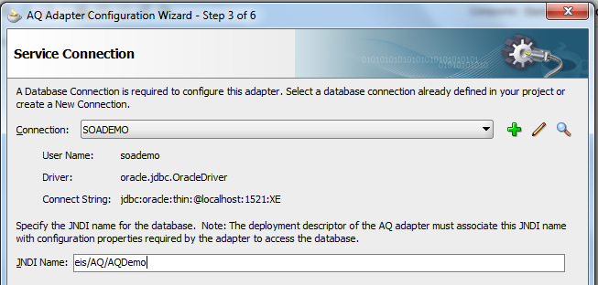

* Select the Dequeue from the Operation type.

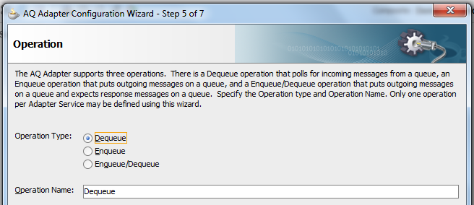

* Select the database schema and select queue by clicking on the browse button.

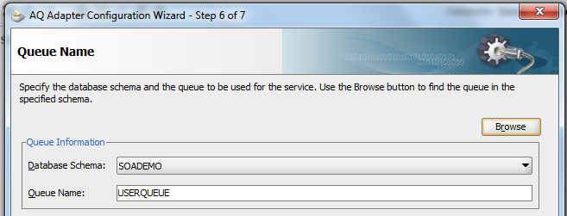

* Select the complete object type and click on finish. AQ adapter is created.

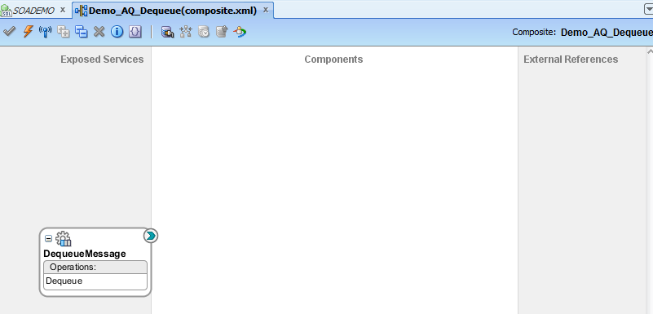

#### Create a file adapter to write messages into XML file

* Select the File adapter from the Service Adapters and drag on the External Reference area. Give the name for the file adapter.

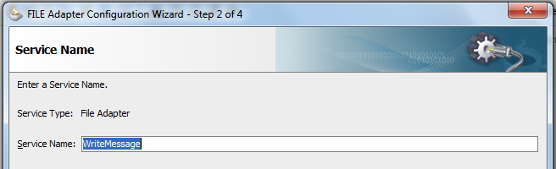

* Select Write File from Operation Type.

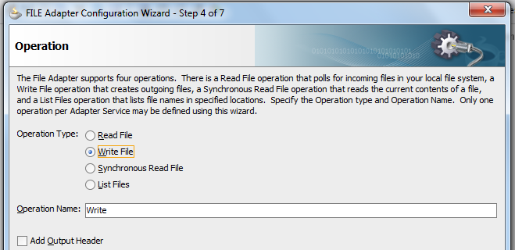

* Give the physical path to store the file and give the file naming convention.

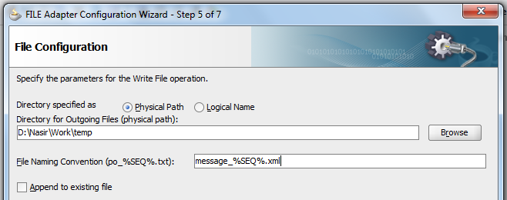

* Select the message type type by clicking on the magnifying icon.

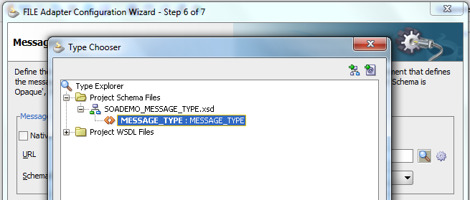

* Select next and click on finish.

#### Create Mediator component to route the messages

* Drag and drop mediator component from the Service Components and name it. Select ‘Define Interface Later’ in template and click on Ok.
* Wire from AQ adapter to mediator and then from mediator to file adapter.

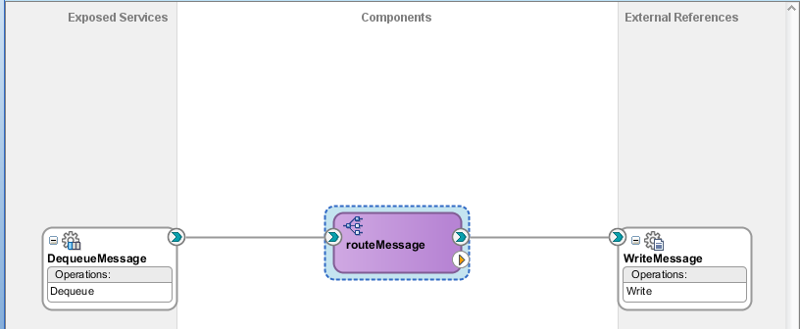

* Double click on the mediator components and open it. Click on the transformation icon and open the Transformation Mapping. Select ‘Create New Mapper File’. Click on OK.
* Give the transformation in the new xsl file.

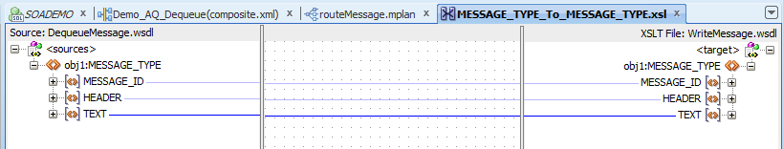

* Composite is ready. Compile, Deploy and test it.

### Working with JMS Queue

#### Create a Simple JMS Queue in Weblogic Server 11g

This example shows the steps to create a simple JMS queue in WebLogic Server 11g for testing purposes.

#### Introduction and Definitions

A JMS queue in Weblogic Server is associated with a number of additional resources:

**JMS Server**

A JMS server acts as a management container for resources within JMS modules. Some of its responsibilities include the maintenance of persistence and state of messages and subscribers. A JMS server is required in order to create a JMS module.

**JMS Module**

A JMS module is a definition which contains JMS resources such as queues and topics. A JMS module is required in order to create a JMS queue.

**Subdeployment**

JMS modules are targeted to one or more WLS instances or a cluster. Resources within a JMS module, such as queues and topics are also targeted to a JMS server or WLS server instances. A subdeployment is a grouping of targets. It is also known as advanced targeting.

**Connection Factory**

A connection factory is a resource that enables JMS clients to create connections to JMS destinations.

**JMS Queue**

A JMS queue (as opposed to a JMS topic) is a point-to-point destination type. A message is written to a specific queue or received from a specific queue.

#### Configuration Steps

The following steps are done in the WebLogic Server Console, beginning with the left-hand navigation menu.

**Create a JMS Server**

1. Services > Messaging > JMS Servers

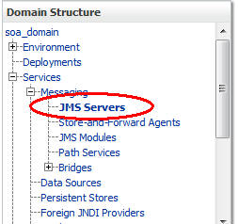

1. Select New
2. Name: TestJMSServer  
   Persistent Store: (none)
3. Target: soa_server1 (or choose an available server)
4. Finish

The JMS server should now be visible in the list with Health OK.

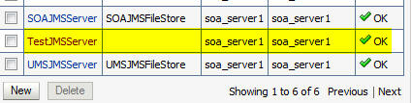

**Create a JMS Module**

1. Services > Messaging > JMS Modules
2. Select New
3. Name: TestJMSModule  
   Leave the other options empty
4. Targets: soa_server1 (or choose the same one as the JMS server)  
   PressNext
5. Leave “Would you like to add resources to this JMS system  
   module” unchecked and  pressFinish.

**Create a SubDeployment**

A subdeployment is not necessary for the JMS queue to work, but it allows you to easily target subcomponents of the JMS module to a single target or group of targets. We will use the subdeployment in this example to target the following connection factory and JMS  
queue to the JMS server we created earlier.

1. Services > Messaging > JMS Modules
2. Select TestJMSModule
3. Select the Subdeployments tab and New
4. Subdeployment Name: TestSubdeployment
5. Press Next
6. Here you can select the target(s) for the subdeployment. You can choose either Servers (i.e. WebLogic managed servers, such as the soa_server1) or JMS Servers such as the JMS Server created earlier. As the purpose of our subdeployment in this example is to target a specific JMS server, we will choose the JMS Server option. Select theTestJMSServer created earlier
7. Press Finish

**Create a Connection Factory**

1. Services > Messaging > JMS Modules
2. Select TestJMSModule and press New
3. Select Connection Factory and Next
4. Name: TestConnectionFactory  
   JNDI Name: jms/demoConnectionFactory  
   Leave the other values at default
5. On the Targets page, select the Advanced Targeting button and select TestSubdeployment
6. Press Finish

The connection factory should be listed on the following page with TestSubdeployment and TestJMSServer as the target.

**Create a JMS Queue**

1. Services > Messaging > JMS Modules
2. Select TestJMSModule and press New
3. Select Queue and Next
4. Name: TestJMSQueue  
   JNDI Name: jms/demoQueue  
   Template:None  
   PressNext
5. Subdeployments: TestSubdeployment
6. Finish

The TestJMSQueue should be listed on the following page with TestSubdeployment and TestJMSServer. Confirm the resources for the TestJMSModule. Using the Domain  
Structure tree, navigate to soa_domain > Services > Messaging > JMS Modules then select TestJMSModule

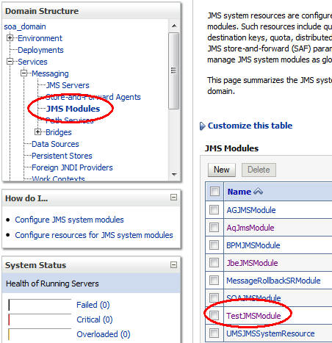

You should see the following resources

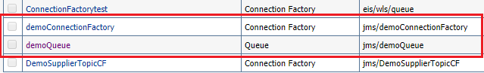

The JMS queue is now complete and can be accessed using the JNDI names

jms/demoConnectionFactory and  
jms/demoQueue.

#### Composite for Produce Message in JMS Queue

* Before creating the Composite, make sure Queue, Connection Factory and the JNDI is created in weblogic console.



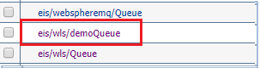

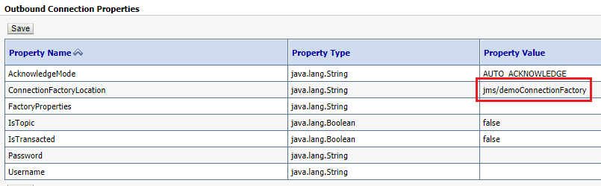

* Create a new project and name it.

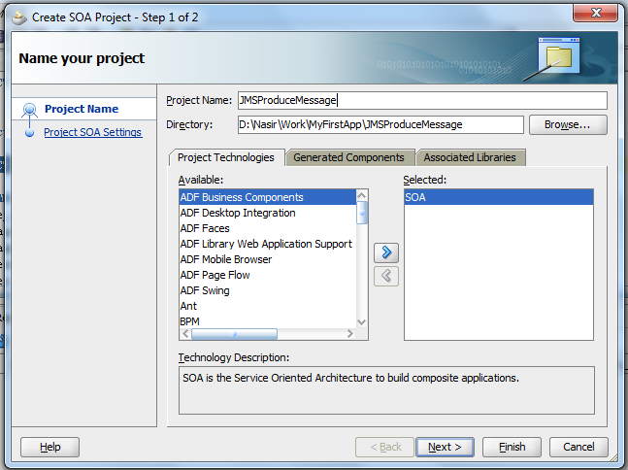

* Create a one way BPEL Process with default input string.

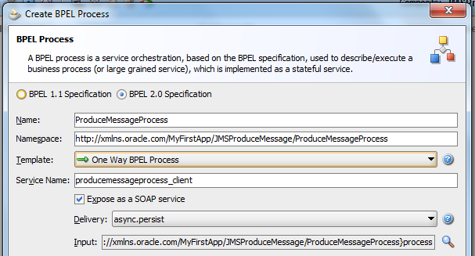

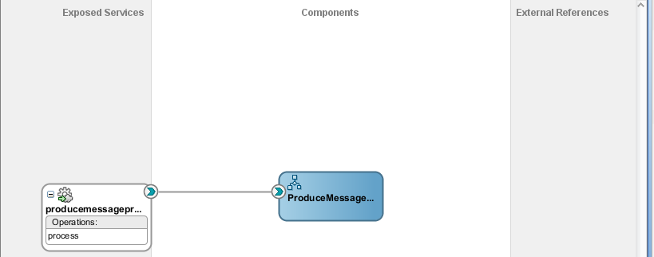

* Drag and drop JMS adapter in external references and give Service Name.

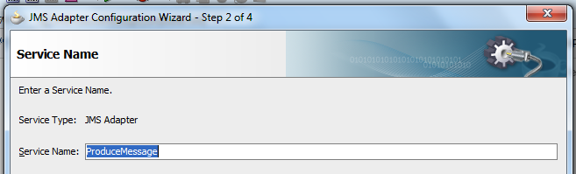

* Select the application Server.

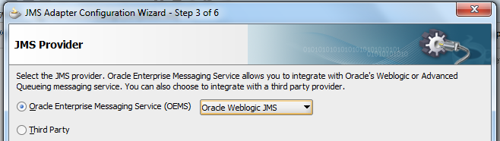

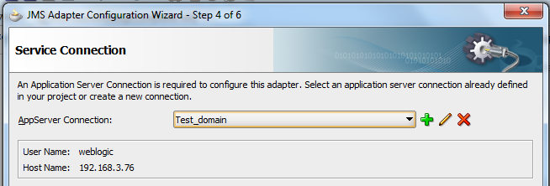

* Select the Operation Type as Produce Message.

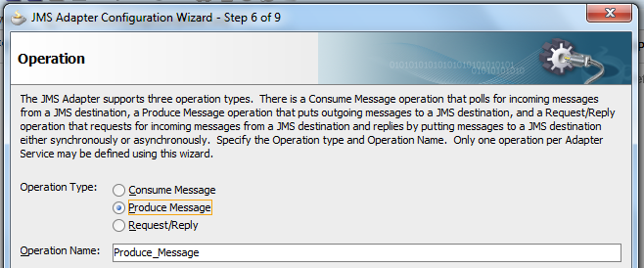

* Click on next and then select the schema and Queue from the browse button.

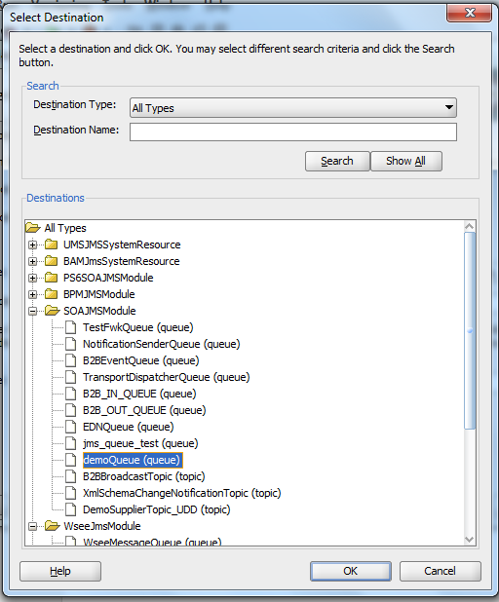

* Give the JNDI name created for JMS Adapter.

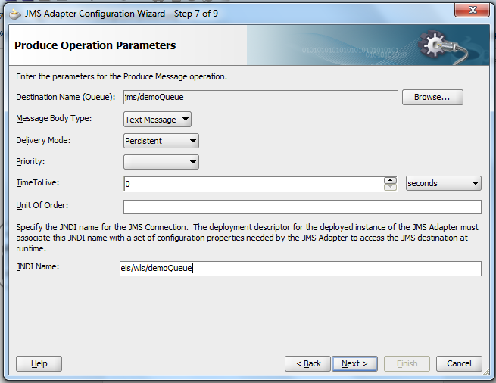

* Select schema for the message. Select from default xsd file.

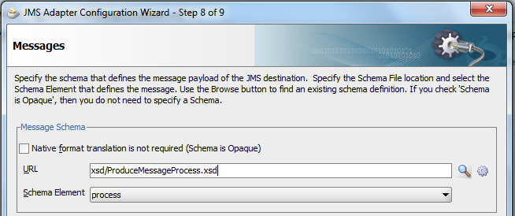

* Click next and then finish.
* Wire the BPEL process with JMS Adapter.

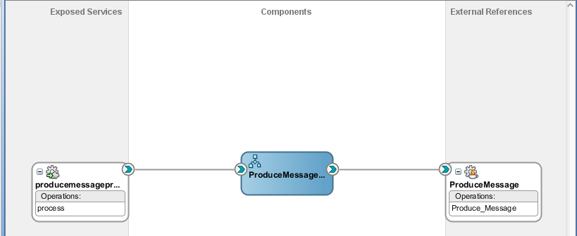

* Open the BPEL process and add invoke and give partner link with the JMS Adapter. Give input variable name as default in invoke activity.
* Drag and drop Assign activity and assign the input to Invoke activity.

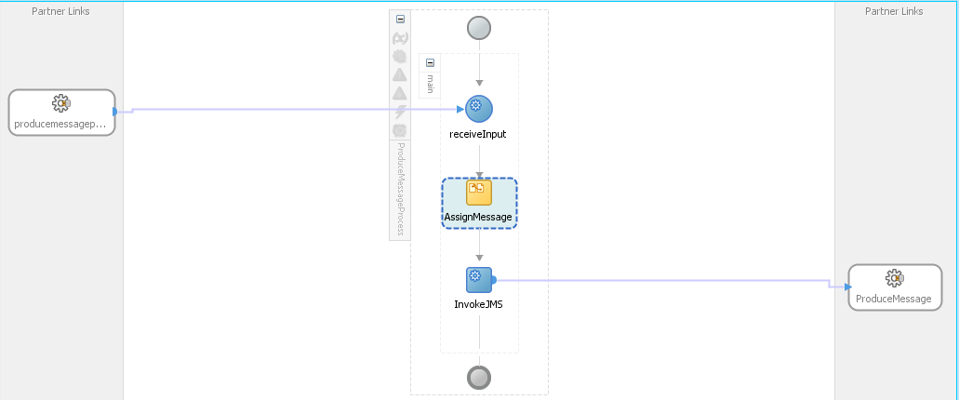

* Compile the application, deploy and test it.
* If the composite runs successfully then a message is created in the Queue. You can open the JMS queue to check the message.

#### Composite for Consume Message in JMS Queue

* Create a new project and name it.

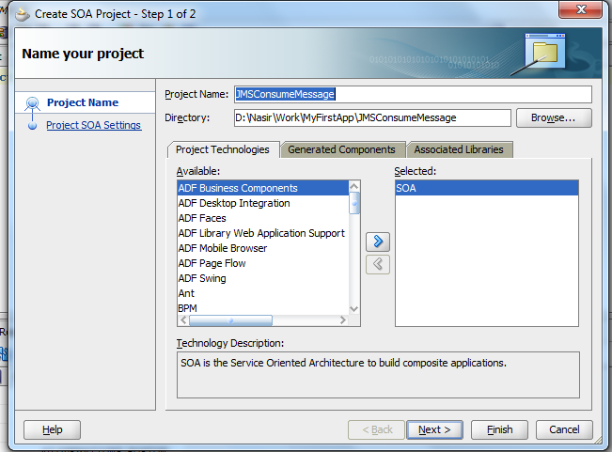

* Create a empty BPEL process.

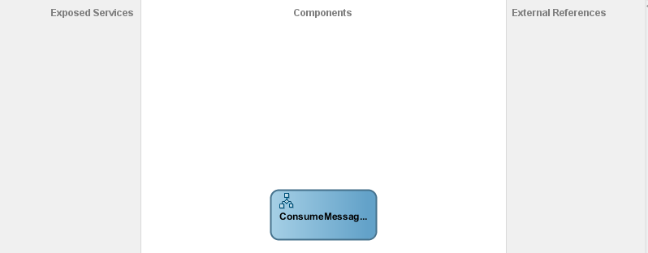

* Drag and drop JMS Adapter service on the Exposed Service area and give the service name.
* Select the OEMS as Weblogic JMS.
* Select the domain and click on next.
* Select the Operation as ‘Consume Message’ and click on next.

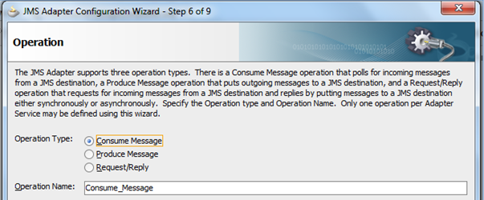

* In the destination name, select the Queue by browse button from which we have to consume the message.
* Give the JNDI name.

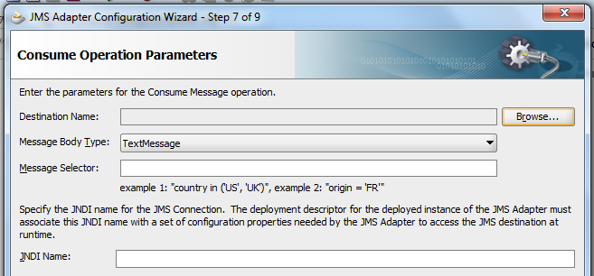

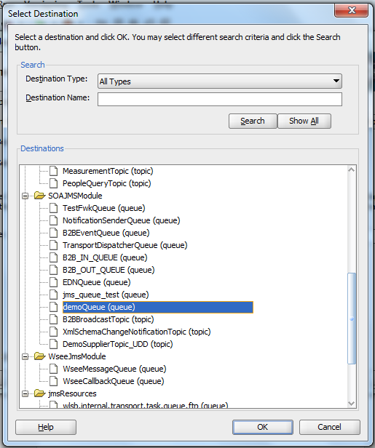

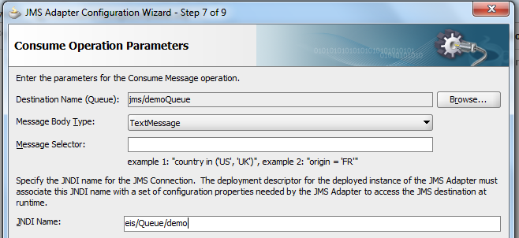

* In the message schema click the option ‘Native format translation is not required’ and click on finish.

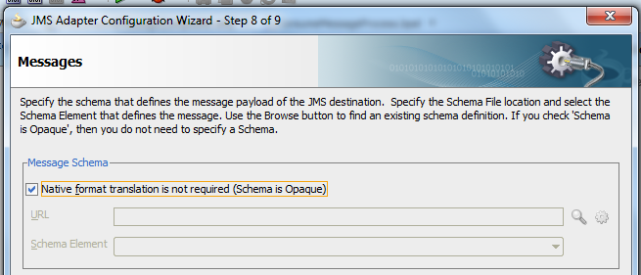

* Open the BPEL process and drop the receive activity. Name it and give the partner link with JMS adapter.

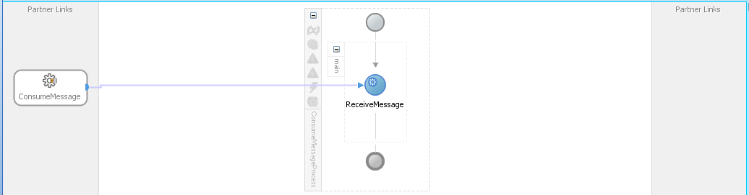

* Drag file adapter to write the consumed message.

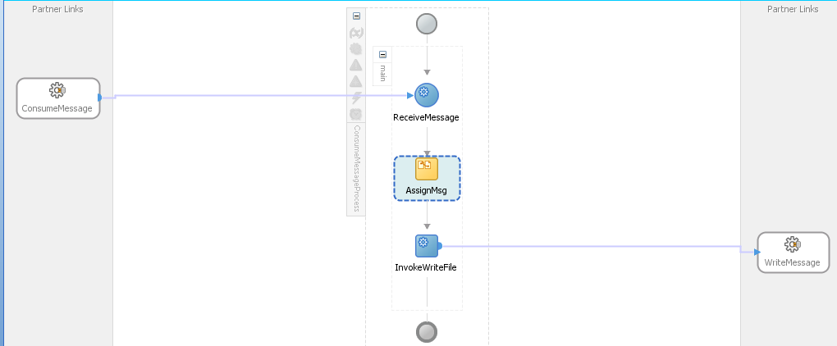

* Compile, deploy and test it.
* You can able to see the files created in the output directory.

### FTP Adapter configuration

1. Open <http://hostname:port/console>

Click Deployments   –>  FTPAdapter[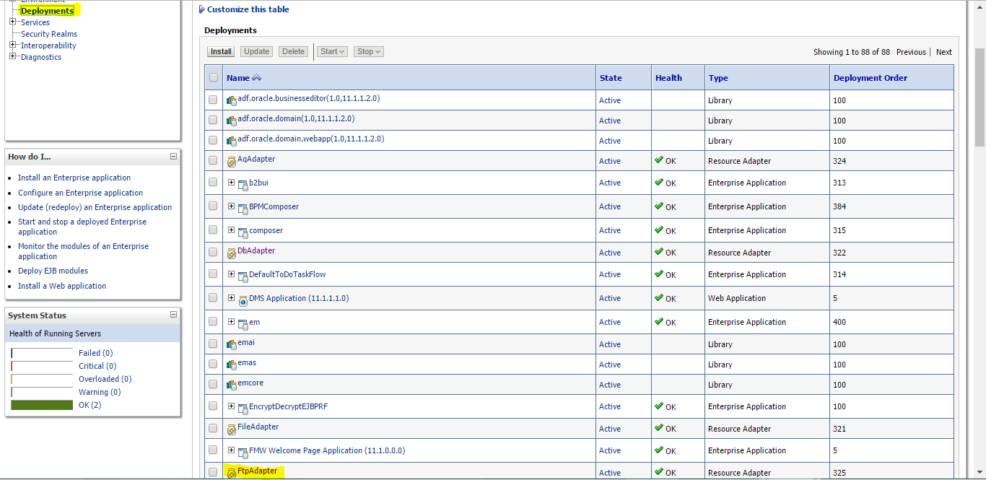](http://logicoy.com/blogs/wp-content/uploads/2017/05/Step1FTPConfig.png)

1. Go to Configuration  –>  Outbound Connection Pools

Click New to create new FTP Configuration

[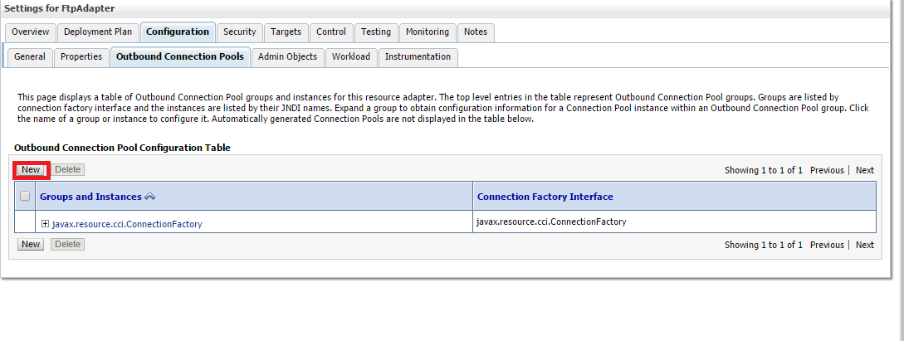](http://logicoy.com/blogs/wp-content/uploads/2017/05/Step2FTPConfig.png)

1. Select javax.resource.cci.ConnectionFactory

[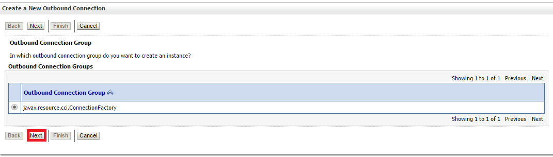](http://logicoy.com/blogs/wp-content/uploads/2017/05/Step03FTPConfig.png)

Click Next

1. Enter the JNDI name and Click Finish

[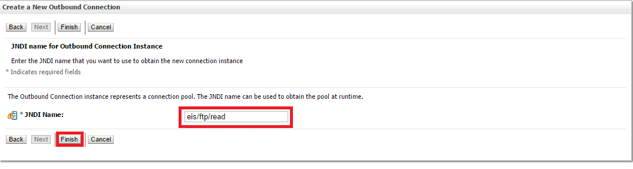](http://logicoy.com/blogs/wp-content/uploads/2017/05/Step4FTPConfig.png)

1. Now click on **eis/ftp/read** to enter the configuration

[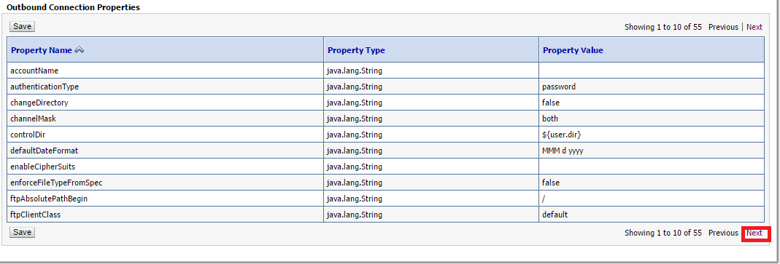](http://logicoy.com/blogs/wp-content/uploads/2017/05/Step5FTPConfig.png)

Select either Public key authentication or password authentication and

click Next

1. Enter the host name

[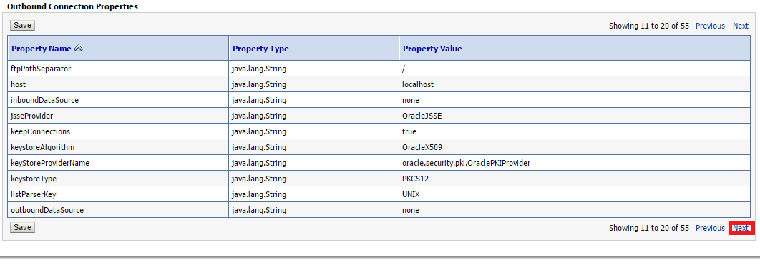](http://logicoy.com/blogs/wp-content/uploads/2017/05/Step6FTPConfig.png)

Click Next

1. Enter password  and port number 21 for FTP and 22 for SFTP

[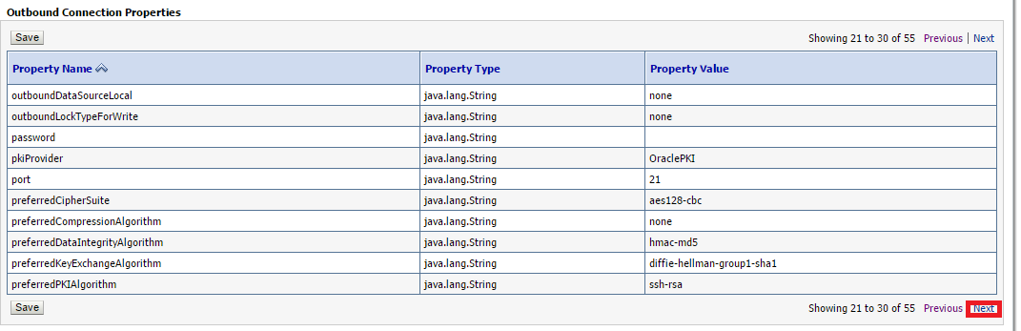](http://logicoy.com/blogs/wp-content/uploads/2017/05/Step7FTPConfig.png)

Click Next

[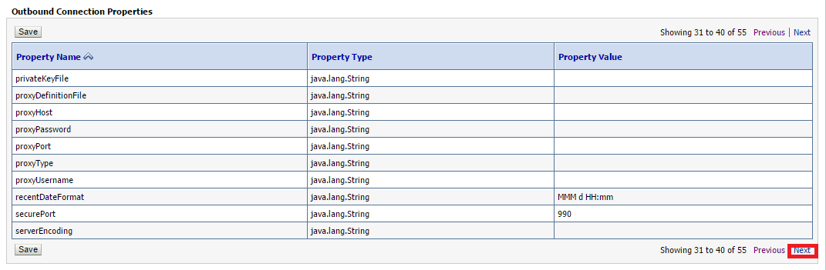](http://logicoy.com/blogs/wp-content/uploads/2017/05/Step8FTPConfig.png)

Click Next

1. Enter Server Type either win for windows or unix

[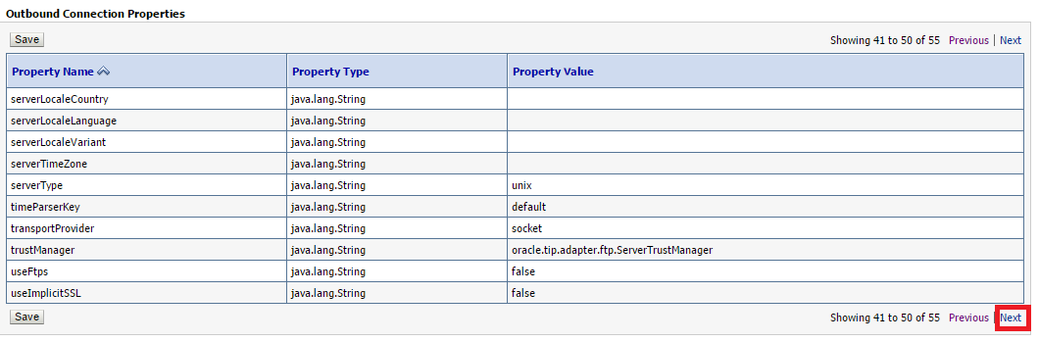](http://logicoy.com/blogs/wp-content/uploads/2017/05/Step9FTPConfig.png)

Click Next

1. Enter Username , if your using SFTP make useSftp to true

[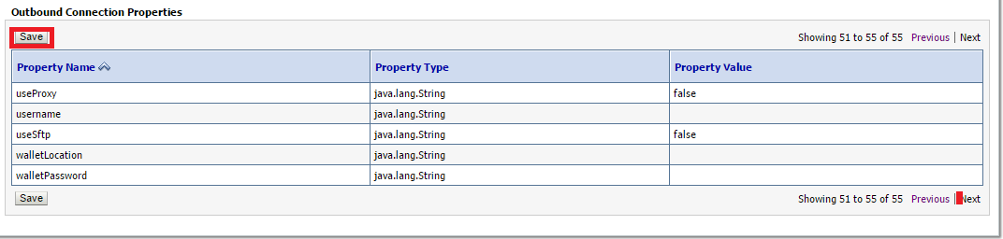](http://logicoy.com/blogs/wp-content/uploads/2017/05/Step10FTPConfig.png)

Click Save

1. Once Configuration is saved Update FTP Adapter

[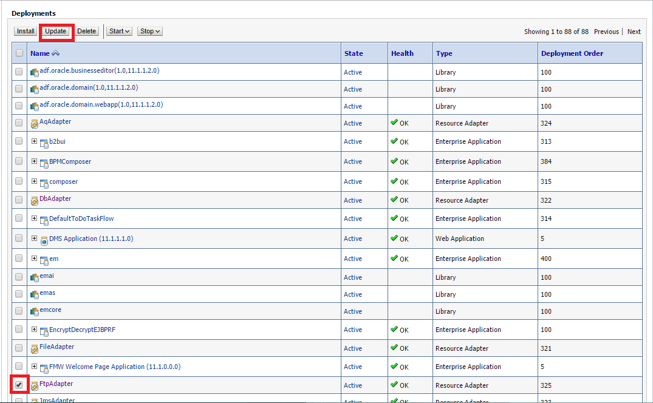](http://logicoy.com/blogs/wp-content/uploads/2017/05/Step11FTPConfig.png)

Select FtpAdapter and click Update

1. Select Update this application in place with new deployment plan changes

[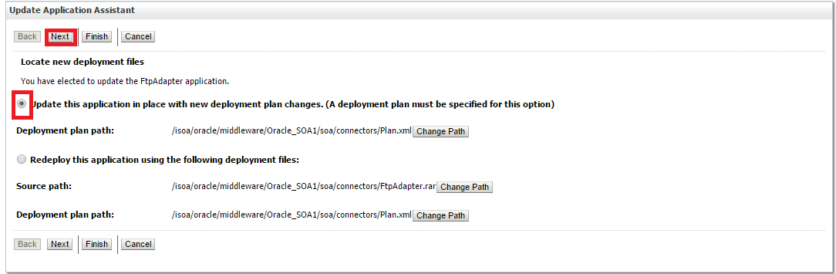](http://logicoy.com/blogs/wp-content/uploads/2017/05/Step12FTPConfig.png)

Click next

[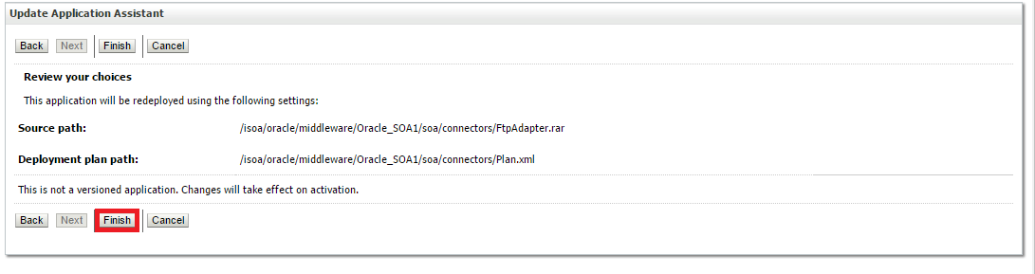](http://logicoy.com/blogs/wp-content/uploads/2017/05/Step13FTPConfig.png)

Click Finish

1. Once update is done click Activate Changes

[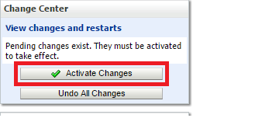](http://logicoy.com/blogs/wp-content/uploads/2017/05/Step14FTPConfig.png)

### Working with Transformations

#### Using for-each for parent-child in Transformation

<top:Dept1Collection>

<xsl:for-each select="/DATA/DEPT">

<top:Dept1>

<top:deptno>

<xsl:value-of select="DEPTNO"/>

</top:deptno>

<top:dname>

<xsl:value-of select="DNAME"/>

</top:dname>

<top:emp1Collection>

<xsl:for-each select="EMP">

<top:Emp1>

<top:empno>

<xsl:value-of select="EMPNO"/>

</top:empno>

<top:mgr>

<xsl:value-of select="MGR"/>

</top:mgr>

<top:sal>

<xsl:value-of select="SAL"/>

</top:sal>

</top:Emp1>

</xsl:for-each>

</top:emp1Collection>

</top:Dept1>

</xsl:for-each>

</top:Dept1Collection>

#### 

#### Using date format in Transformation

<top:hiredate>

<xsl:value-of select='xp20:format-dateTime(HIREDATE,"[D01]-[M01]-[Y0001]")'/>

</top:hiredate>

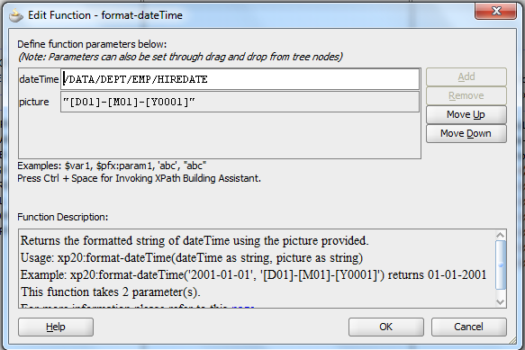

#### Sorting records in Transformation

* **Sorting text data**

<xsl:template match="/">

<top:EmpCollection>

<xsl:for-each select="$Invoke1_Output.EmpCollection/top:EmpCollection/top:Emp">

<xsl:sort select="top:ename" data-type="text"/>

<top:Emp>

<top:empno>

<xsl:value-of select="top:empno"/>

</top:empno>

</top:Emp>

</xsl:for-each>

</top:EmpCollection>

</xsl:template>

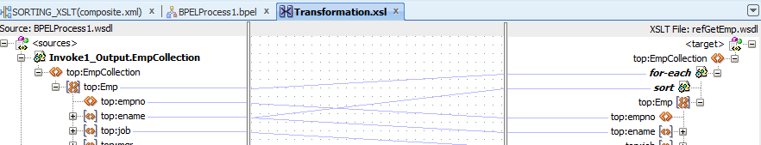

### Global and Local Transactions

We will simulate a global transaction via a xaDataSource between a BPEL Composite and OSB that interact via native transports (SB and SOA-DIRECT) and define transaction boundaries. Global Transaction is governed by the following parameters viz. the message exchange pattern, the datasource and the composite properties for the particular components viz. bpel.config.

**Behaviour**: In a single global transaction, any fault within the Composite will result in a complete rollback of all transactions. However, if there are boundaries then in the event of a fault within the global transaction, local transactions will be committed while the global transaction is rollbacked. If fault happens in the partnerlink and it is not handled then the local transaction is rollbacked and a FabricInvocationExceptions is thrown back to the parent BPEL process. If fault happens in the partnerlink and it is handled then the local transaction is committed.

How to create local transactions or boundaries:

The boundaries are defined in the composite.xml of the component properties of the called process. The exact properties are dependent on the Message Exchange Pattern of the called Component:

1. If MEP is Sync Request Response, then transaction=requiresNew
2. If MEP is Async Request Response, then transaction=requiresNew, oneWayDeliveryPolicy=sync
3. If MEP is One Way, then transaction=requiresNew, oneWayDeliveryPolicy=sync

Note : The transaction parameters are only defined for BPEL Components. So, if you do want to create local transactions, you would have to embed adapters in bpel processes. I do not understand why this limitation should be there.

Steps:

1. Create a Thin XA Datasource that supports ‘Two-Phase Commit’ global transaction and a connection pool. We will require the JNDI of this pool for the project.
2. Create two OSB Business Services for inserting and updating a table in the datasource configured in Step 1. These are based on the JCA transport which is transactional in nature. A link is provided in resources for the same.
3. Create Proxy Services for these Business Services based on SB-transport which is also transactional.
4. Create a composite with two BPEL processes viz. GlobalTransactionBPELRequestor which makes inserts into a table NAME_ID via OSB Proxy Service and LocalTransaction_BPEL_Insert2 which inserts into a table NAME_ID2 again via OSB Proxy Service. In addition, GlobalTransactionBPELRequestor also invokes the LocalTransaction_BPEL_Insert2 and then throws an Assert Fault based on the input.

LocalTransaction_BPEL_Insert2 snapshot:

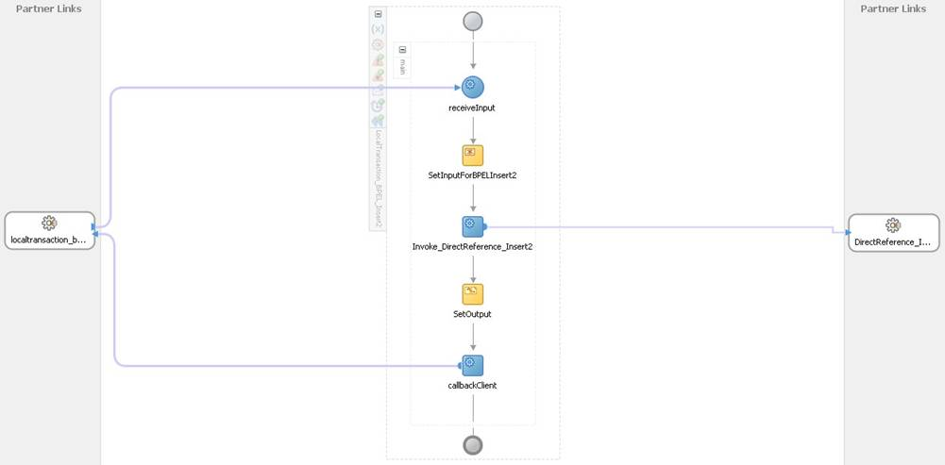

The input for the LocalTransaction_BPEL_Insert2 is:

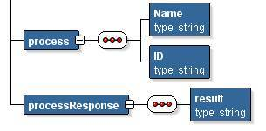

GlobalTransactionBPELRequestor snapshot:

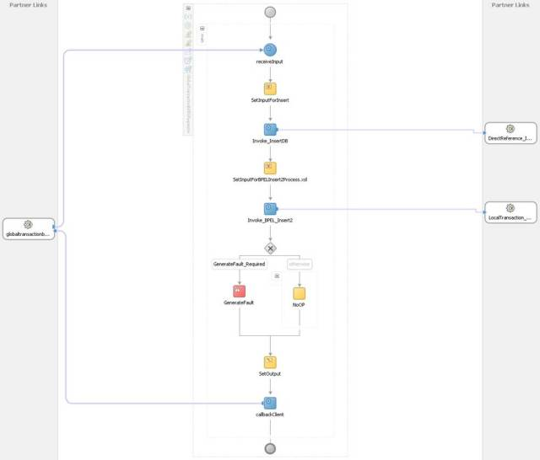

The input for the GlobalTransactionBPELRequestor looks like:

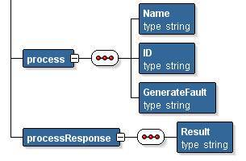

Name and ID will go into the NAME_ID table which the GenerateFault (values Yes or No ) will decide on whether to throw the fault or not within the switch activity.

Here, the process inserts data into NAME_ID table via the Invoke_InsertDB invoke to an OSB Proxy. After this, the process makes an Async one way call to the second bpel process via Invoke_BPEL_Insert2. After this, based on the GenerateFault value of YES or NO, a deliberate Assert Fault is thrown.

The database tables, the Assert Fault and the inputs have been created merely to create this simulation. Knock yourself out with any other options you can think of.

1. Now, we wire these components together in the Composite:

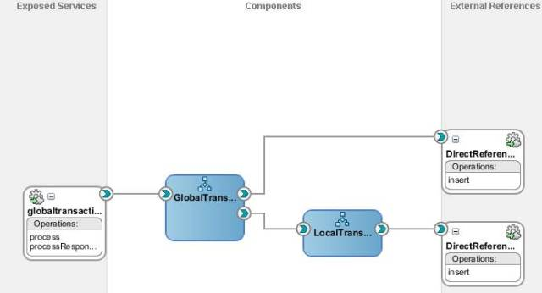

1. As per the earlier discussion, we will now insert the following custom properties inside the component property of the called BPEL process viz. LocalTransaction_BPEL_Insert2.

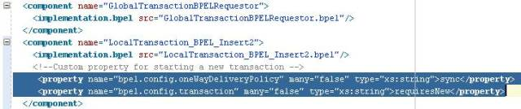

This ensures that the LocalTransaction_BPEL_Insert2 invoke will result in a separate local transaction.

1. Now, deploy the components and test the GlobalTransactionBPELRequestor with the following inputs

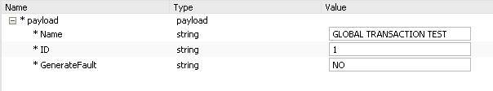

1. The Trace in shows that the test completes successfully and the entries for the name and id show up in both the tables:

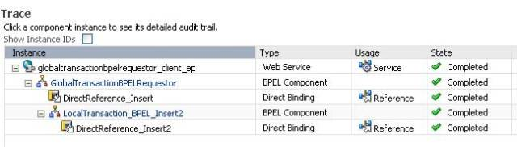

1. Now, test the same process with the following inputs:

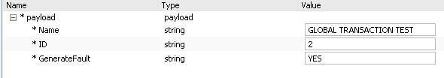

This means, insert name “GLOBAL TRANSACTION TEST” and ID 2 into the tables NAME_ID and NAME_ID2 and throw a fault in the Parent BPEL process i.e. GlobalTransactionBPELRequestor.

1. The trace shows that the LocalTransaction_BPEL_Insert2 process completes without fault while the GlobalTransactionBPELRequestor faults as expected. The table NAME_ID does not have the new entry now ( as this is part of the global transaction that has been rollbacked ) while the table NAME_ID2 has the entry ( as this is the local transaction that commits without any fault )
2. You can also remove the transactional parameters we set earlier in the composite.xml of the LocalTransaction_BPEL_Insert2 and deploy and test with the inputs we used in step 9. The em trace will show that the fault has happened at the end as expected and the entire global transaction is rolled back.
3. This tutorial shows how we can create sets of local transactions in a single global transaction and thereby have better control over what we want to achieve.

### Working with Exception Handling

We have a synchronous BPEL process **getEmpName** which takes the employee id as input and gives employee name as output. In this bpel process we use the following function to check the given employee id is exists and return the employee name, if the employee id does not exists then it sends an exception with the error code.

CREATE OR REPLACE FUNCTION GETEMPNAME(emp_number IN VARCHAR2)

RETURN VARCHAR2 AS

emp_name EMP.ENAME%TYPE;

BEGIN

SELECT ename

INTO emp_name

FROM emp

WHERE empno = emp_number;

RETURN emp_name;

EXCEPTION

WHEN NO_DATA_FOUND THEN

raise_application_error(-20001, 'UNKNOWN EMPLOYEE ID');

END GETEMPNAME;

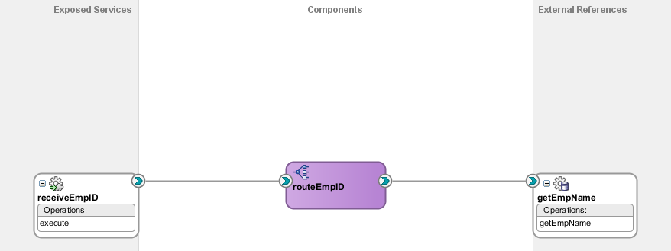

We create asynchronous BPEL process which calls the **getEmpName** composite. It executes for the employee id in database but for the exception we need to handle the **binding fault**.

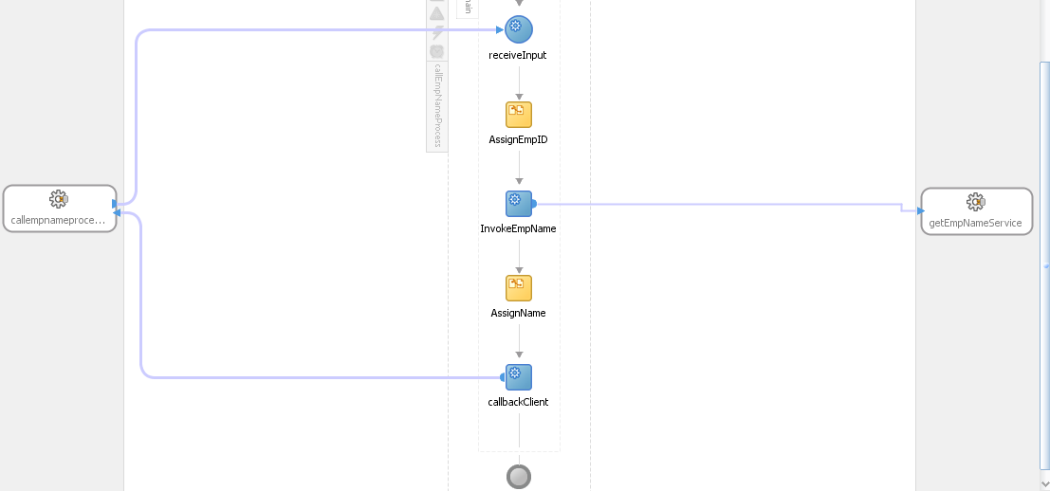

We will call the **getEmpName** without any fault handling then it shows the below error.

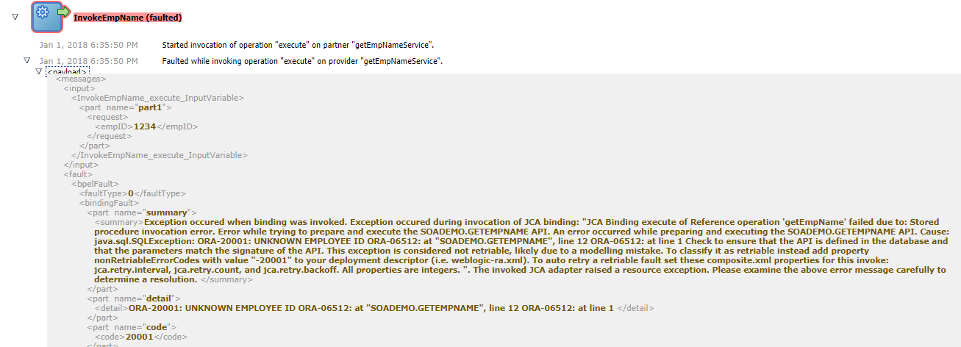

#### Handling remote faults

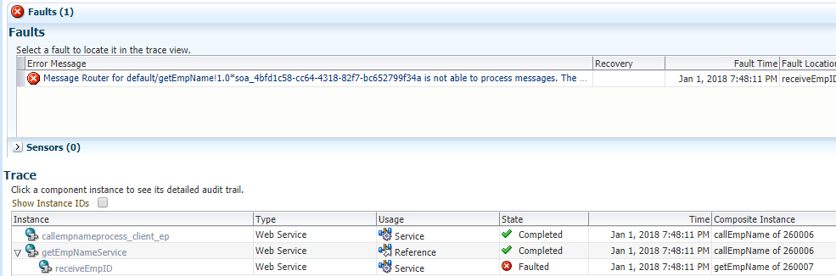

You can able to run the **CallEmpName** composite which make a web service call to **getEmpName**. If the composite **getEmpName** is set to off then the composite **CallEmpName** will not execute and we can see the error in the flow trace. This is the situation of **remoteFault**. We can handle this by using the concept of **remoteFault**.

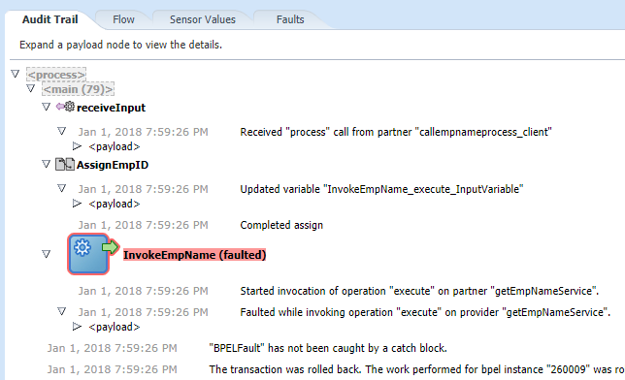

#### Creating a fault policy

1. In JDeveloper, right-click on the **CallEmpName** project and select **New**.
2. Select the All **Technologies** tab.
3. Select XML in the General Categories.
4. Select XML Document in the Items pane.
5. Name the new file fault-policies.xml.

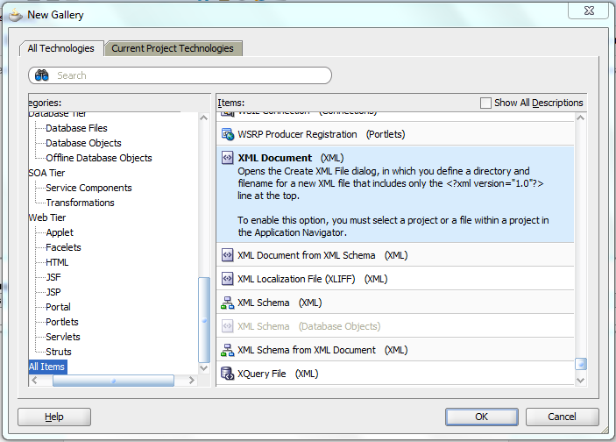

1. Add the following to the fault-policies.xml:

<?xml version="1.0" encoding="UTF-8" ?>

<faultPolicies xmlns="http://schemas.oracle.com/bpel/faultpolicy">

<faultPolicy version="2.0.1" id="CallEmpNameFaults"

xmlns:env="http://schemas.xmlsoap.org/ soap/envelope/"

xmlns:xs="http://www.w3.org/2001/XMLSchema"

xmlns="http://schemas.oracle.com/bpel/faultpolicy"

xmlns:xsi="http://www.w3.org/2001/ XMLSchema-instance">

<Conditions>

<!-- Step #1: Add your fault handler for remote fault here: -->

<!-- Step #2: Add your fault handler for binding fault here: -->

<!-- Step #3: Add your fault handler for mediator faults here: -->

</Conditions>

<Actions>

<!-- Step #4: Add the Action definition for handling mediator faults using custom java here:-->

<!-- Custom Java Handler: Logs the fault details to a log file -->

<Action id="my-java-handler">

<javaAction className="soatraining.faulthandling. MyFaultHandler"

defaultAction="ora-terminate" propertySet="myProps">

<returnValue value="OK" ref="ora-rethrow-fault"/>

</javaAction>

</Action>

<!-- Retry -->

<Action id="ora-retry">

<retry>

<retryCount>4</retryCount>

<retryInterval>2</retryInterval>

<exponentialBackoff/>

</retry>

</Action>

<!-- Rethrow action -->

<Action id="ora-rethrow-fault">

<rethrowFault/>

</Action>

<!-- Human Intervention -->

<Action id="ora-human-intervention">

<humanIntervention/>

</Action>

<!-- Terminate -->

<Action id="ora-terminate">

<abort/>

</Action>

</Actions>

<!-- Property sets used by custom Java actions -->

<Properties>

<!-- Property set for MyFaultHandler customer java action -->

<propertySet name="myProps">

<property name="logFileName">myfaulthandler.log</property>

<property name="logFileDir">c:\temp</property>

</propertySet>

<!-- Step #5: Add new property set for MyFaultHandler for logging Mediator faults here:-->

</Properties>

</faultPolicy>

</faultPolicies>

1. Save the file.
2. Follow the same steps to create another XML file. This time, name the file as fault-bindings.xml.
3. Add the following to this file:

<?xml version="1.0" encoding="UTF-8" ?>

<faultPolicyBindings version="2.0.1"

xmlns="http://schemas.oracle.com/bpel/faultpolicy"

xmlns:xsi="http://www.w3.org/2001/XMLSchemainstance">

<composite faultPolicy="CallEmpNameFaults"/>

</faultPolicyBindings>

1. Save the file.
2. Open the fault-policies.xml file in JDeveloper and add the following XML to handle all remote faults that occur in any component in the CallEmpName composite under the comment marked Step #1.

<faultName xmlns:bpelx="http://schemas.oracle.com/bpel/extension"

name="bpelx:remoteFault">

<condition>

<action ref="ora-human-intervention"/>

</condition>

</faultName>

1. Click on the Save All button and deploy the **CallEmpName** composite.
2. Invoke the **CallEmpName** composite using the Web Service tester in the Enterprise Manager console.
3. Navigate to the instance ID of the newly invoked **CallEmpName** to view the flow trace.
4. In the flow trace window, click on **CallEmpNameProcess** to view the BPEL Audit Trail. You will see that the activity has faulted as before but this time it is waiting for a manual recovery.

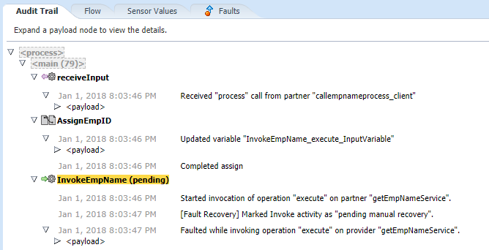

1. Before you attempt a recovery, start the **getEmpName** composite from the Application Server Navigator in JDeveloper. In this case, select Turn On to startup the composite.

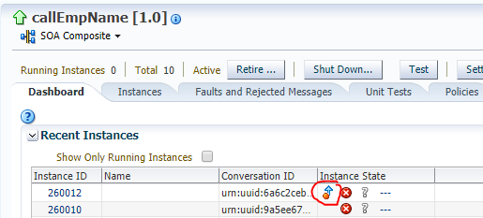

1. Back in the Flow Trace window, select the Faults tab.
2. Click on the row containing the fault. This will show the fault details including the contents of the input variable to the invoke activity.

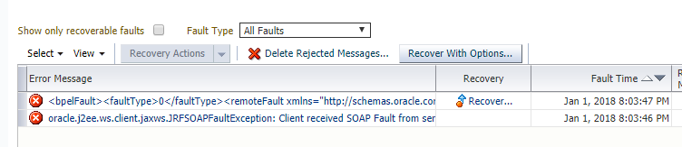

1. Select Retry as the recovery action and click on Recover.

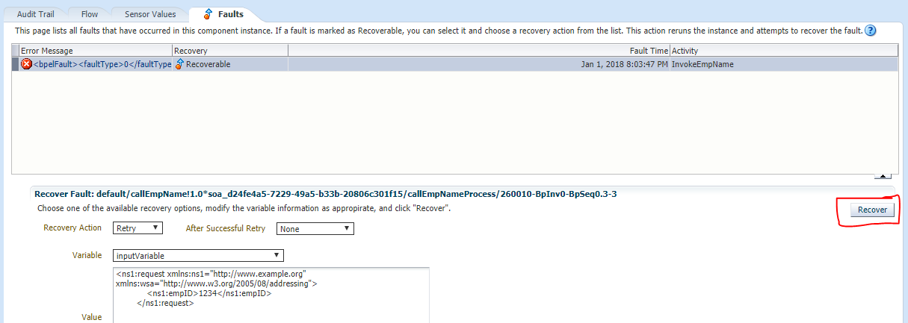

1. You should see the fault clear up from the Faults tab. Click on the Audit Trail tab to view the BPEL flow. You should see that the BPEL has completed the execution successfully (you may need to refresh the window to see the updated trace).

#### Handling exceptions in BPEL

1. Drag a scope activity under the InvokeEmpName activity and drag the **InvokeEmpName** and **AssignName** into the scope activity.

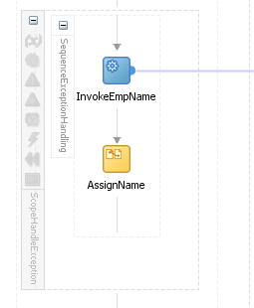

1. Click on add catch block icon from the Scope activity.

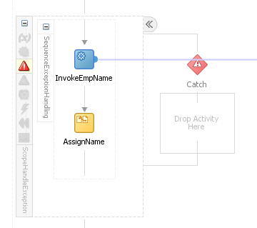

1. Double click on the catch activity. Choose magnifier icon.
2. Select the **bindingFault** from the System Faults.

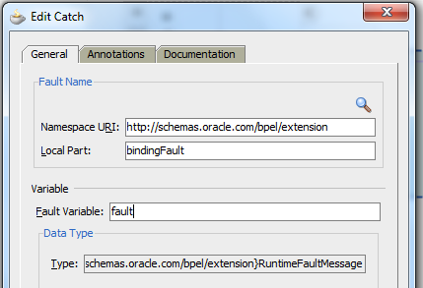

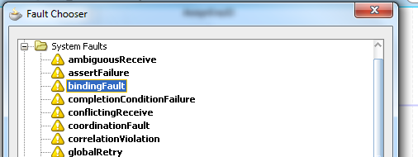

(If you get error for the fault variable created in catch block, just add a throw activity and create the fault variable and then delete the throw activity.)

1. Add a if condition in the catch block to check the error number. And assign the values according to the condition.

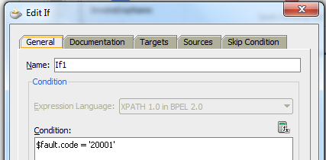

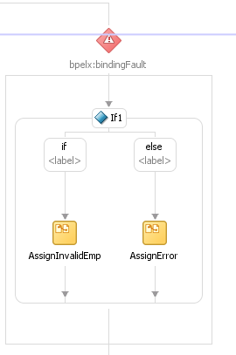

1. Save and compile the composite. The composite looks like below.

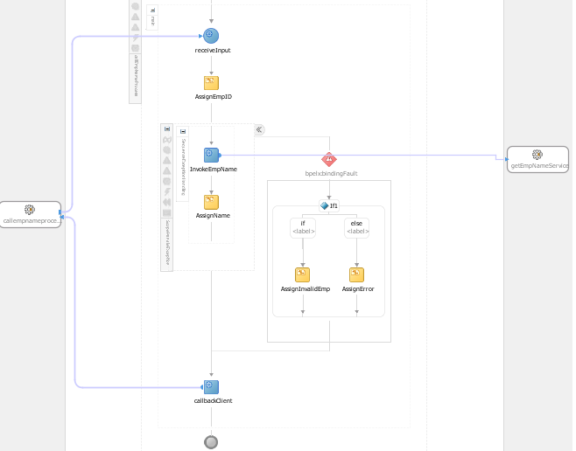

1. Add the following to fault-policies.xml after the comment for step 2.

<faultName xmlns:bpelx="http://schemas.oracle.com/bpel/extension"

name="bpelx:bindingFault">

<condition>

<!-- Let the component handle this specific

binding fault -->

<test>$fault.code="20001"</test>

<action ref="ora-rethrow-fault"/>

</condition>

</faultName>

1. Deploy and test the composite with employee id that does not available in emp table. You will get error.

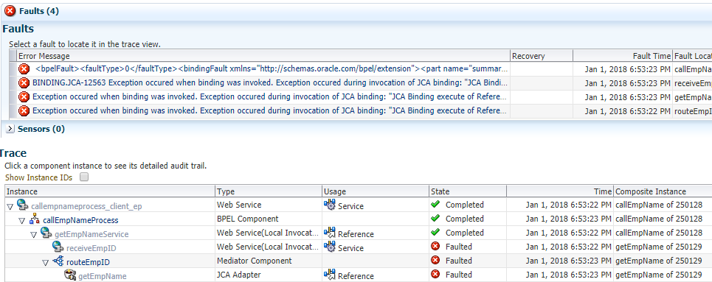

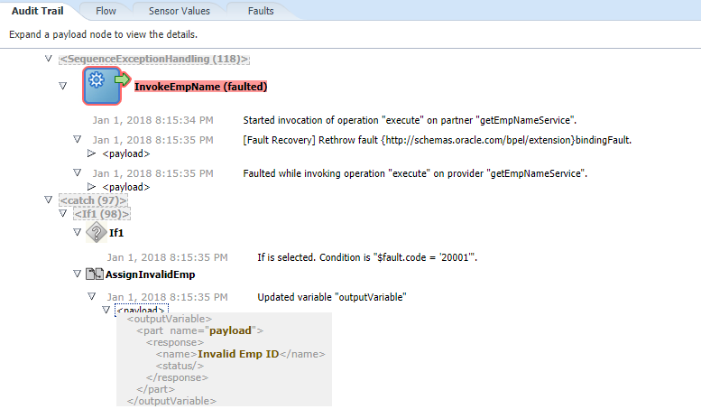

#### Using a custom Java fault handler

In addition to some of the pre-defined actions like humanIntervention, rethrowFault, abort, and so on, you can also define your own custom exception handler using Java. In this exercise, you will change the policy for bindingFault and, instead of re-throwing the fault, you will use a custom Java class to handle it.

1. Install the custom Java handler by copying the provided **myfaulthandler. jar** created as per out requirement in other chapters to the lib directory of your Weblogic Server domain home: c:\Oracle\Middleware\home_11gR1\user_projects\domains\domain1\lib. If you would like to see the Java source for this handler you will find it in the solutions folder for this chapter.
2. Restart the Weblogic SOA server.
3. Modify the fault-policies.xml and change the bindingFault handling that you just added from:

<faultName xmlns:bpelx="http://schemas.oracle.com/bpel/extension"

name="bpelx:bindingFault">

<condition>

<!-- Let the component handle this specific

binding fault -->

<test>$fault.code="20001"</test>

<action ref="ora-rethrow-fault"/>

</condition>

</faultName>

to

<faultName xmlns:bpelx="http://schemas.oracle.com/bpel/extension"

name="bpelx:bindingFault">

<condition>

<!-- Let the component handle this specific

binding fault -->

<test>$fault.code="20001"</test>

<action ref="my-java-handler"/>

</condition>

</faultName>

1. This custom Java code will simply write the details of the fault to a log file and return. Once the Java code completes execution, depending on the return value of the Java call, the framework will take appropriate action. In this case, the Java code always returns a status of OK and the exception-handling definition is set to re-throw the fault on receiving an OK. The following code snippet from fault-policy.xml shows how you define a Java fault handler. The **defaultAction** attribute defines the action to be taken in case the Java class returns values that are not explicitly handled.

<!-- Custom Java Handler: Logs the fault details to a log file -->

<Action id="my-java-handler">

<javaAction className="soatraining.faulthandling.

MyFaultHandler"

defaultAction="ora-terminate"

propertySet="myProps">

<returnValue value="OK" ref="ora-rethrow-fault"/>

</javaAction>

</Action>

1. Ensure that the directory **c:\temp\log** exists. If you would like the log file to be created in a different directory, modify the **logFileDir** property in the fault-policies.xml file.
2. Deploy the **CallEmpName** composite and test using the same XML input as before. You should see a file, myfaulthandler.log, in **c:\ temp \log**. You should also see that **CallEmpName** handles the fault when you view the composite process instance in the Enterprise Manager console.

### Calling ODI scenario from BPEL

ODI provides a synchronous and asynchronous Web services interface for applications to invoke ODI scenarios out of the box. Currently, ODI can execute a Web service asynchronously, but when the Web service is completed, it cannot reference back to the ODI job and signal that it completed successfully or failed. The callback reference allows ODI to call a Web service asynchronously and the Web service then knows where to call back ODI when the job is finished, to signal the outcome of the job. If a BPEL business process uses this interface to invoke a large, long-running load, it is likely that the synchronous invocation will time out before the ODI load is complete.

#### Calling Synchronous ODI

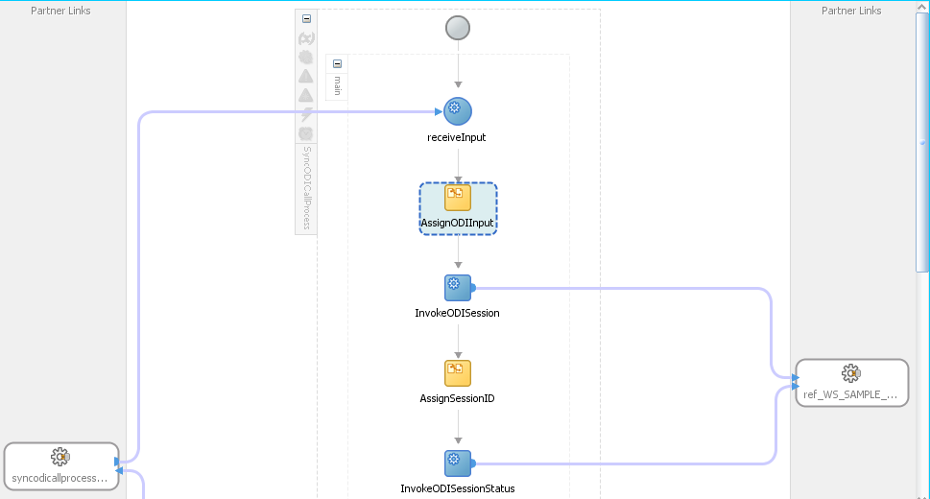

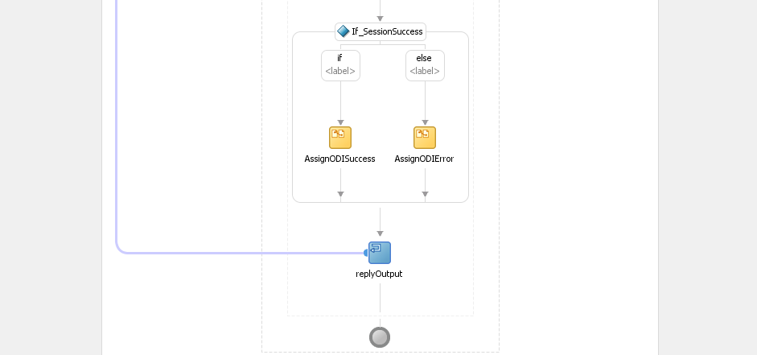

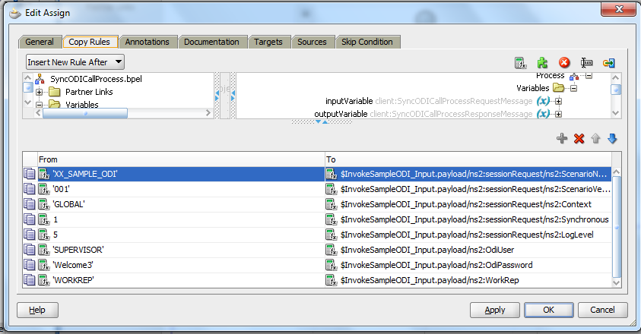

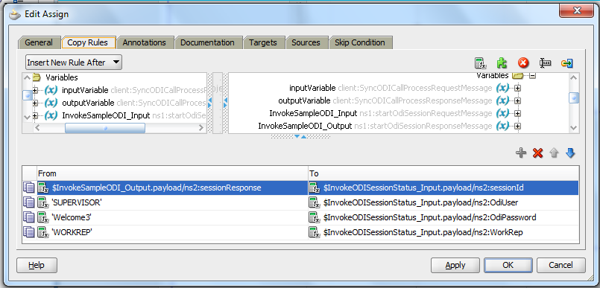

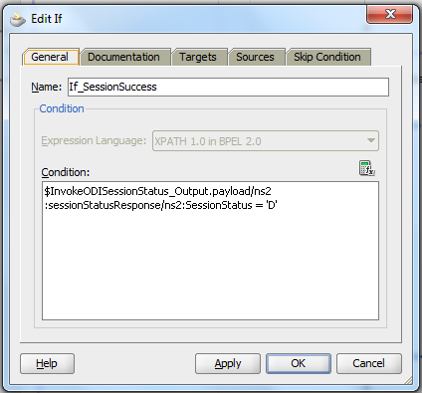

#### Calling Asynchronous ODI

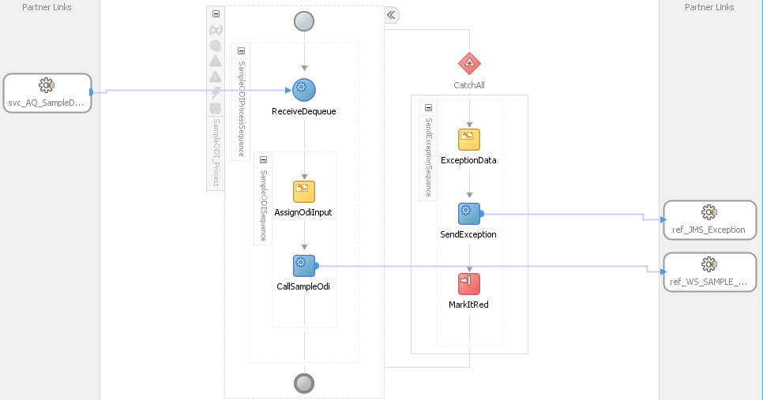

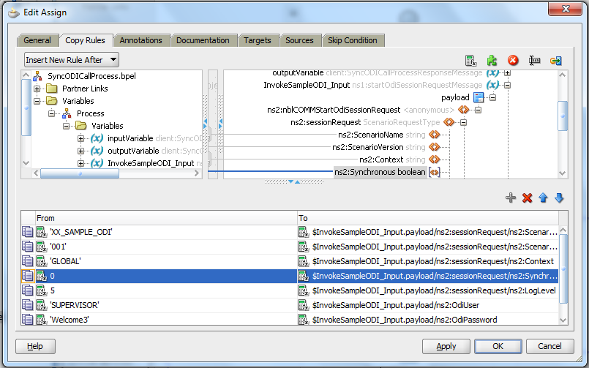

### Incorporating Java and Java EE Code in a BPEL Process

#### Creating a simple java class and jar file

1. Create application and project for the java.

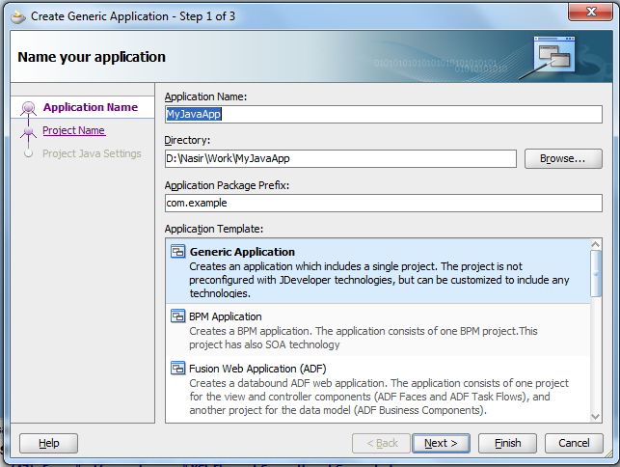

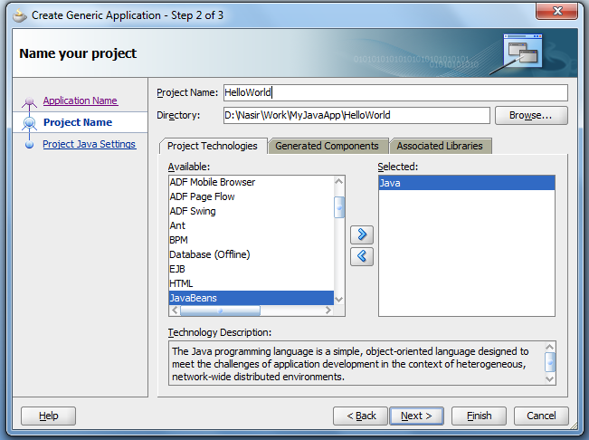

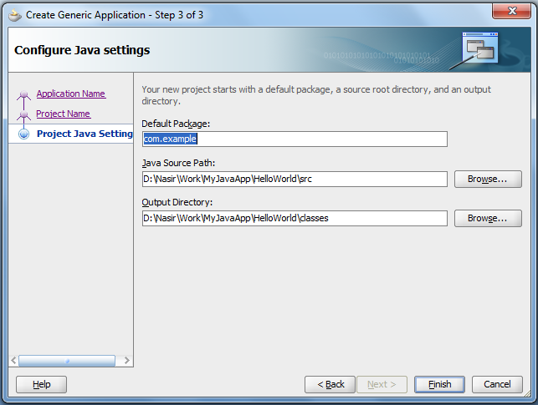

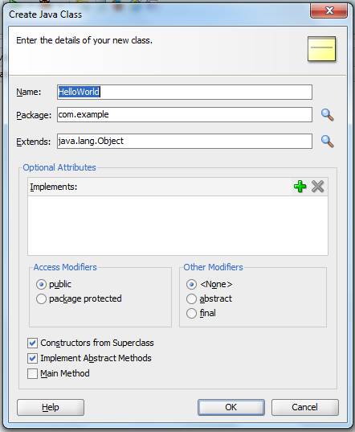

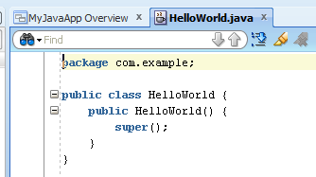

1. Below is the screen shot of the Java class which we want to use in our BPEL process.

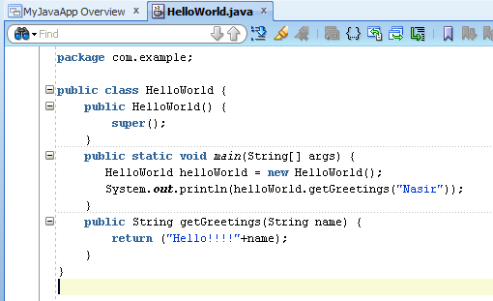

1. Select project and go to deploy and select jar
2. Give the Name to Jar file "HelloWorldJava"
3. This HelloWorld.Jar goes inside the deploy folder of this project by default.

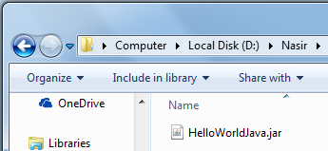

#### Use java class from the .jar file inside the BPEL process

1. Create a new SOA composite and drop a BPEL process inside composite.xml , Copy the HelloWorldJava.jar which we just created in the precious steps inside the Composite "SCA-INF/lib" folder.
2. Now drop a Java Embedding activity inside the BPEL process.

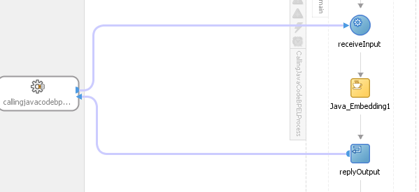

1. Inside the Java Embedding use the below code

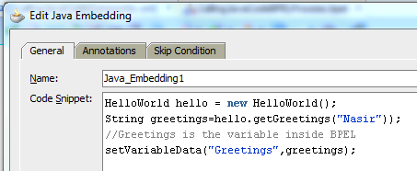

We need to do 2 things here first include the Jar in the project and then use import statement to use those classes inside the BPEL  
  
1.) To include the JAR in the project, double click on the project to open the project properties click on "Libraries and class path" now click "Add JAR/Directory...” and include the jar file which we have placed inside the SCA-INF/lib folder of the same project.  
  
2.) Use Import statement inside the BPEL source code, inside the BPEL process we have to manually use Import statement to import the java class in order to use the class inside the BPEL.

1. Create a new variable "Greeting" of String type, inside the Java code we are passing the output of the java method to this variable, this will bring the output of the java to BPEL process.

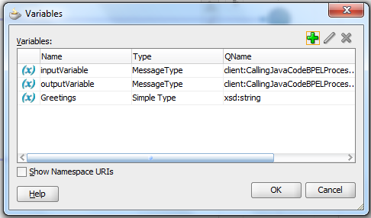

1. Use a Assign activity to map the Greeting variable to output variable.

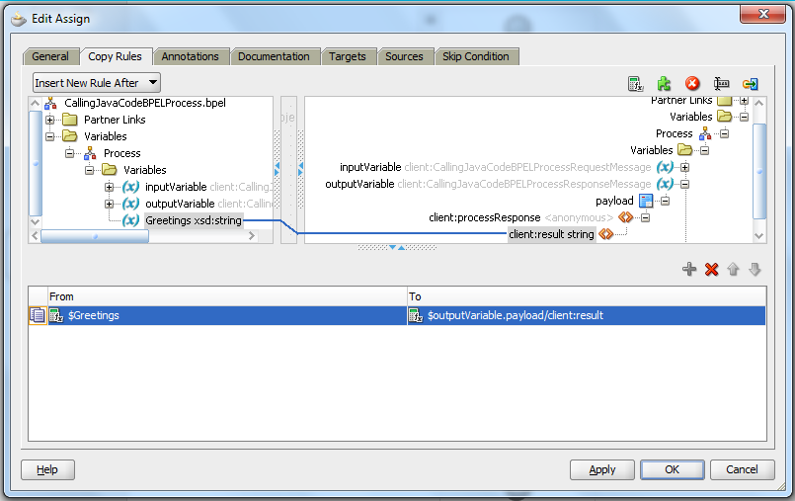

1. Deploy and test.

#### Get SAO Server Details using Java Embedding

String weblogicDomainName = "Unknown" ;

String machineName = "Unknown" ;

String serverName = "Unknown" ;

String message = "na" ;

InitialContext ctx = null ;

try {

// Make local connecion to Runtime MBean Server

ctx = new InitialContext();

MBeanServer beanServer = (MBeanServer)ctx.lookup("java:comp/env/jmx/runtime");

// Get RuntimeServiceMBean

ObjectName runtimeService = new ObjectName("com.bea:Name=RuntimeService,Type=weblogic.management.mbeanservers.runtime.RuntimeServiceMBean");

// Retrieve DomainConfiguration MBean from RuntimeServiceMBean

ObjectName domainCFG = (ObjectName) beanServer.getAttribute(runtimeService, "DomainConfiguration");

// Get Weblogic DomainName *attribute) from DomainConfiguration MBean

weblogicDomainName = (String) beanServer.getAttribute(domainCFG, "Name");

// Retrieve ServerConfiguration MBean from RuntimeService MBean

ObjectName serverCFG = (ObjectName) beanServer.getAttribute(runtimeService, "ServerConfiguration");

// Retrieve Machine MBean from ServerConfiguration MBean

//ObjectName machineCFG = (ObjectName) beanServer.getAttribute(serverCFG, "Machine");

// Retrieve Machine Name from Machine MBean

//machineName = (String) beanServer.getAttribute(machineCFG, "Name");

// Retrieve ManagedServer Name from ServerConfiguration MBean

serverName = (String) beanServer.getAttribute(serverCFG, "Name");

} catch (Exception ex) {

message = "Exception occured in embedded Java action ;" + ex ;

}

setVariableData("SOAServerDetails","WeblogicDomain:" + weblogicDomainName + "; Server:" + serverName + "; " + message);

### Use Pick Activity in BPEL

#### Use on message acitvity the BPEL process

We are creating a BPEL process which creates the instance automatically when data is inserted/updated in a table or file is placed in local system. For this we create three adapters one database adapter one file adapter.

1. Crate one database adapter and one file read adapter in exposed services, from which we need to get the data.
2. Create a database adapter in which we need to insert the data

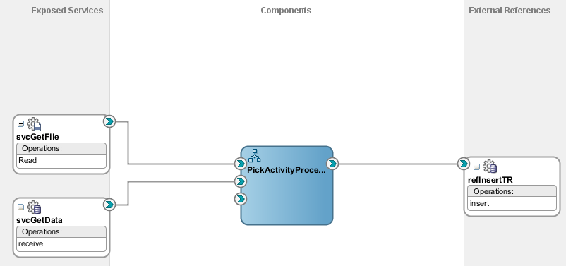

1. Create a bpel process and place the pick activity in bpel.

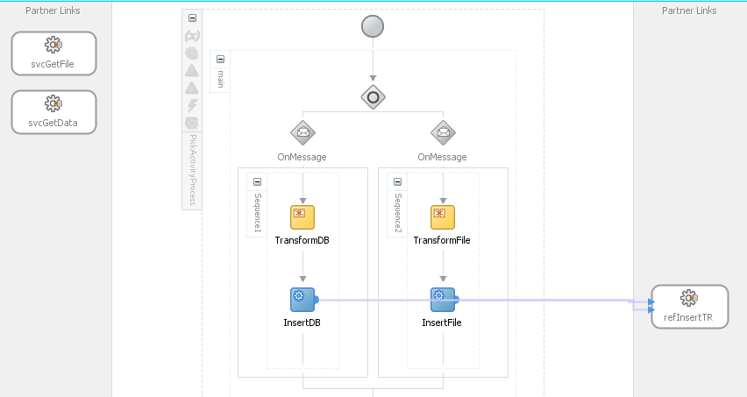

1. We need to start the process when data in table updated or the file in the location is created. So check the create instance.

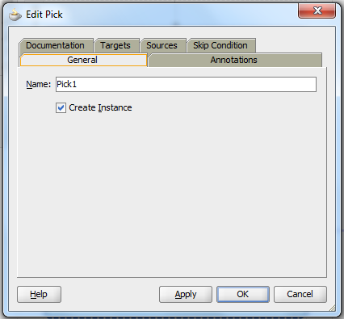

1. One message is executed when the table is modified. We can use the database adapter as input to the message. Use transformation to insert the data into table.

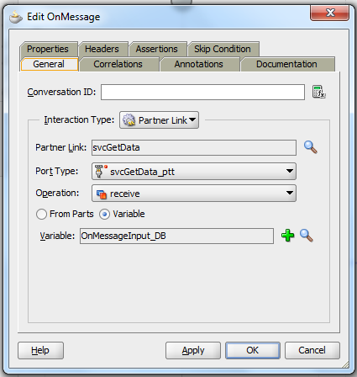

1. Other message is executed when the file is created in the path. So assign the file to the message as input and use the transformation to insert the data into database.

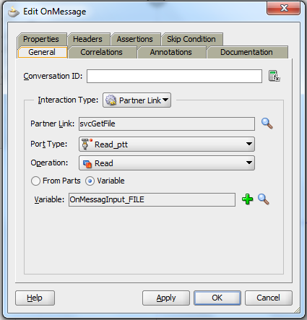

### Use Human Task Activity in BPEL

#### Create simple Approve/Reject Human Activity

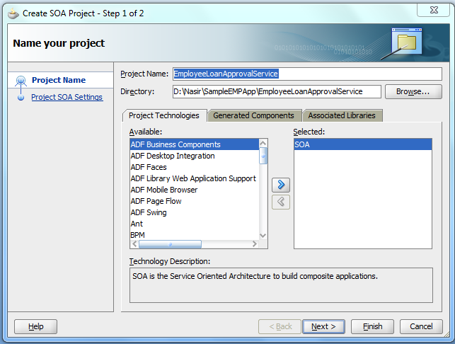

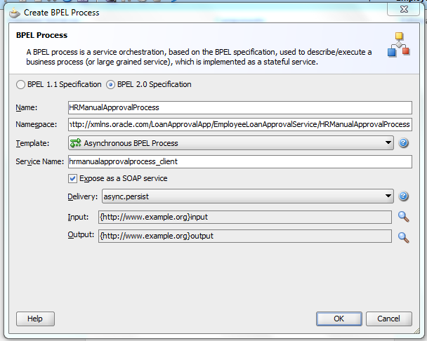

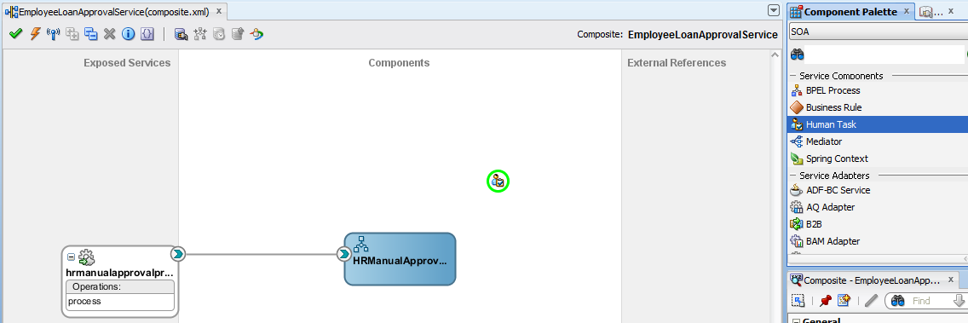

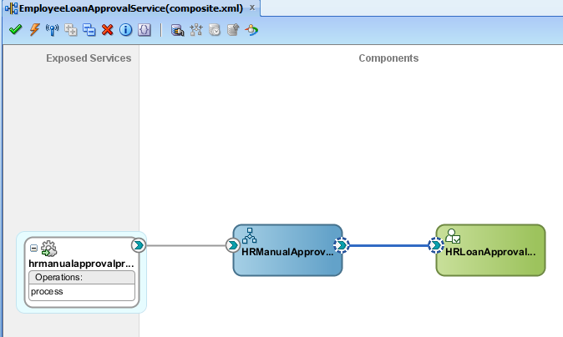

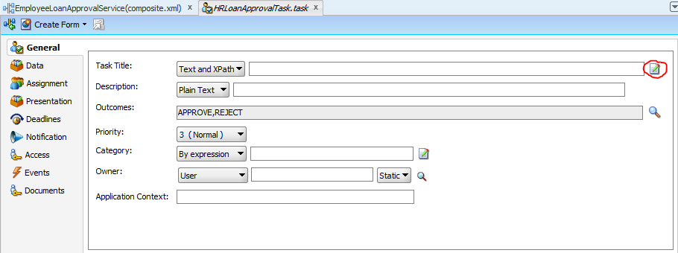

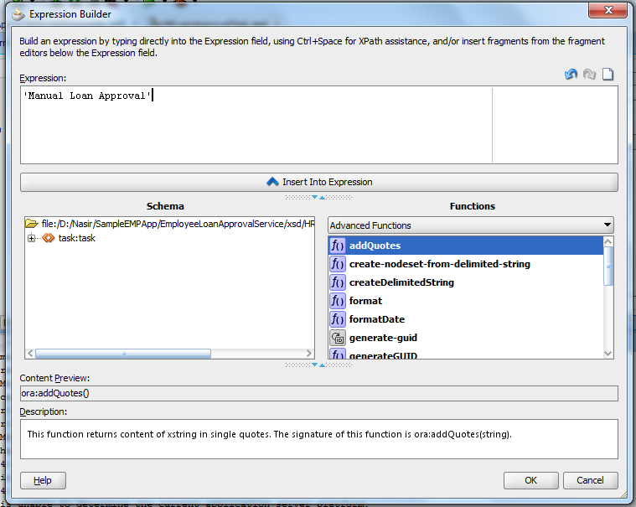

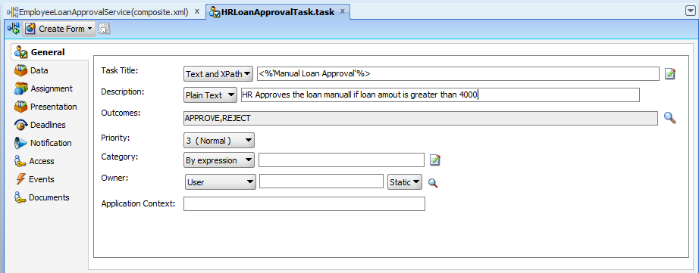

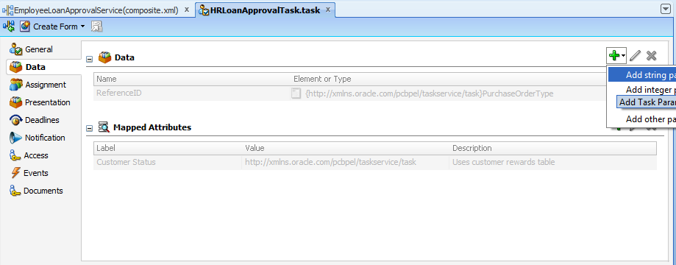

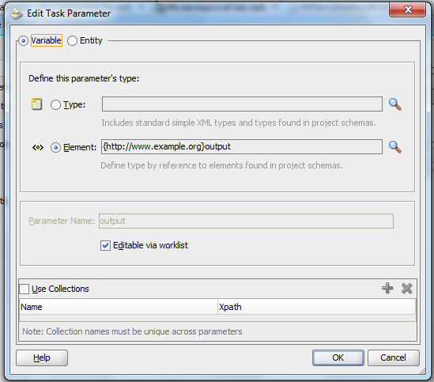

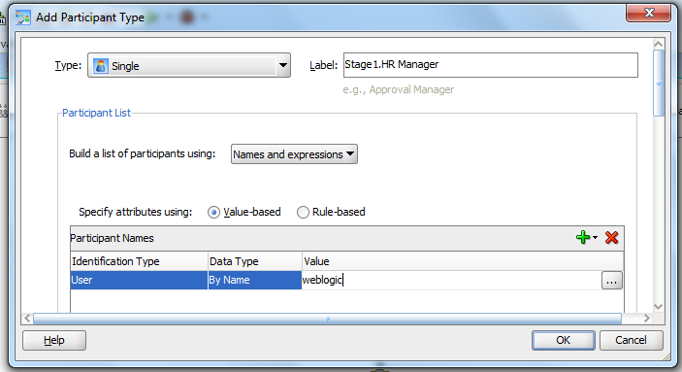

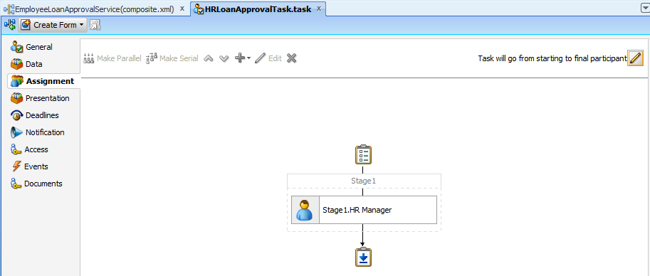

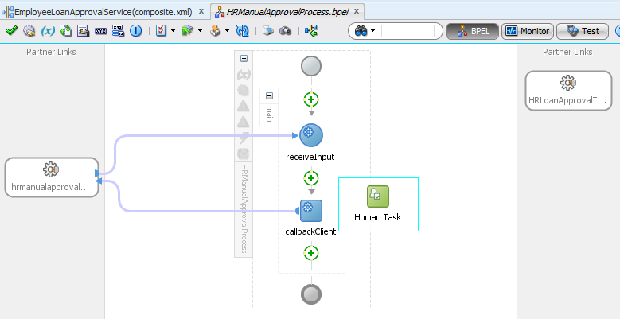

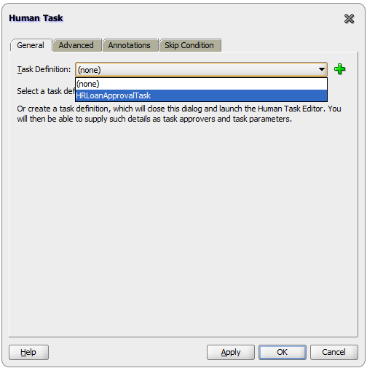

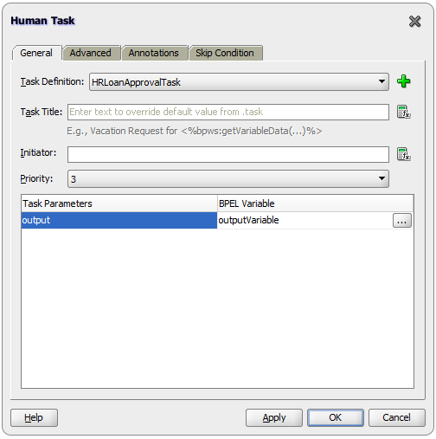

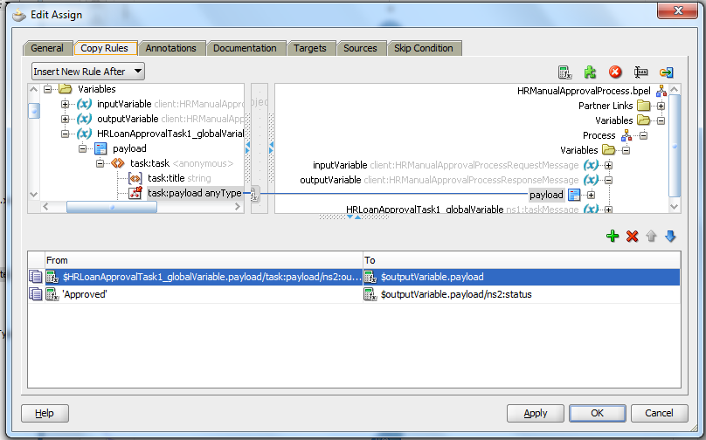

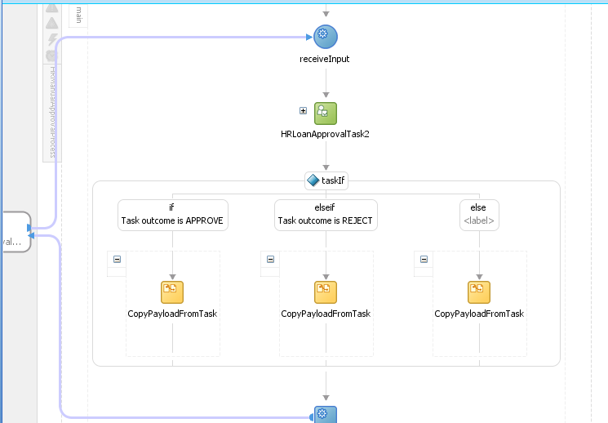

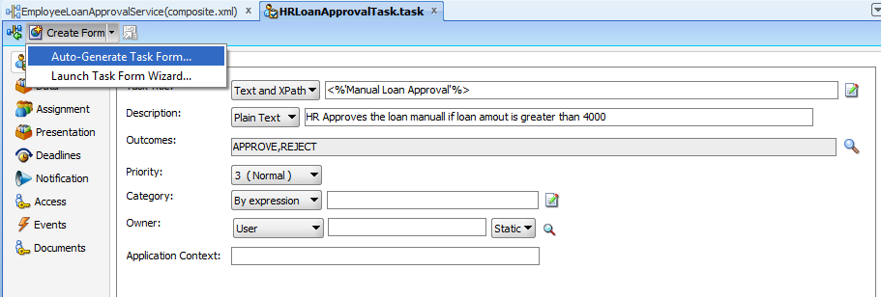

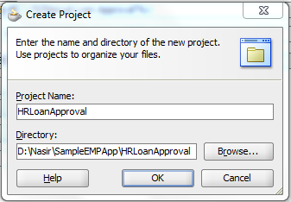

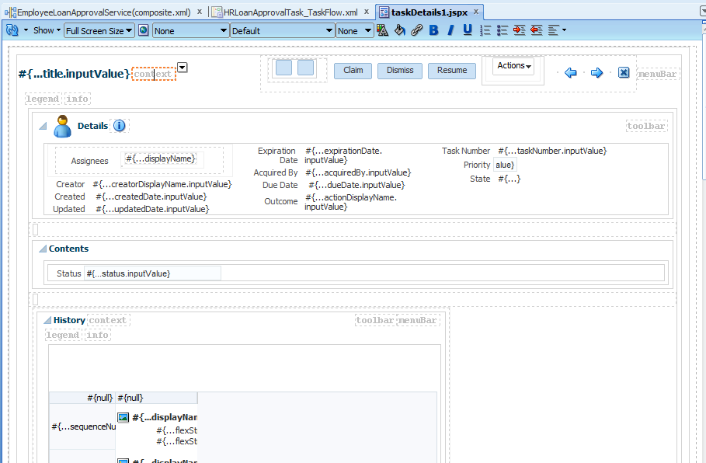

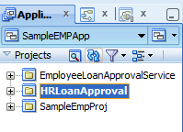

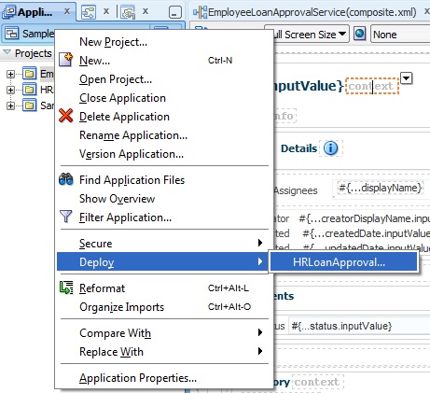

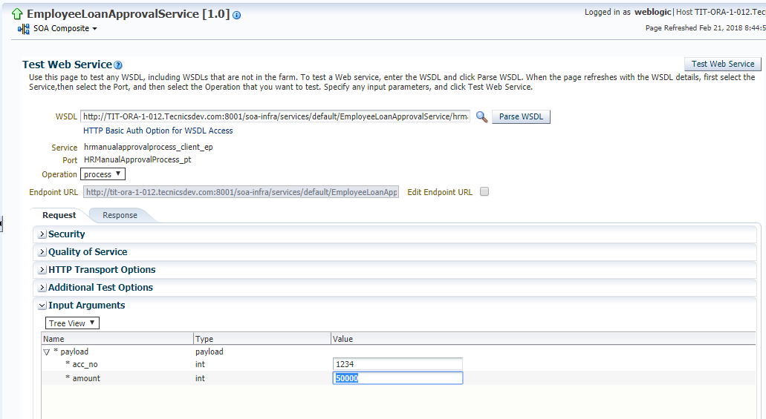

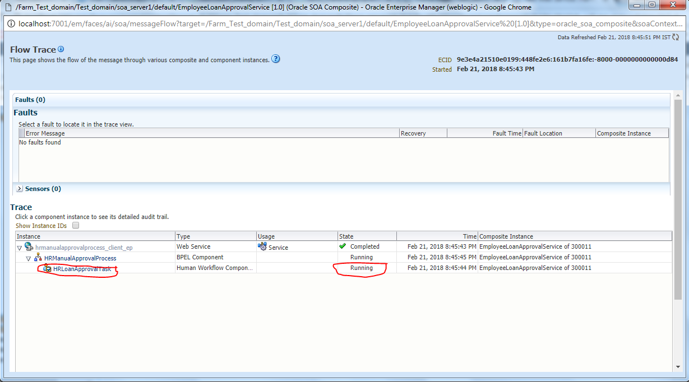

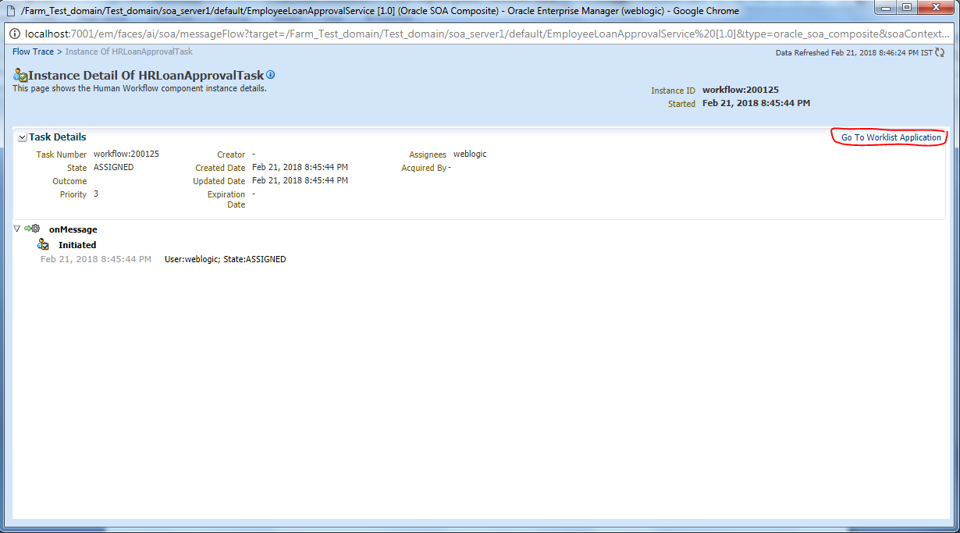

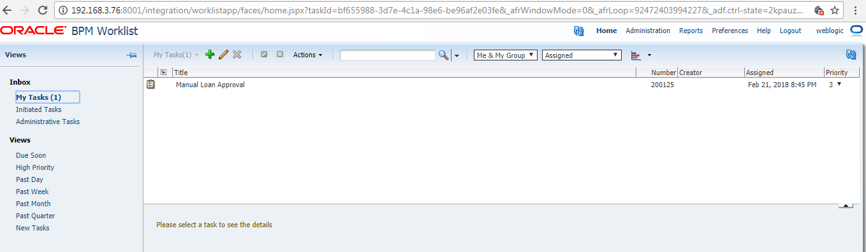

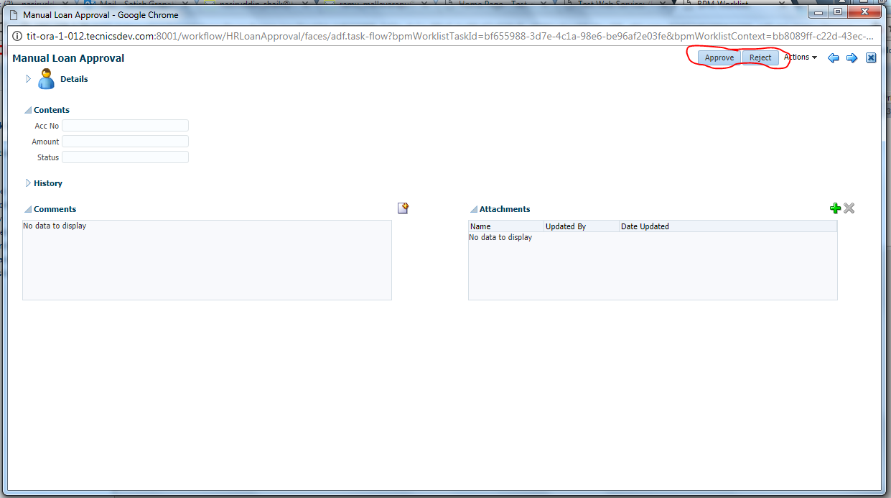

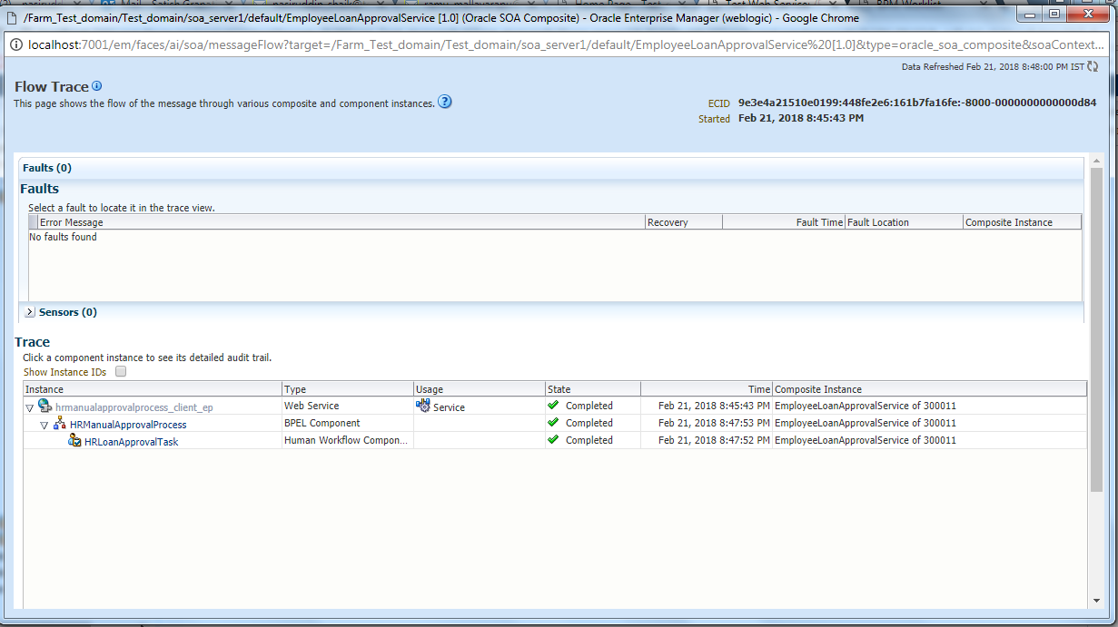

### Use Direct-Binding in BPEL

#### Creating Direct-Binding for synchronous BPEL process

Drag the “Direct Binding” component from component palette.  In create Direct Binding pop-up window, choose type as service and choose service wsdl file and click on ok.

[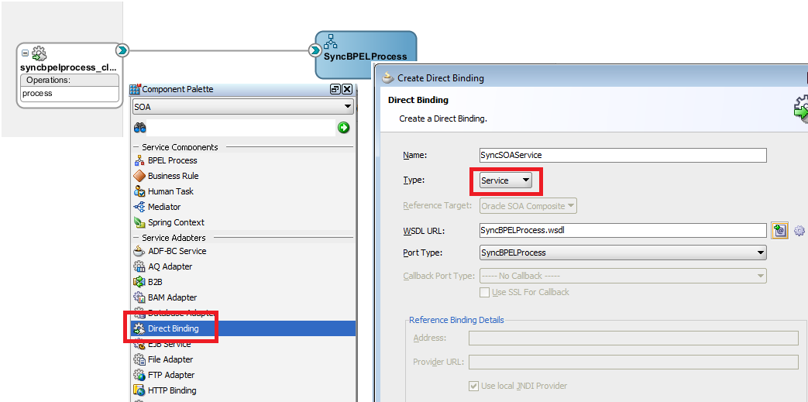](https://2.bp.blogspot.com/-nh_fq9ZB8-Y/VGRQmyu2heI/AAAAAAAAGbs/w8brg8RPdQ8/s1600/OSB_SOA-Direct_Modify_Composite.png)

Now wire the direct binding service reference to already existing wire so now we can invoke the service either by default binding or by direct binding. Your composite should look like below.

[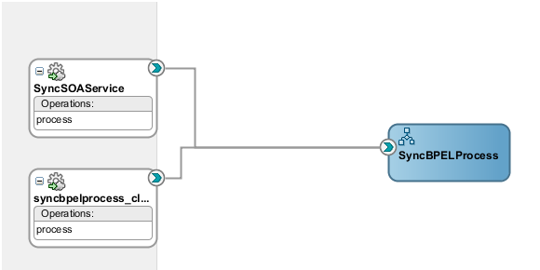](https://3.bp.blogspot.com/-2sM42z4ZvGM/VGRQocNYvpI/AAAAAAAAGcE/4vbPyVNnB_s/s1600/OSB_SOA-Direct_Sync_service_2.png)

Now we will create OSB project from where we invoke above created SOA service using SOA Direct protocol. To invoke the service we need either WSDL URL of that service or WSDL file which we need to import to OSB project.

We can not access direct binding from EM console , so to access that service, open the below URL and select your service.

<http://localhost:8001/soa-infra>

Copy the service endpoint which we will use in later stage.

[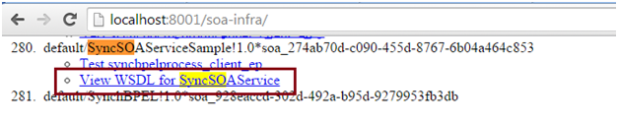](https://2.bp.blogspot.com/-4Tp04Rv5mYw/VGRQpR2EJ8I/AAAAAAAAGcc/Azhvk4BwoFw/s1600/OSB_SOA-Direct_Sync_service_3.png)

### Working with Spring Context

#### Creating the direct Exposed Service from Spring Context

Right click on project and select new.

Go to all technologies and select java.

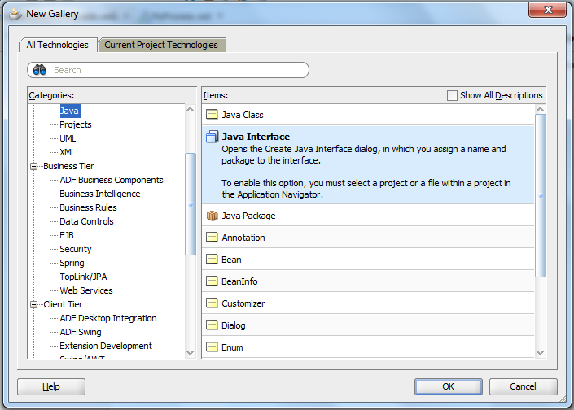

Select Java Interface and give name.

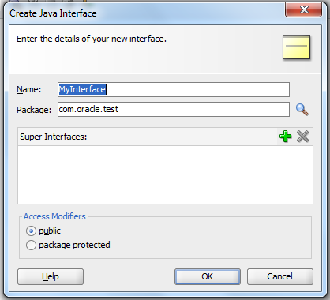

Enter methods you want to create.

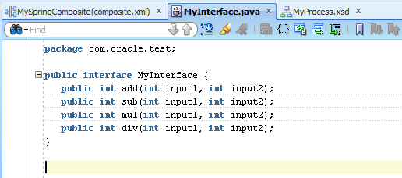

Next select the class from the menu using the same step and click ok.

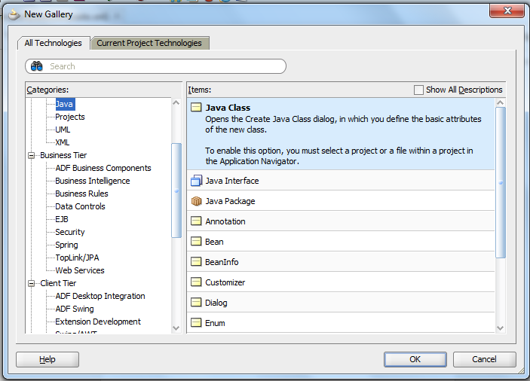

Give the class name and the interface name created in implement.

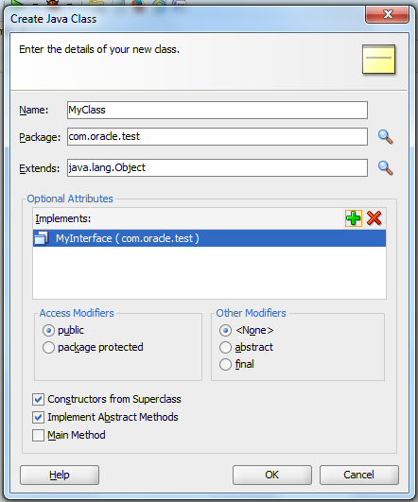

Implement the methods you have created in the class.

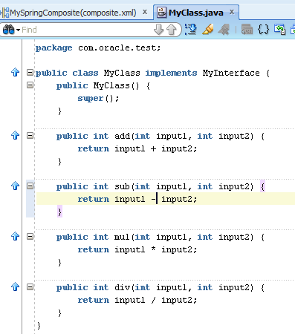

Open Composite.xml file and select the Spring Context in the Component area.

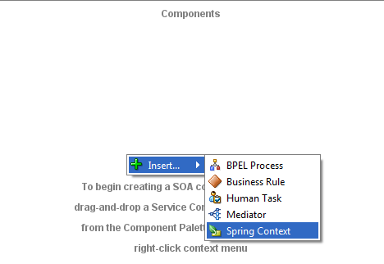

Enter the name and select OK.

Open the spring context and add the bean data.

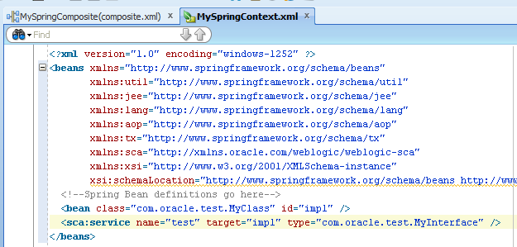

A port is crated on the Spring Context.

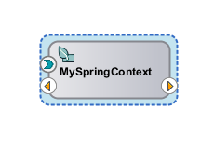

Drag a exposed web service by dragging the service on the Exposed Services pane.

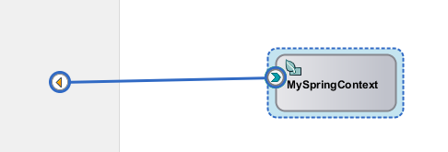

Select Web Service form the Service Type Option.

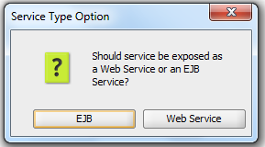

A Web Service is crated and it should be like the below image.

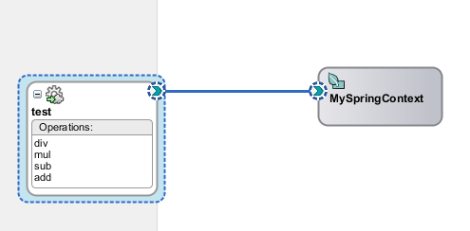

### Create a simple Class and Interface in Spring Context

First, we need to create a new Application by selecting **New**and then **Application** from the **File**menu. Enter a name for the application, I called mine **RedStackSpring**, and select **SOA Application** from the **Application Template** list.  Then click on **Next**.

[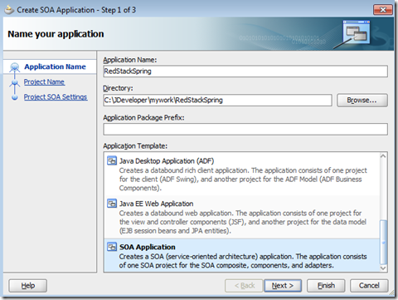](https://redstack.files.wordpress.com/2011/04/image1.png)

Enter a name for your project, I called mine **MySpringComposite**.  Then click on **Next**.

[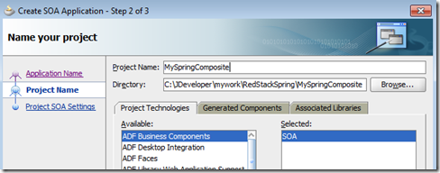](https://redstack.files.wordpress.com/2011/04/image2.png)

For this example, you can go ahead and create an **Empty Composite**.  Click on **Finish** to continue.

[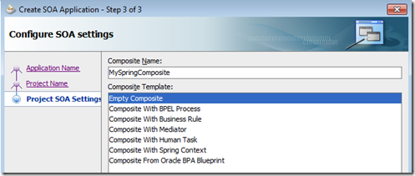](https://redstack.files.wordpress.com/2011/04/image3.png)

Now drag a **BPEL Process** from the palette across to the **Components** area in the middle of your composite and drop it there.

[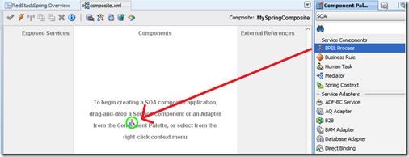](https://redstack.files.wordpress.com/2011/04/image4.png)

In the **Create BPEL Process** wizard, enter a name for your process, I called mine **MyProcess** and select **BPEL 2.0 Specification** (go ahead – you may not have used it yet, may as well try it out now).  If you are using 11.1.1.3, or an earlier version, BPEL 2.0 will not be available.   Leave the **Expose as a SOAP service** box checked and click on **OK** to create your process.

[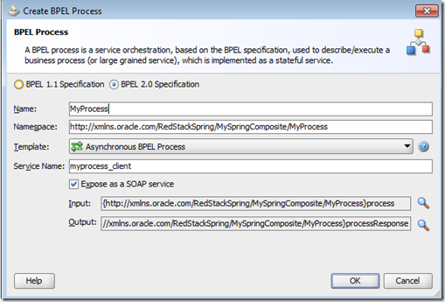](https://redstack.files.wordpress.com/2011/04/image5.png)

Next, we want to drag a **Spring Context** into the composite.  In the **Create Spring**wizard, enter a name for your component, I called mine **MySpringComponent** and click on **OK**to create it.

[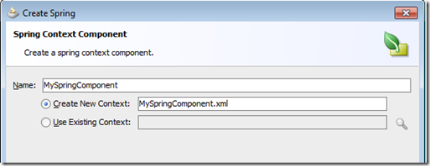](https://redstack.files.wordpress.com/2011/04/image6.png)

Your composite should now look like this:

[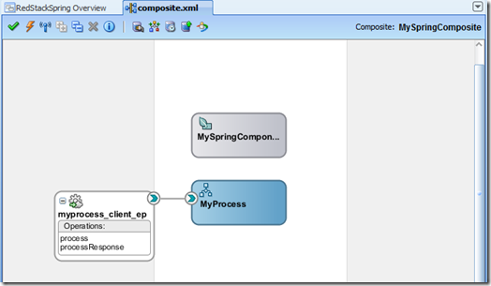](https://redstack.files.wordpress.com/2011/04/image7.png)

Now, let’s create a simple Java class that we can expose through this Spring component.    Select **New** from the **File**menu.  In the **New Gallery**, select **Java Class** from the **General** category.  If you do not see it in the list, you may have to select the **All Technologies** tab at the top first.  Then click on **OK**.

[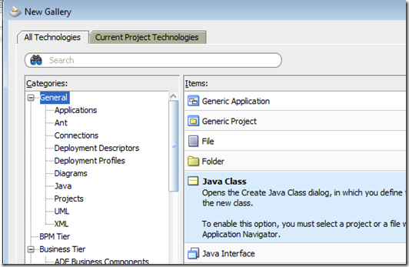](https://redstack.files.wordpress.com/2011/04/image8.png)

Enter a class name and package for your new class, I called mine **com.redstack.MyClass**.  Then click on **OK**.

[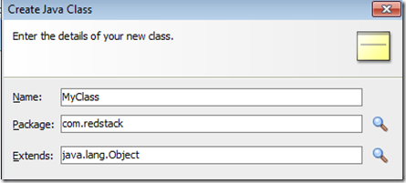](https://redstack.files.wordpress.com/2011/04/image9.png)

For this example, we can just create a really simple class.  Of course, in real life, you can do whatever you like at this point – you can include libraries (JARs) and call whatever APIs you need to.  Here is the simple demo class for this example:

package com.redstack;

public class MyClass implements MyInterface {

  public MyClass() {

    super();

  }

  public String doSomething(String input) {

    return "hello" + input;

  }

}

We will expose the **doSomething()** method to our composite shortly.

We are also going to need an interface, so let’s create that too.  Again, select **New** from the **File** menu, and this time select **Java Interface** from the **General** category.  Give your interface a name, I called mine **com.redstack.MyInterface** and put the following simple code in to it:

package com.redstack;

 public interface MyInterface {

  String doSomething(String input);

}

Now let’s configure the Spring component to invoke this class.  Return to your **composite.xml** and double click on your Spring component to open the **MySpringComponent.xml** configuration file.  There will already be some data in this file.  We need to add a couple of lines to point to our class.  After doing so, your file should look like this:

<?xml version="1.0" encoding="windows-1252" ?>

<beans xmlns="<http://www.springframework.org/schema/beans>"

       xmlns:util="<http://www.springframework.org/schema/util>"

       xmlns:jee="<http://www.springframework.org/schema/jee>"

       xmlns:lang="<http://www.springframework.org/schema/lang>"

       xmlns:aop="<http://www.springframework.org/schema/aop>"

       xmlns:tx="<http://www.springframework.org/schema/tx>"

       xmlns:sca="<http://xmlns.oracle.com/weblogic/weblogic-sca>"

       xmlns:xsi="<http://www.w3.org/2001/XMLSchema-instance>"

       xsi:schemaLocation="<http://www.springframework.org/schema/beans>

<http://www.springframework.org/schema/beans/spring-beans-2.5.xsd>

<http://www.springframework.org/schema/util>

<http://www.springframework.org/schema/util/spring-util-2.5.xsd>

<http://www.springframework.org/schema/aop>

<http://www.springframework.org/schema/aop/spring-aop-2.5.xsd>

<http://www.springframework.org/schema/jee>

<http://www.springframework.org/schema/jee/spring-jee-2.5.xsd>

<http://www.springframework.org/schema/lang>

<http://www.springframework.org/schema/lang/spring-lang-2.5.xsd>

<http://www.springframework.org/schema/tx>

<http://www.springframework.org/schema/tx/spring-tx-2.5.xsd>

<http://www.springframework.org/schema/tool>

<http://www.springframework.org/schema/tool/spring-tool-2.5.xsd>

<http://xmlns.oracle.com/weblogic/weblogic-sca>

         META-INF/weblogic-sca.xsd">

  <!--Spring Bean definitions go here-->

  <bean class="com.redstack.MyClass" id="impl" />

  <sca:service name="test" target="impl" type="com.redstack.MyInterface" />

</beans>

The **bean** entry defines our Java class to the Spring context.  The **sca:service** entry will create an interface on the Spring component that matches the Java interface we have specified.  This interface will show up on the composite diagram so that we can wire the Spring component to our process.  Note that the **target** attribute in the **sca:service** entry points to the bean using its **id** attribute.

Save this file and return to your composite diagram.  You can now draw a wire from the (right hand side of your) BPEL process to the (left hand side of the) Spring component.  If you get any messages about needing to compile your class, or creating WSDL, go ahead and say yes to those.  Your composite should now look like this:

[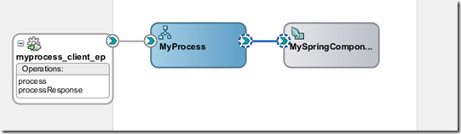](https://redstack.files.wordpress.com/2011/04/image10.png)

Now, let’s put some simple logic in the BPEL process to interact with the Spring component so we can deploy our composite and see it working.  Double click on the BPEL Process to open it.  It should look like this:

[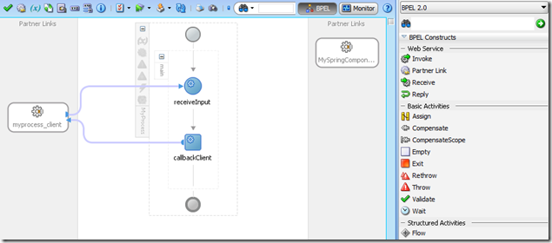](https://redstack.files.wordpress.com/2011/04/image11.png)

Notice that there is a **Partner Link** on the right hand side for the **MySpringComponent** that we just wired to the process.  Now is also a good time to take a look at the palette for BPEL 2.0, if you have not seen it before.  You will notice some new icons, some new names for some familiar activities from BPEL 1.1, and some new things added in BPEL 2.0.

Let’s drag an **Invoke** activity into the process, between the **receiveInput** activity and the **callbackClient**activity:

[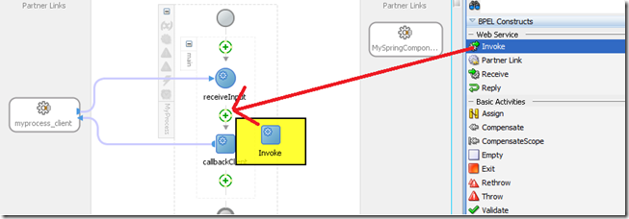](https://redstack.files.wordpress.com/2011/04/image12.png)

Now drag a wire from the right hand side of the invoke to the **MySpringComponent**partner link:

[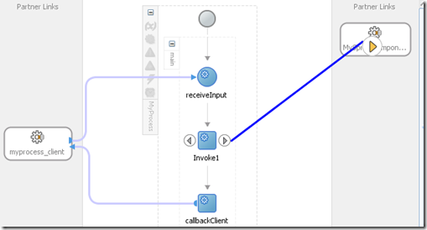](https://redstack.files.wordpress.com/2011/04/image13.png)

Click on the green ‘plus’ sign in the **Input** tab to automatically create an input variable of the correct type.  Then select the **Output** tab and create an output variable the same way.

[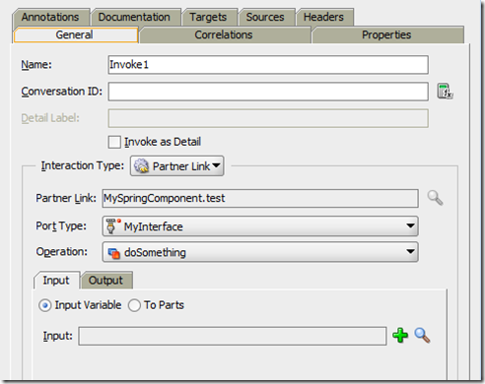](https://redstack.files.wordpress.com/2011/04/image14.png)

You can accept the default names. Then click on **OK**.

Now, let’s add an assign to pass the input of the process to the Spring component. Drag an **Assign** activity between the **receiveInput** activity and the **Invoke** you just created.

[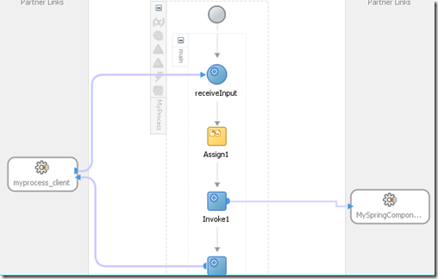](https://redstack.files.wordpress.com/2011/04/image15.png)

**Double click on the assign to open its settings. If you have not used BPEL 2.0 before, welcome to the new Assign editor! Drag a line from the client:input inside the inputVariable on the left, to the arg0 inside your Invoke1_doSomething_InputVariable on the right as shown below. Then click on OK.**

[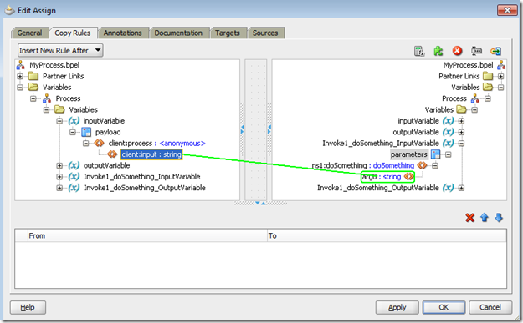](https://redstack.files.wordpress.com/2011/04/image16.png)

Now we are ready to deploy our composite and test it. Select **Save** **All** from the **Filemenu**, then right click on the **MySpringComposite** project and select Deploy and then **MySpringComposite**… from the popup menu.

### Token Configurations in Oracle SOA Suite PS6 ( 11.1.1.7.0)

Oracle Soa Suite PatchSet 6 or 11.1.1.7.0  now has support for Token configurations which really can help administrators in configuring or overriding external Web Service Reference parameters like the protocol ( http, oramds or https ),  the remote host etc.  
  
Important to know this only works on the location attribute of the binding.ws element of the composite.xml file. But when you use Metadata Service (MDS) and call a Web Service like a Java WS, .Net WS,  OSB or SOA Suite Reference Services then you can use this new feature.   
  
First step is to make all these services in depended of each other.  
  
In this demo I created a workspace with a MDS project which contains some WSDL's with a XML Schema. This WSDL is used in the Helloworld Reference Soa project. Deployed it together with the MDS soa sar and I put the Impl of the Reference WSDL back to the MDS so it can be used in my other main project ( I downloaded it from the EM and changed the xml schema import ).  
  
The main project will call this helloworld reference service and in this project we will use a server name token in the WSDL url ( location attribute of the binding.ws element ).

[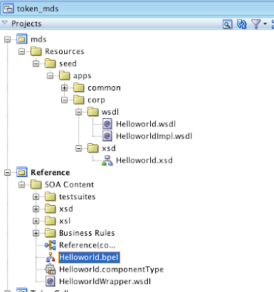](http://2.bp.blogspot.com/-Q5KCcLTZ1Ck/UVs1pP6Qj2I/AAAAAAAAFnc/cgTeV69YswQ/s1600/Screen+Shot+2013-04-02+at+8.06.01+PM.png)

In my main project I added this externel reference web service to my composite by selecting the Reference Impl from the MDS  ( First add a File MDS in the Resource Palette and map this to your local MDS location and finally lookup the WSDL, for compiling you also need to add an extra MDS location to the adf-config.xml )

After adding the reference service, we need to fix some hard references in the composite.xml to this remote service.

Change the location attribute of the composite import to oramds://

Do the same for ui:wsdlLocation attribute of the Reference element.

In the location attribute of the Binding.WS element we need to use the real reference WSDL url ( see the EM for the reference WSDL url  ).

[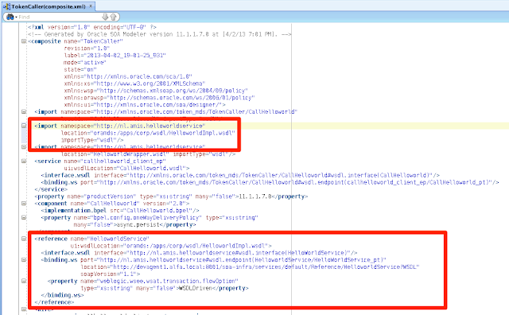](http://4.bp.blogspot.com/-EqNFEAAbNc0/UVs1rtEPLWI/AAAAAAAAFow/xo_0_-nmBZY/s1600/composite.png)

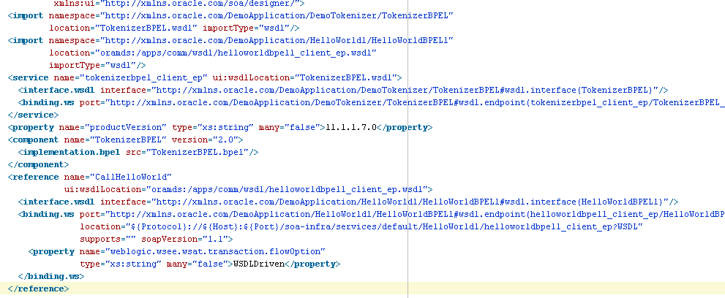

Do the same for the Reference Wrapper WSDL

[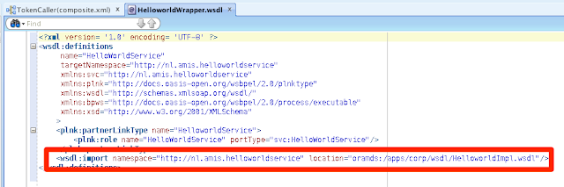](http://4.bp.blogspot.com/-s6HasKjtNIw/UVs1r-afxyI/AAAAAAAAFo8/kmg25P9awCM/s1600/wrapper.png)

Now our main Soa Suite project only needs this reference service at runtime and we won't have any deployment issues or invalid composites after a reboot of the Soa Suite Service.

Next step is to create a Token file which contains some server host entries, we can use this file in the JDeveloper Token wizard or later when we want to import these Tokens in the Oracle Enterprise Manager.  See this url for an Token xml example <http://docs.oracle.com/cd/E28280_01/dev.1111/e10224/sca_bindingcomps.htm#CIHFJFJC>

I added two host key values entries

[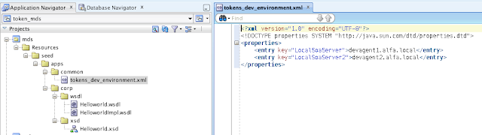](http://4.bp.blogspot.com/-8feoUaNCqeQ/UVs1rNhwNNI/AAAAAAAAFoY/byTkbWLgSUI/s1600/Screen+Shot+2013-04-02+at+9.03.47+PM.png)

Click the token button of the composite.xml editor.

[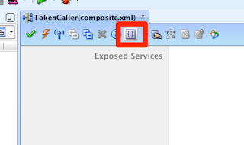](http://2.bp.blogspot.com/-DO2NDydjKPg/UVs1rpqpqGI/AAAAAAAAFo0/mpf5tlzw1B4/s1600/tokenizer.png)

Select our reference service and click on edit.  
Lookup the just created Token file and on the Host field we can lookup our LocalSoaServer entry.

[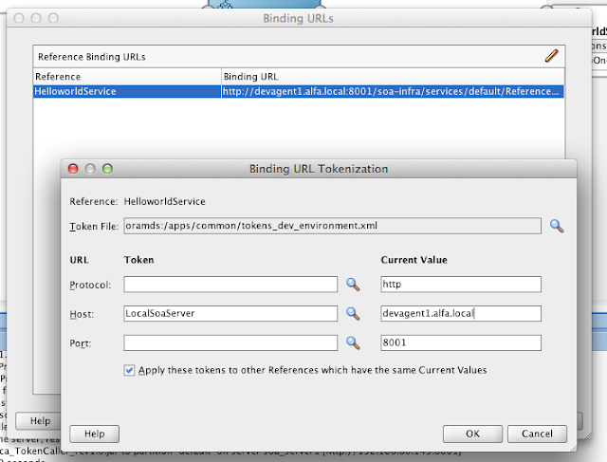](http://3.bp.blogspot.com/-4YxtVbXWs2w/UVs1qaYJj9I/AAAAAAAAFoQ/Exfr-YyjGgo/s1600/Screen+Shot+2013-04-02+at+8.36.39+PM.png)

This will change the location attribute to http://${LocalSoaServer}:8001.....

[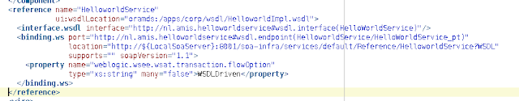](http://1.bp.blogspot.com/-Y2Avj8SIGXo/UVs1pvC1LgI/AAAAAAAAFno/a4l-vgBSqcY/s1600/Screen+Shot+2013-04-02+at+8.19.15+PM.png)

We are ready to compile the project.  
  
The Soa Suite server does not know this LocalSoaServer token so we need to create this token in the Enterprise Manager.  
  
Go to SOA Infrastructure -> SOA Administration -> Token Configurations.

[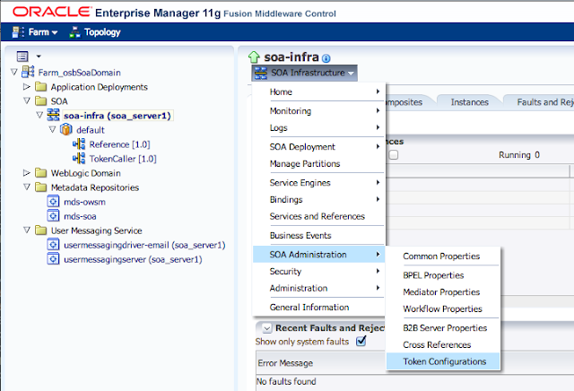](http://1.bp.blogspot.com/-8gVgFi_Itf4/UVs1ppvk6iI/AAAAAAAAFnw/Q0OpiknlmaM/s1600/Screen+Shot+2013-04-02+at+8.20.09+PM.png)

Click on Modify Configuration File and add a new token.

[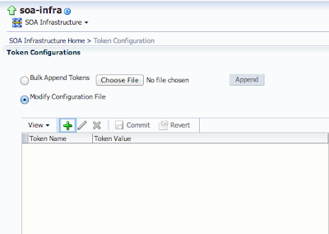](http://3.bp.blogspot.com/-4poN63tnOvM/UVs1p9MIxOI/AAAAAAAAFn4/fm-ld70bVv4/s1600/Screen+Shot+2013-04-02+at+8.20.40+PM.png)

Add the LocalSoaServer Token with its value.

[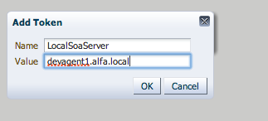](http://4.bp.blogspot.com/-6UnpN548yOU/UVs1qP0VKzI/AAAAAAAAFoA/k4Sct8LdqfI/s1600/Screen+Shot+2013-04-02+at+8.21.16+PM.png)

Commit this token.

[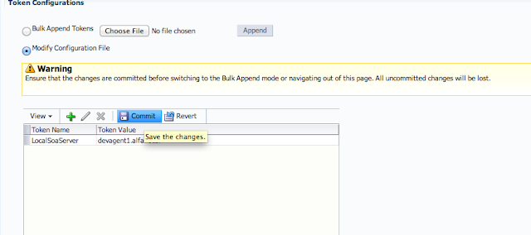](http://2.bp.blogspot.com/-6VlTdjMWE1w/UVs1qEWAKSI/AAAAAAAAFn8/gksYHiXVLMs/s1600/Screen+Shot+2013-04-02+at+8.21.31+PM.png)

 This will update the mdm-url-resolver.xml file located in the config/fmwconfig folder of the weblogic soa domain.

[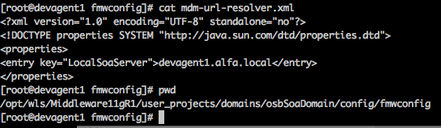](http://2.bp.blogspot.com/-D6RIzG-V6ro/UVs1qh9f7TI/AAAAAAAAFoM/BBDfgWFxNew/s1600/Screen+Shot+2013-04-02+at+8.50.20+PM.png)

 We can also upload the Token file of JDeveloper, this will add the missing tokens.

[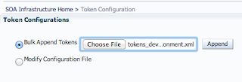](http://3.bp.blogspot.com/-obEry9gFPhI/UVs1rNTUyUI/AAAAAAAAFoc/Ere-DBI9a2c/s1600/Screen+Shot+2013-04-02+at+9.12.02+PM.png)

[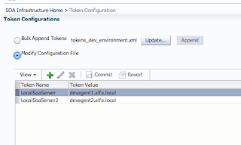](http://1.bp.blogspot.com/-XnpJuLJeZko/UVs1rAzVdEI/AAAAAAAAFog/2unSfN_D41w/s1600/Screen+Shot+2013-04-02+at+9.12.19+PM.png)

You need to reboot the Soa Server, after this you can deploy the main project and test the main project.

### Security

### Securing Composites and Calling Secure Web Services

#### Restricting a composite with HTTP Basic Security

1. Open the Configure SOA WS Policies dialog.

In the composite, right-click on the service you wish to protect and choose the

Configure WS Policies... option.

This will bring up the Configure WS Policies dialog:

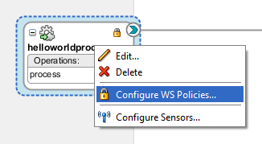

1. Add an HTTP authentication policy.

Click on the plus ( ) icon next to Security to bring up the Select Server Security

Policies dialog. Choose oracle/wss_http_token_service_policy and click on OK.

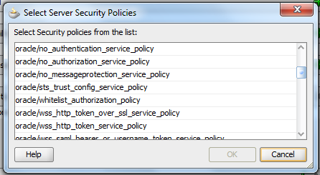

1. Confirm that the policy is attached.

Verify that the selected policy appears in the Security section of the dialog box and

select OK.



1. Deploy and test the composite.

The composite can now be deployed and the test screen can be used to verify that the service cannot be called without providing a valid username and password recognized by the WebLogic domain. Go to the **Test Web Service** screen and test the service endpoint without providing the credentials. You should get a **Webservice invocation failed** dialog box. Expand the **Show Additional Trace Information** link to see the full error. Note that there is a Bad **response: 403 Forbidden** message indicating that access to the page has been denied:

Close the dialog and expand the **Security** section of the **Test Web Service page**. Select the HTTP **basic Auth** radio button and provide the **Username** and **Password** of the user in the WebLogic domain. Then submit the request.

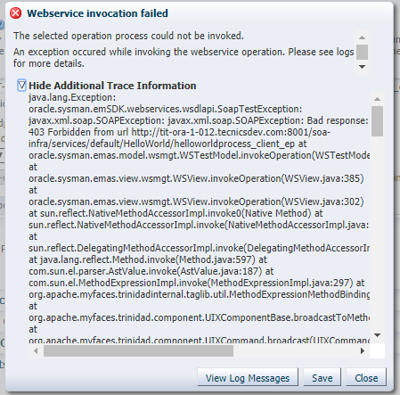

Close the dialog and expand the Security section of the Test Web Service page. Select the HTTP basic Auth radio button and provide the Username and Password of the user in the WebLogic domain. Then submit the request.

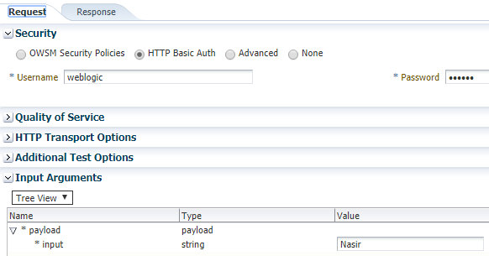

In the SOAP UI add the username and password in properties.

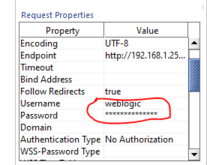

**Note**, that the policy **oracle/wss_http_token_service_policy** that we used has a particular name structure:

* **oracle**/ identifies it as a built-in, Oracle-provided, policy.
* **wss** identifies it as associated with web service security.
* **http** tells us that the policy is based on HTTP transport properties.
* **token** means that there is some kind of credential being passed.
* **service** tells us that the policy is restricted to service endpoints and cannot be used with references. There are usually corresponding client policies that request WSM to inject credentials into a request made through a reference.

#### Securing Oracle SOA/OSB services with OWSM Policies

**Attaching Policies to Policy Subjects**

There are two points in the lifecycle of an application in which you can attach policies: at design time and post deployment.

* At design time, you can attach OWSM policies to applications programmatically. You typically do this using your favorite IDE, such as Oracle JDeveloper. Oracle JDeveloper automates ADF and SOA client policy attachment.
* Post-deployment, you can attach OWSM policies to Oracle Infrastructure web Services, RESTful web services, and Java EE web services using Oracle Enterprise Manager Fusion Middleware Control or WLST. This provides the most power and flexibility because it moves web service security to the control of the security administrator. Polices can be attached directly to an endpoint, or globally to a range of endpoints using policy sets.

**Direct Policy Attachment**

After the application is deployed, you can attach OWSM policies directly to policy subjects, such as SOAP web service and client endpoints and RESTful resources and clients.

**Global Policy Attachments Using Policy Sets**

A policy set, which can contain multiple policy references, is an abstract representation that provides a means to attach policies globally to a range of endpoints of the same type, regardless of the deployment state. You can create and manage policy sets using both Fusion Middleware Control and the WebLogic Scripting Tool, WLST.

### Change DB JNDI dynamically in SOA 11g

Let’s take one simple example , we want to retrieve data from employees table of HR schema based on employee_id.For that I created a datasource and outbound connection factory in database adapter.I passed on the newly created JNDI name in adapter .jca file accordingly and deployed.It ran successfully.

But my requirement is to pass on the JNDI name dynamically from descriptor, means if the destination database change then user can change the JNDI name from soa preference of deployed process, no need for redeployment. Here are some simple steps to achieve that,

Say like below you created your composite,

[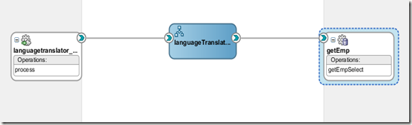](https://lh4.ggpht.com/__uBBiZbr6Ck/TZntrqVwzJI/AAAAAAAAASY/z9FNImvy0GI/s1600-h/image%5b3%5d.png)

In composite.xml for the BPEL process I created one preference say,jndiVar like,

[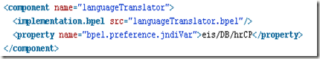](https://lh5.ggpht.com/__uBBiZbr6Ck/TZnts7Jo2UI/AAAAAAAAASg/dm8MC-lfRjI/s1600-h/image%5b13%5d.png)

Here is my BPEL flow outline,

[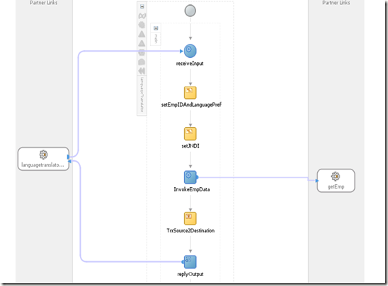](https://lh5.ggpht.com/__uBBiZbr6Ck/TZntuY-GF2I/AAAAAAAAASo/NAqRt7Ddnwo/s1600-h/image%5b18%5d.png)

At setJNDI I’m assigning preference value to a process variable,

[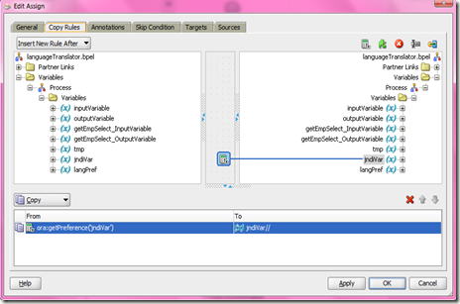](https://lh5.ggpht.com/__uBBiZbr6Ck/TZntwAmPP-I/AAAAAAAAASw/evzF_HF9bhQ/s1600-h/image%5b22%5d.png)

Then after creating the adapter go to the BPEL source and add

<bpelx:inputProperty name="jca.jndi" variable="jndiVar"/> as below,

[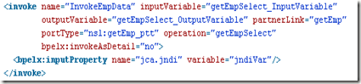](https://lh3.ggpht.com/__uBBiZbr6Ck/TZntxpwnHLI/AAAAAAAAAS4/PFExTQdnKhs/s1600-h/image%5b26%5d.png)

Then deploy the process and change your preference value accordingly to point to right JNDI as below,

Farm_soa_domain > Weblogic Domain > soa_domain > right mouseclick and select ‘System MBean Browser’.

[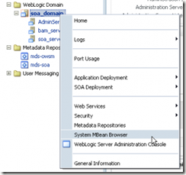](https://lh3.ggpht.com/__uBBiZbr6Ck/TZntzOEtUNI/AAAAAAAAATA/UsBCf9e0Ss0/s1600-h/image%5b29%5d.png)

Navigate to Application Defined MBeans > oracle.soa.config > Server : soa_server1 > SCAComposite > your_project > SCAComposite.SCAComponent > your bpel_process.  
Select the Attribute ‘Properties’.

[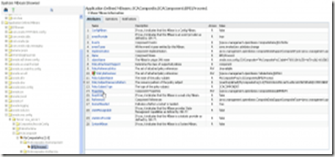](https://lh5.ggpht.com/__uBBiZbr6Ck/TZnt0s3dC8I/AAAAAAAAATI/SvWZmYN3CmI/s1600-h/image%5b35%5d.png)

Change the value of our preference,set JNDI accordingly and click apply.

[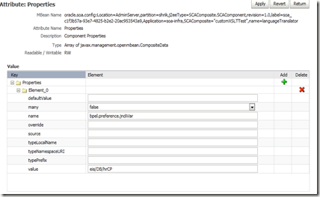](https://lh6.ggpht.com/__uBBiZbr6Ck/TZnt2MIAsDI/AAAAAAAAATQ/HMRoPqsS6x8/s1600-h/image%5b39%5d.png)

Thats all your adapter will retrieve the data using new JNDI, obviously that JNDI should be defined in weblogic.

# Oracle Service bus

Re-usability is one of the fundamental concepts of SOA, which can lead to cost benefit. The service has to be well designed and exposed through a generic-enough interface. There may be many applications that have designed by keeping a little re-use in mind. It is not a good idea to reengineer all your applications for reuse. But we can achieve this by virtualization layer that can map arcane interfaces to more re-usable ones, as well as expose them over more standard protocols (SOAP or REST, for instance) than what they natively exposed.

Another problem is that the business requirements change as the business requirements evolves. A simple change in the application can lead to the effect on all the clients who are using the application. That’s why we required an intermediate layer which can deliver agility for the rapid changing business requirements.

The key element to build this virtualization layer is a service bus, coupled to a service registry and repository to ensure governance and discoverability.

### What is Bus?

The service bus decouples the different components of a service in the form of asynchronous events like topic in publish/subscribe pattern that allows every part to be decoupled from the other part and we do not need to span transactions or hold connections between the internal components that would ultimately cause a degradation in the performance of the system.

### Resources in Oracle Service Bus

 In Oracle Service Bus world, all the artifacts are called the OSB resources. In a typical SOA environment, there will be a need to share the different resources across the projects. The resources can be anything like WSDLs, XSDs, Proxy, Business service etc..

We cannot create all kinds of resources in the OSB Configuration Project. For example creating WSDL or XSD in configuration project will give the error. We can only create the Global Resources like Proxy Server, JNDI Provider and SMTP Server. All these resources that can be created in the OSB Configuration Project can be accessed from different OSB projects present in the Configuration Project.

### Proxy Services and Business Services

Oracle Service Bus provides intelligent message brokering between business services (such as enterprise services and databases) and service clients (such as presentation applications or other business services) through proxy services that you can configure using Oracle Service Bus Console. Proxy services are Oracle Service Bus definitions of intermediary Web services that Oracle Service Bus implements locally on WebLogic Server. With Oracle Service Bus message brokering, service clients exchange messages with an intermediary proxy service rather than working directly with a business service.

Oracle Service Bus allows you to implement proxy services independently and configure them dynamically, as driven by your business needs without requiring costly infrastructure development efforts. The configuration functions are separated from the management functions in Oracle Service Bus Console. A proxy service can route messages to multiple business services; you can choose to configure a proxy service with an interface that is independent of the business services with which the proxy service communicates. In such cases, you can configure a message flow definition to route a message to the appropriate business service and map the message data into the format required by the business service’s interface.

### Message Flows and Pipelines

In Oracle Service Bus, a message flow is the implementation of a proxy service. You configure the logic for the manipulation of messages using proxy service message flow definitions. This logic includes such activities as transformation, publishing, and reporting, which are implemented as individual actions within the stages of a pipeline.

Pipelines are one-way processing paths that include no branching. A pipeline is a named sequence of stages containing actions, representing a non-branching one-way processing path. It is used to specify the message flow for service requests and responses.

### Pipeline Pairs

Pipeline pairs are request and response pipelines. The request pipeline definition specifies the actions that Oracle Service Bus performs on request messages to the proxy service before invoking a business service or another proxy service. The response pipeline definition specifies the processing that Oracle Service Bus performs on responses from the business or proxy service that the proxy service invokes before returning a response to a client.

Each pipeline consists of a sequence of stages, each stage containing actions. However, a single service-level request pipeline might optionally branch out into operational pipelines (you can configure one default operational pipeline at most one per operation). The determination of the operation is done through user-selected criteria. The response processing starts with the relevant operation pipeline which then joins into a single service-level response pipeline.

### OSB Components

### OSB Tasks

#### Creating the project and importing resources

If not already running, start the OSB Examples Server from the start menu. If not already running, start your SOA server.

1. Log into OSB Web Console (http://localhost:7021/sbconsole) with username as weblogic and password as weblogic.
2. Click on the **Create** button in the lefthand corner of the screen to start a new session. In OSB, all changes are done in a sandbox called a session. You first create the sandbox by creating a session in the **Change Center**. After a set of related changes is done, you deploy all the changes in the session as a unit by clicking on **Activate** in **Change Center**.

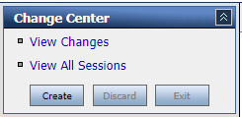

You first need to create a project with sub-folders. You could create it using the console, but instead you will import this to illustrate how configuration can be imported into OSB. If you decide to go directly to the solution, you can import the solution in the same way.

1. Scroll down the lefthand pane and click on **Project Explorer**.

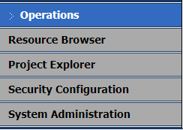

1. Click on **Create** button on action center tab.

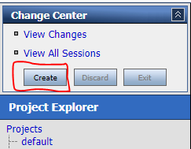

1. Click on **Projects** in projects explorer and then enter the project name you want to create. Click on **Add Project** button.

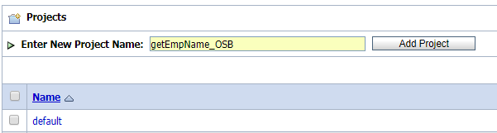

1. Project has been created in the Project Explorer. Click on the project to add the project resources.

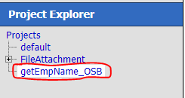

1. Give the folder name as **BusinessService** and click on the Add Folder button.
2. Repeat the above step and add **ProxyService** and **Resources** folders.

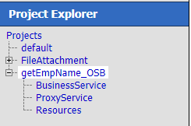

1. Click on the **Resources** folder and then select **Resources from URL** in create resource.

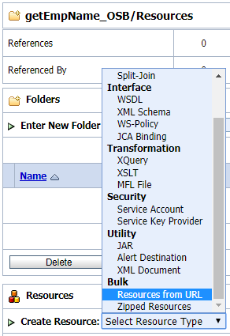

1. Enter the WSDL file url of the project we want to add to OSB. You can select the url from the test of **em**.
2. Enter the resource name.

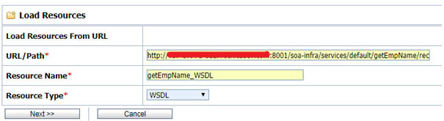

1. Click on next and then click on import.
2. WSDL and corresponding XSD file added. Now you can click on Activate button to activate the changes.
3. Now we have to create a **Business** **Service** based on the WSDL file we have loaded.
4. Now click on **Create** button.
5. Click on **BusinessService** of the project in **Project Explorer**.
6. Select **Business Service** from **Create Resources**.
7. Select WSDL Web Service radio button and click on browse button.
8. Enter the name of the **Business Service**. We can select the WSDL file we have loaded and select ports and then submit.

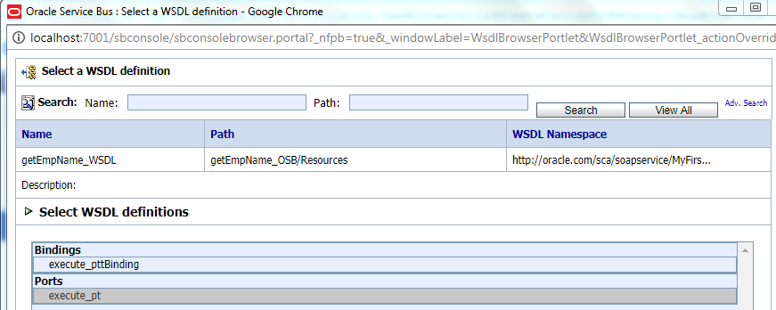

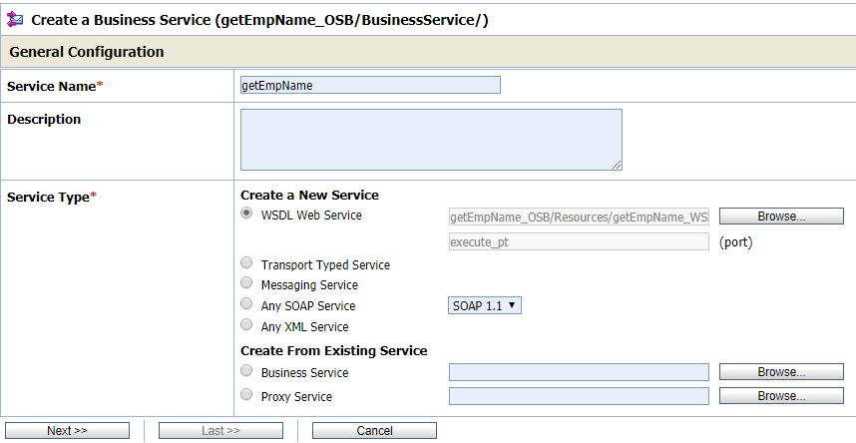

1. Click on next and select default, at last click on save button.
2. Click on **Activate** to activate the changes.



1. To test the **Business** **Service** we have created click on Launch Test Console button. A test console will open. Enter the employee id at input and click on execute button.

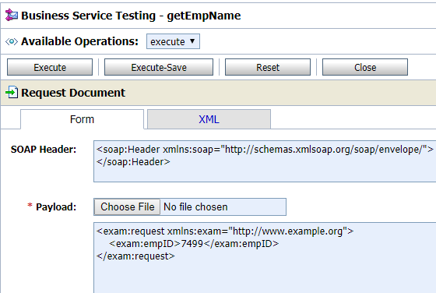

You can able to see the output from the composite we have created.

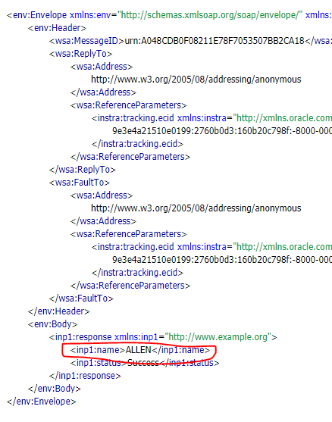

**Configuring the proxy service**

A proxy service is the OSB mediation and virtualization logic that virtualizes the endpoints that OSB routes to and decouples them from the client. You first create a proxy service exposed to the client that just routes to the business service. Later you add more logic in the proxy service.

1. Click on the **Create** button in the **Change Center** to start a new session.
2. Navigate to the **ProxyServices** folder. Click on the **Create Resources** drop-down box and select **Proxy Service**.

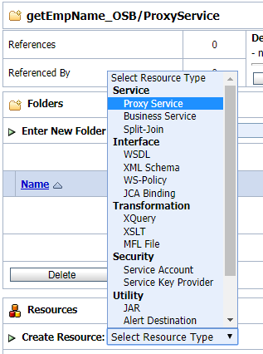

1. On the **General Configuration** page, enter the **Service Name**. Set **Service Type** to WSDL Web service. Click on the **Browse** button, select the WSDL you just imported, select **execute_pt** under **ports**, and click on **Submit**.
2. Click on **Next** through the remaining configuration screens, making note of some of the settings for Proxy. Notice that you can configure security for your services, as well as enable content and attachment streaming.
3. On the **Summary** page, click on the **Save** button at the bottom of page:

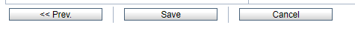

1. Navigate to the newly created Proxy Service through **Project Explorer**.
2. Activate the Changes.
3. Click on the Message Flow icon next to **Proxy Service** name**.** This will take you to the Message Flow editor:

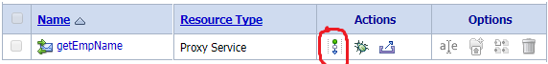

1. Click on the **getEmpName** icon and select **Add Route**.
2. Click on the **RouteNode1** icon and select **Edit Name and Comments**. Change the name to **RouteTo_getEmpName** and click on **Save**.
3. Click on **RouteTo_ getEmpName** and select **Edit Route**.

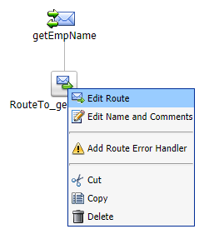

1. Click on **Add an Action**, select **Communication**, and then select **Routing**.

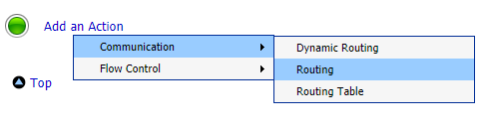

1. Click on **service** link and select **getEmpname** and click on **Submit**.

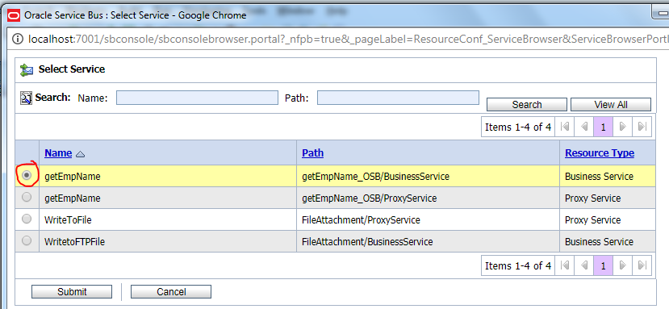

1. Select the **Use Inbound operation for outbound** checkbox. Click on **Save All**.

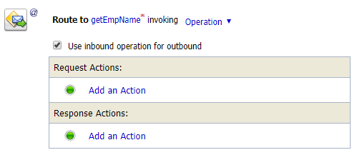

1. Click on **Activate** in the Change Center and Confirm to deploy your changes to the session. You are now ready to test your new Proxy!
2. Navigate to the new Proxy Service and click on the icon to bring up the Test Console.



1. Cut and paste the same XML as in previous step into the **Payload** text box.
2. Click on the **Execute** button. You should see output similar to when you tested your Business Service.

**Auto Generate Proxy Service**

Instead of the previous steps, an alternative way to create the same proxy service is to auto-generate it from the business service. When creating the proxy service, on the General Configuration page, select Create From Existing Service and click on Browse to select the business service you created.

**Configuring Message Flow**

Now that the Proxy Service is created and working, change the message flow to add reporting and input validation.

1. Navigate to the newly created Proxy Service through **Project Explorer**.
2. Click on **Create** to start a new session in **Change Center**.
3. Click on the Message Flow icon next to **getEmpName**. This will take you to the Message Flow editor.

Next you will add some processing steps to the Message Flow.

1. Click on the envelope above **getEmpName**. Select **Add Pipeline Pair**.
2. Click on **Request_Pipeline** to the left and select **Add Stage**. The request pipeline does the processing of the request and the response pipeline does the processing of the response. A pipeline contains a sequence of stages:

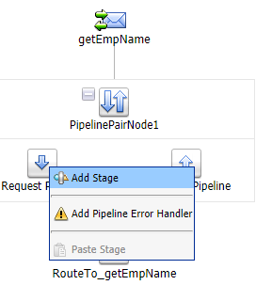

1. Click on the new Stage and select **Edit Stage**.

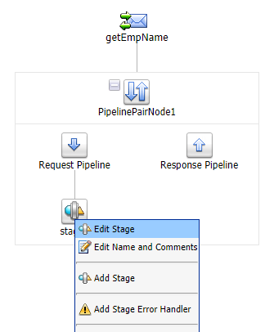

Now we will add two actions: **Report** and **Validate**. The **Report** action allows you to record any payload elements along with key-value pairs to a database. **Validate** allows you to check for valid input (by a schema) to get employee name service and throws an error if an invalid input message is detected.

1. Click on **Add Action | Reporting | Report**.

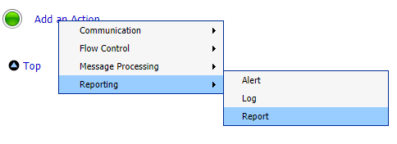

1. Fill in fields as follows:

* **Expression**: **$body**
* **Key Name**: **CCNumber**
* **Key Value**:   [./exam:request](javascript:editExpr('editxpathexpr',%20'submitXpathReport',%20'S0A0',%20'0');) in variable **body**

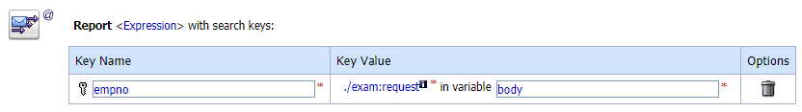

1. Add a **Validate** action.

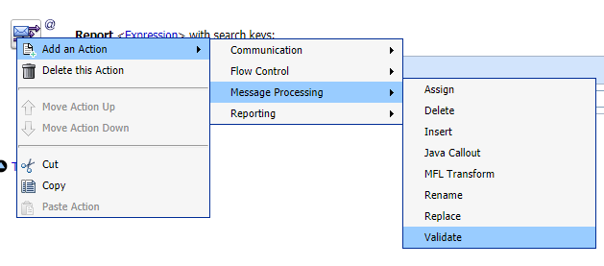

1. Fill in fields as follows:

* **XPath**: **./\*** (dot slash star)
* **variable**: **body**
* **Resource**: **[ Employee ] ( Element = "request" )**

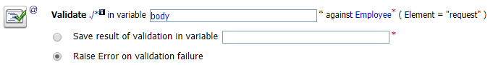

1. Click on the **Save** button.
2. Navigate to the top of the message flow and click on the envelope. Select **Add Service Error Handler**. Click on **Error Handler**. Select **Add Stage**.

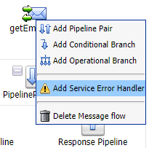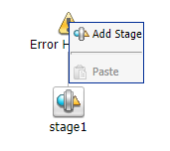

1. Click on the stage and select **Edit Stage**.

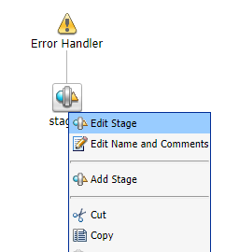

1. Click on **Add an Action | Reporting | Alert**.

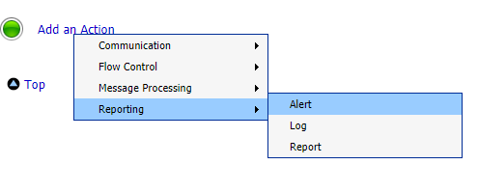

1. Fill in **Alert** as depicted below and click on **Save All**.

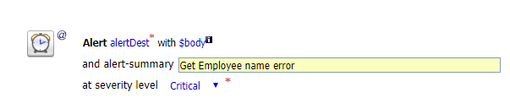

1. **Activate** the session in **Change Center**.

#### Calling asynchronous BPEL Service from OSB by using Direct-Binding

Since we added Direct Binding in comspoite.xml file so you can’t get WSDL and Schema files directly from EM console. To get the WSDL and schema file go to http://host:8001/soa-infra/ login with your credentials and select your deployed service and save WSDL and schema files.

Step 1: Create a new OSB project and import Asynchronous web service WSDL and import as I mentioned in previous post also. See previous Post Step 1 for details steps.

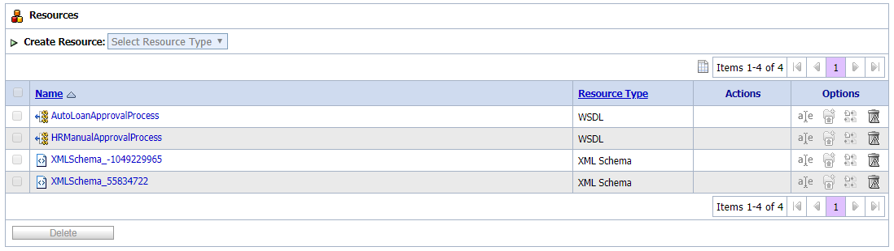

Step 2: Before creating Business service, we require Call Back proxy service that we will use in business service.

* Click on “proxy” folder and choose “Proxy Service” as “Select Resource Type” from Create Drop down list.
* Give it any name and choose “WSDL Web Service” as Service Type. Click on Browse button and select previously imported WSDL file.

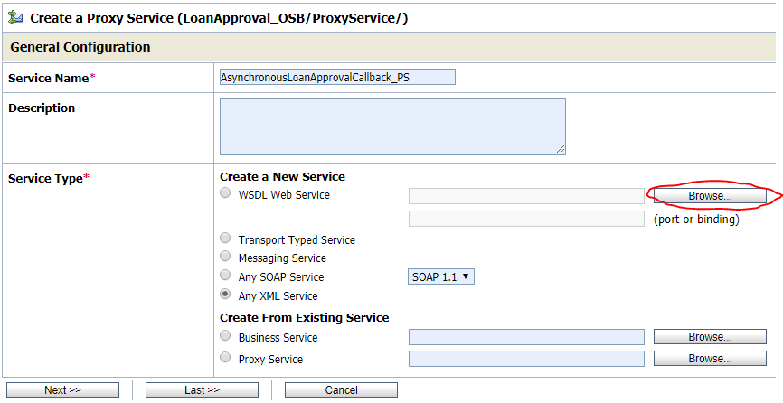

* Choose HRManualApprovalProcessCallbackBinding from Bindings and click Submit. Then click on Next button.

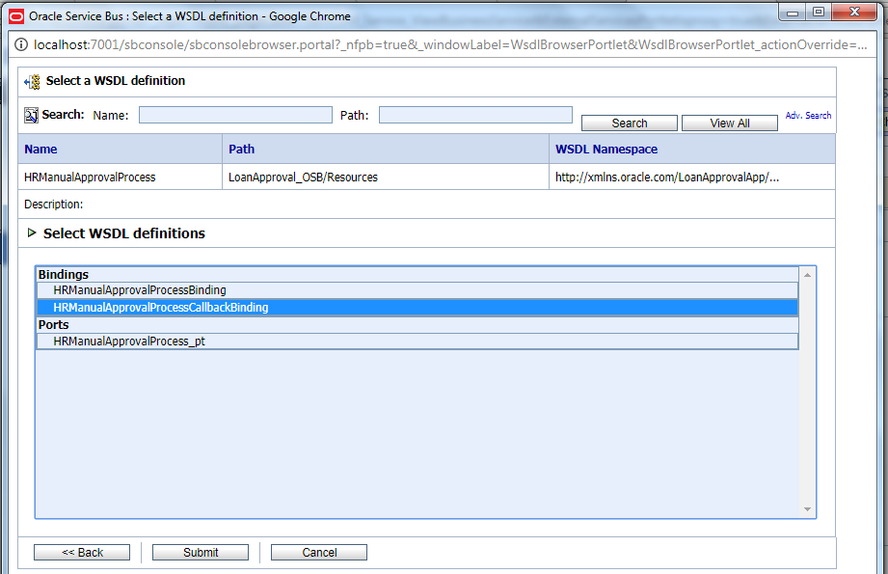

* Choose “sb” protocol and click next.

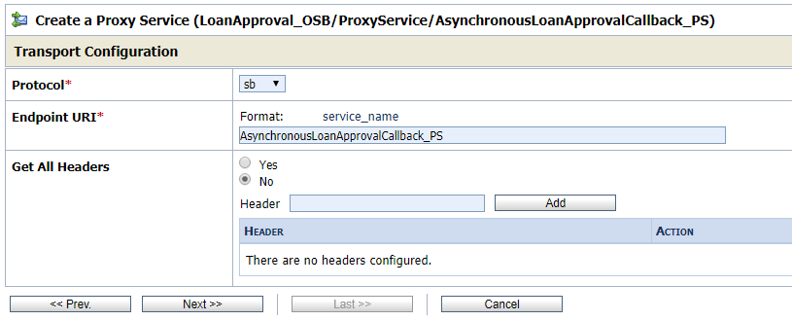

* Accept default values and we have call back proxy service ready. Now we can move to Business service creation.

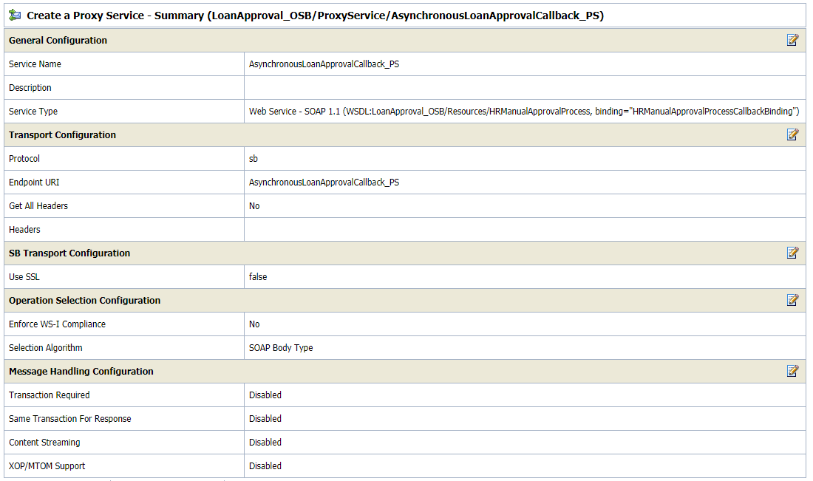

Step 3: In this step we will create Business Service based on Asynchronous web service WSDL file.

* Click on “business” folder and choose “Business Service” as “Select Resource Type” from Create Drop down list.
* Give it any name and choose “WSDL Web Service” as Service Type. Click on Browse button and select previously imported WSDL file.

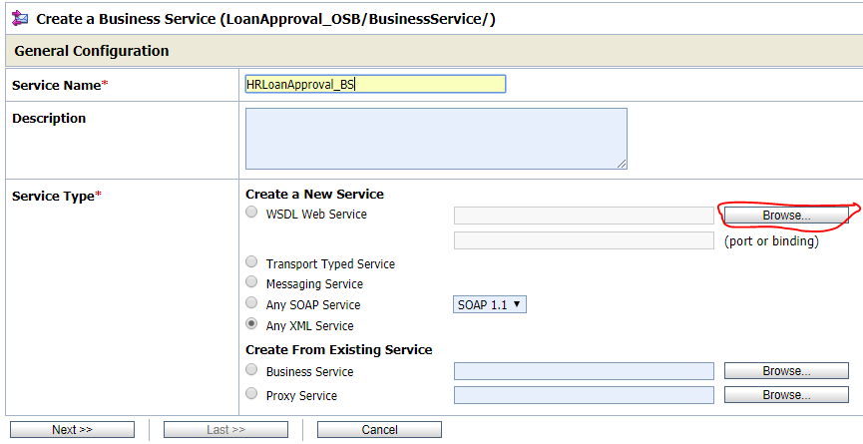

* Select “HRManualApprovalProcessBinding” from WSDL definitions. Click Submit and then go to Next step.

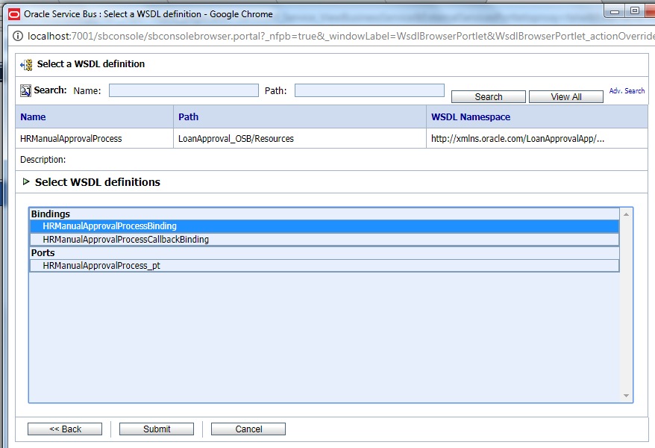

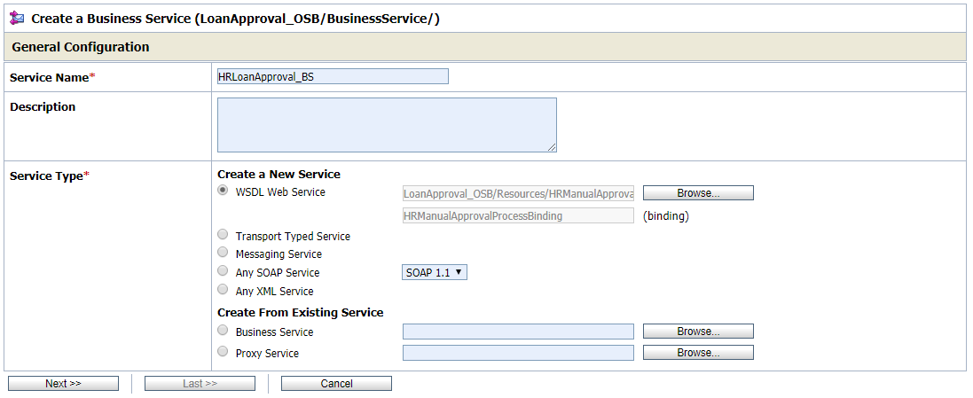

* Choose “soa-direct” protocol and check server host and port in Endpoint URI and click on Add button. Then click on Next button.

You can take "Endpoint URI" from "location" attribute under <Service> tag of AsynchronousComposite Wsdl file.

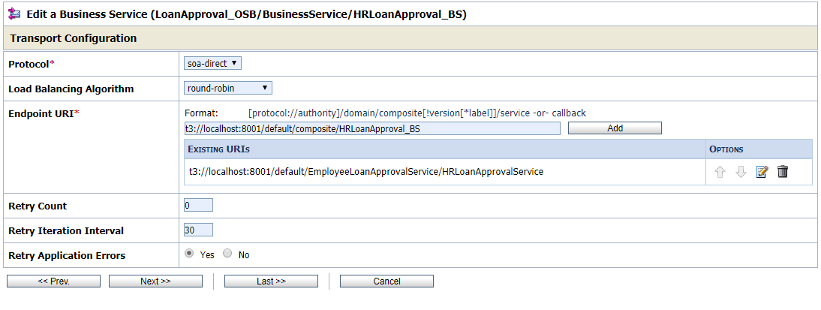

* Select “Asynchronous client” as Role. Then browse for Call Back proxy service and choose previously created Call Back proxy service.

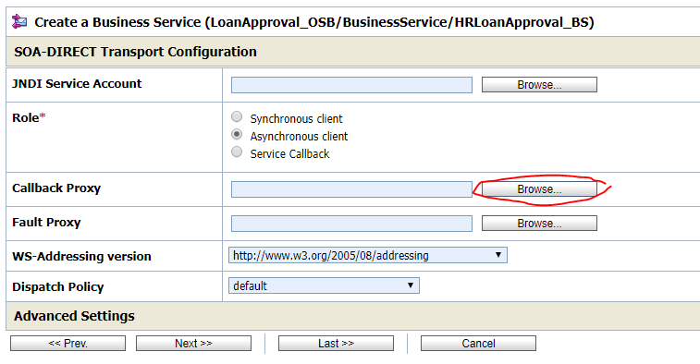

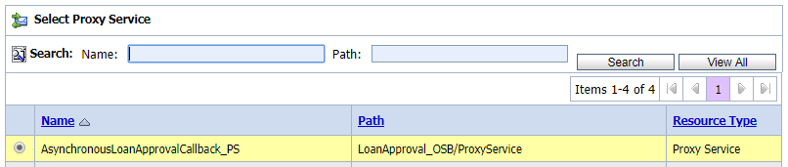

* Accept Default values and you are ready with Business service.

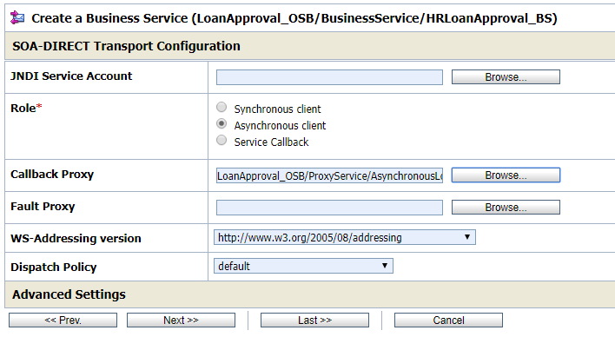

Step 4: Now we will create Proxy service that will invoke Business service that we just created.

* Click on “proxy” folder and choose “Proxy Service” as “Select Resource Type” from Create Drop down list.
* Give it any name and choose “WSDL Web Service” as Service Type. Click on Browse button and select previously asynchronousweb serviceWSDL file.
* Select Direct Binding port. Accept Default values.

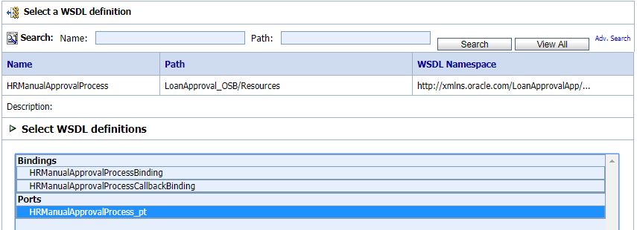

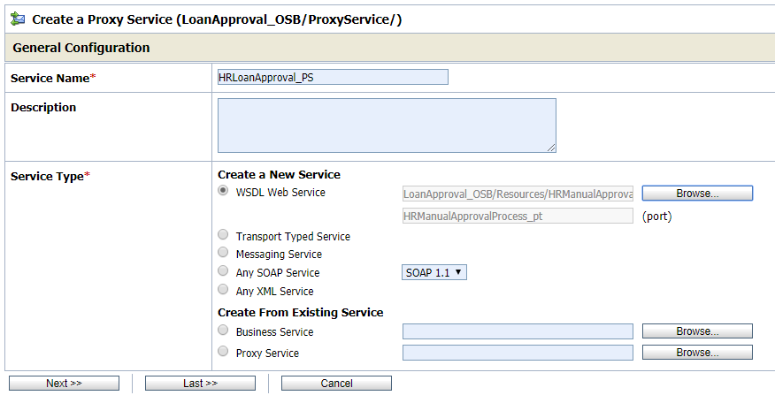

* Now we are ready with Client proxy service.

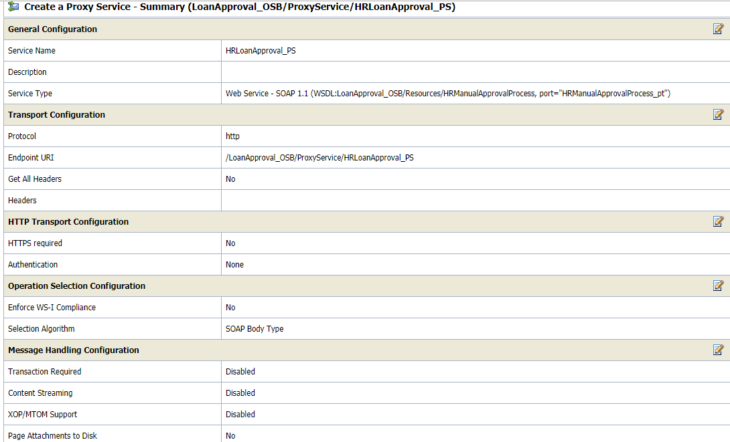

Step 4: Only step remaining is to connect Client proxy service to Business Service.

* Go to Client proxy Service Message flow.

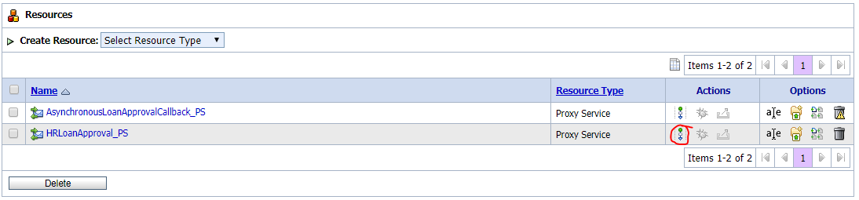

* Add Route Activity to proxy service flow to call Business Service. You can edit the name of the route activity.

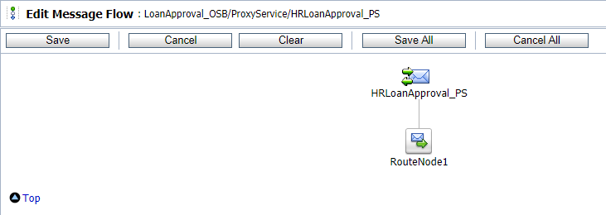

* Now Go to Edit Route.

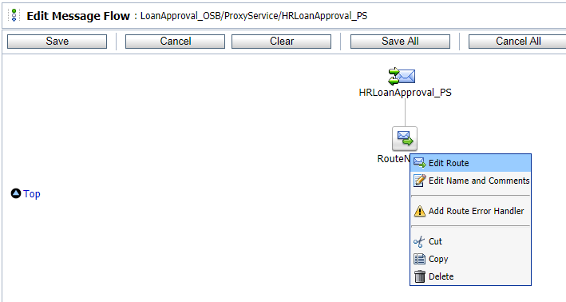

* Add a new Action “Routing” inside Route Node.

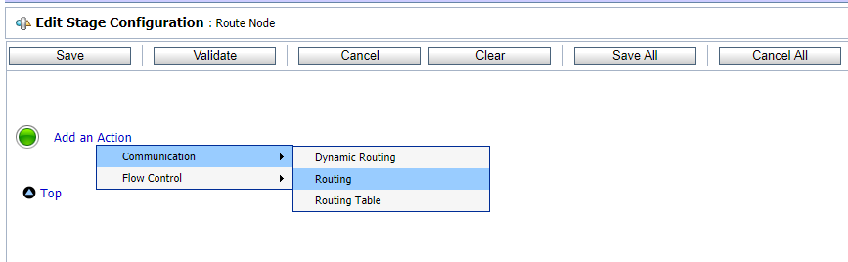

* Choose Business Service. And choose operation for the Business Service.

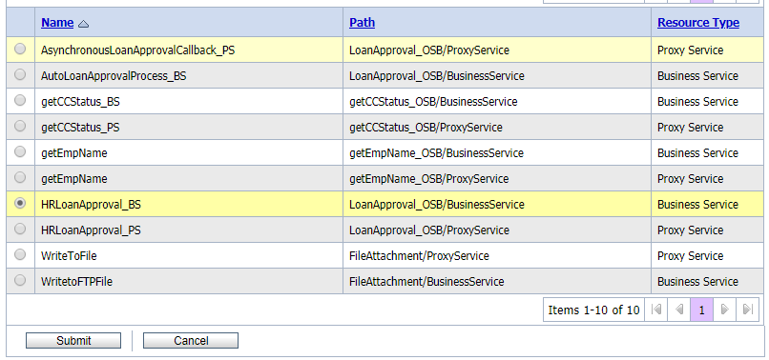

This is it. Now we are ready to test it.

**Testing Scenario**: From Outside we will invoke Client Proxy service then Client proxy service will invoke Business Service which in turn calls Asynchronous web service. Asynchronous will process the message and send the response back asynchronously. Call back proxy catch that response and we can do  whatever we want to do there.

#### Using simple Assign and Replace activities in OSB (Adding Two numbers)

1. Create a wsdl file which containing the request and response operations.

<?xml version="1.0" encoding="UTF-8" standalone="no"?>

<wsdl:definitions xmlns:soap="http://schemas.xmlsoap.org/wsdl/soap/" xmlns:tns="http://www.example.org/MyFirst_WSDL/" xmlns:wsdl="http://schemas.xmlsoap.org/wsdl/" xmlns:xsd="http://www.w3.org/2001/XMLSchema" name="MyFirst_WSDL" targetNamespace="http://www.example.org/MyFirst_WSDL/">

<wsdl:types>

<xsd:schema targetNamespace="http://www.example.org/MyFirst_WSDL/">

<xsd:element name="NewOperation">

<xsd:complexType>

<xsd:sequence>

<xsd:element name="param1" type="xsd:int"/>

<xsd:element name="param2" type="xsd:int"/>

</xsd:sequence>

</xsd:complexType>

</xsd:element>

<xsd:element name="NewOperationResponse">

<xsd:complexType>

<xsd:sequence>

<xsd:element name="result" type="xsd:int"/>

</xsd:sequence>

</xsd:complexType>

</xsd:element>

</xsd:schema>

</wsdl:types>

<wsdl:message name="NewOperationRequest">

<wsdl:part element="tns:NewOperation" name="parameters"/>

</wsdl:message>

<wsdl:message name="NewOperationResponse">

<wsdl:part element="tns:NewOperationResponse" name="parameters"/>

</wsdl:message>

<wsdl:portType name="MyFirst_WSDL">

<wsdl:operation name="NewOperation">

<wsdl:input message="tns:NewOperationRequest"/>

<wsdl:output message="tns:NewOperationResponse"/>

</wsdl:operation>

</wsdl:portType>

<wsdl:binding name="MyFirst_WSDLSOAP" type="tns:MyFirst_WSDL">

<soap:binding style="document" transport="http://schemas.xmlsoap.org/soap/http"/>

<wsdl:operation name="NewOperation">

<soap:operation soapAction="http://www.example.org/MyFirst_WSDL/NewOperation"/>

<wsdl:input>

<soap:body use="literal"/>

</wsdl:input>

<wsdl:output>

<soap:body use="literal"/>

</wsdl:output>

</wsdl:operation>

</wsdl:binding>

<wsdl:service name="MyFirst_WSDL">

<wsdl:port binding="tns:MyFirst_WSDLSOAP" name="MyFirst_WSDLSOAP">

<soap:address location="http://www.example.org/"/>

</wsdl:port>

</wsdl:service>

</wsdl:definitions>

1. Create a proxy service

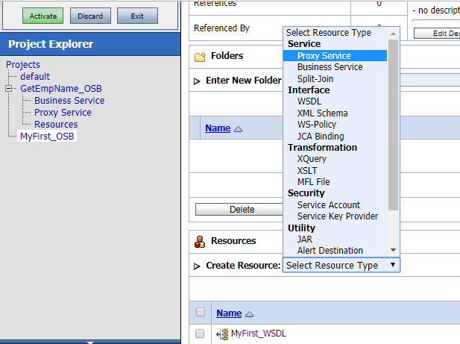

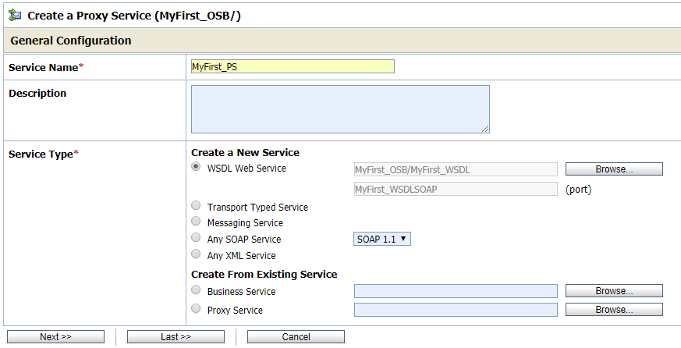

1. Select all defaults and save the proxy service.
2. Go and edit the message flow of the proxy service.
3. Add a pipe line service.

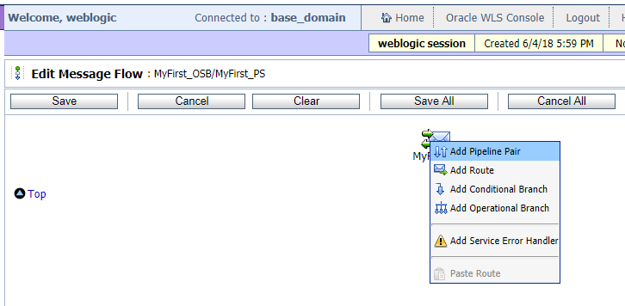

1. At the response pipe line add stage and click on edit.

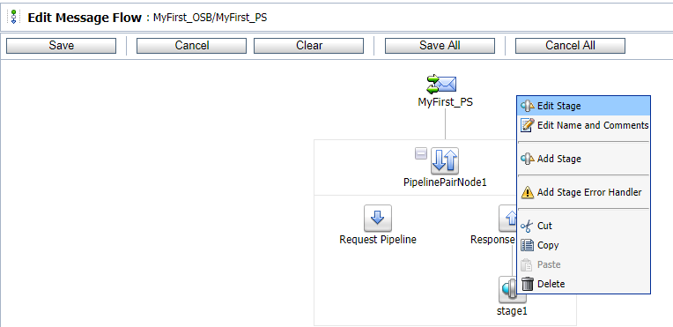

1. Select assign action to assign the values to a variable. (Adding the two input variables and assign the value to a temporary variable)

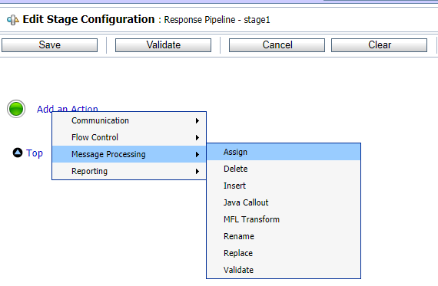

1. In the expression add the two variables by opening the xpath.

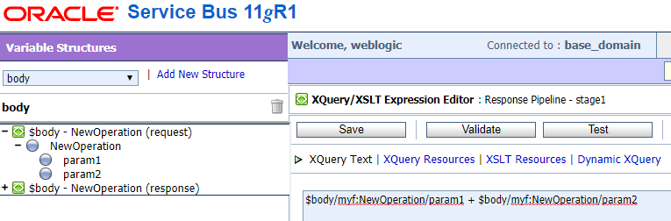

1. Create one variable (say res) to assign the xpath value.

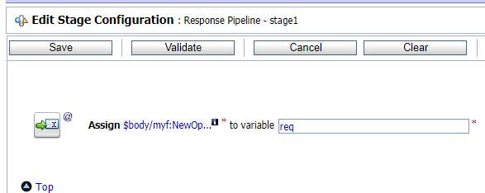

1. Add a Replace activity to replace the output variable with the result value.

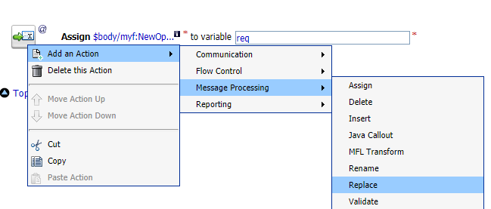

1. In the xpath expression select ‘.’
2. Assigning the value to the body of output.

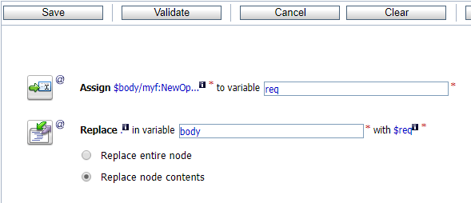

1. Click on ‘Save All’ and activate the changes.
2. Launch test console and test the proxy service.

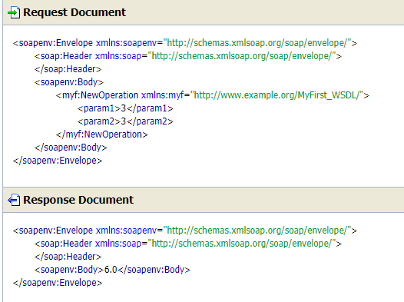

#### Using simple if condition in OSB (Subtracting Two numbers)

1. Follow the steps from 1 to 6 in the above task.
2. Add a **IF** condition to the action.

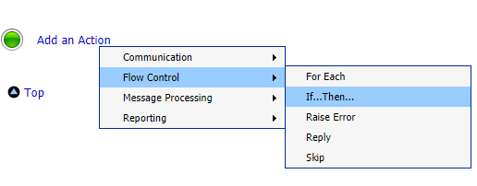

1. A if condition is crated.

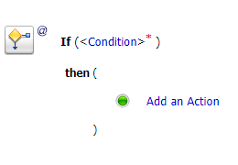

1. Add the condition in xpath expression by clicking on the Condition tab.

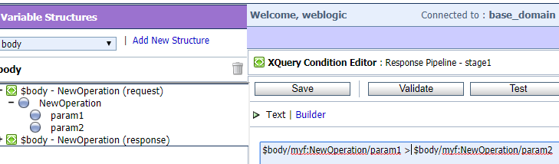

1. Then add the activity in Action tab. ( Adding assign activity)

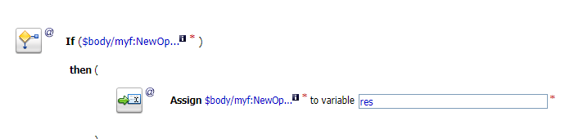

1. Add conditions if you have more in the same way.

